Module1 (2 Month )

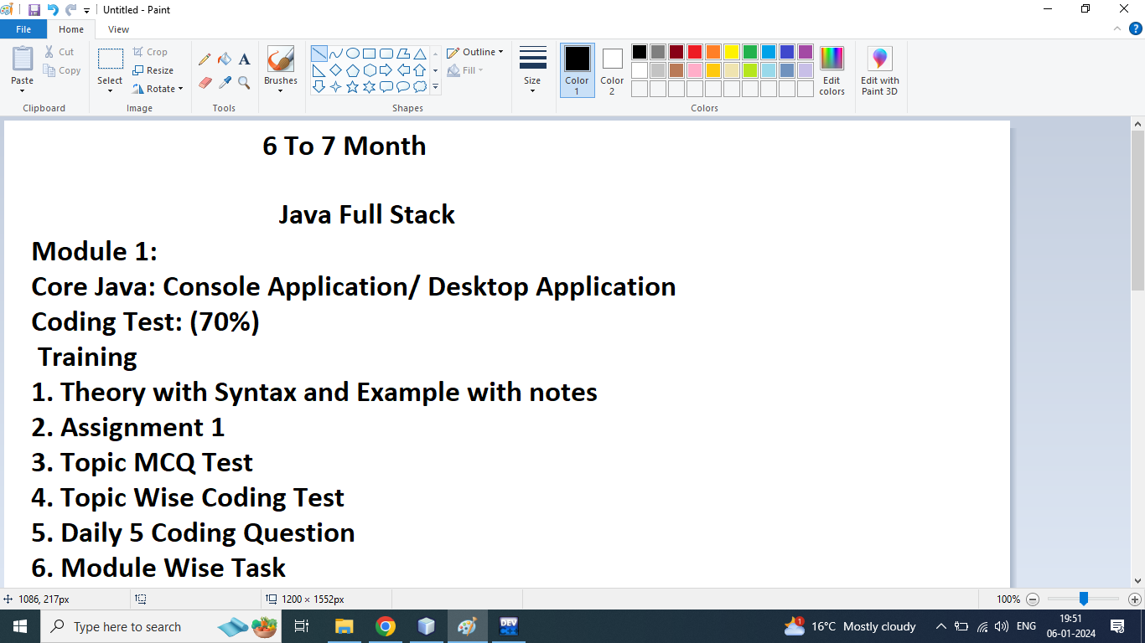

Module2 (2 Month )

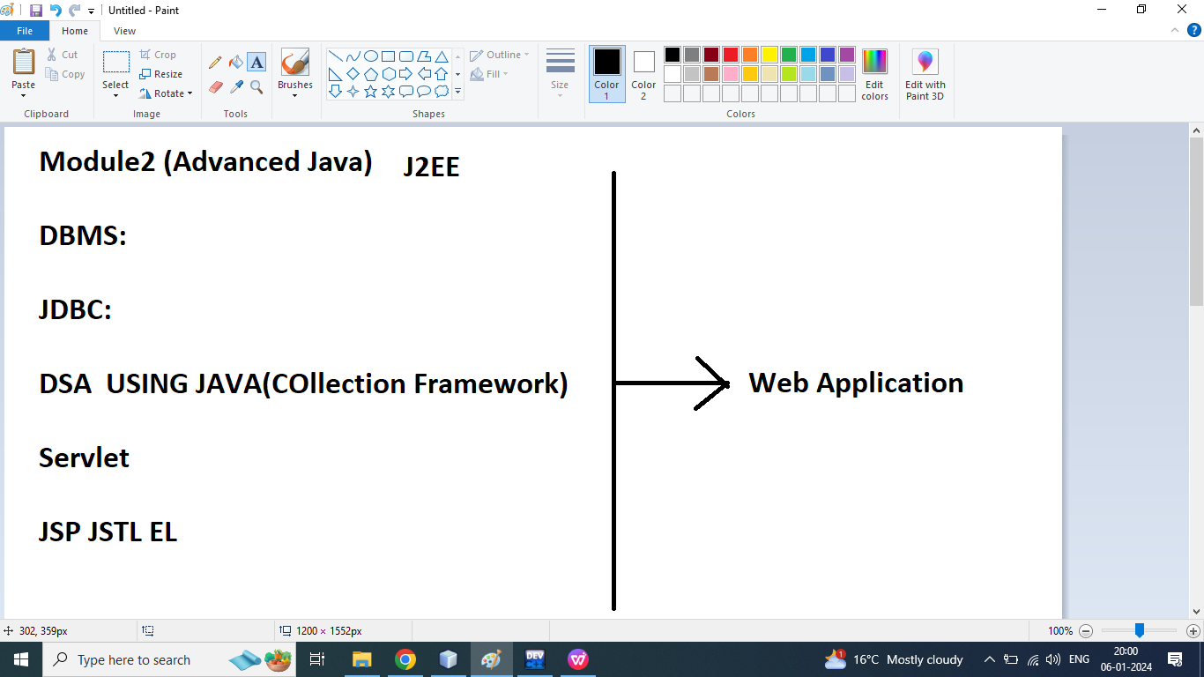

Module3 (2 Month )

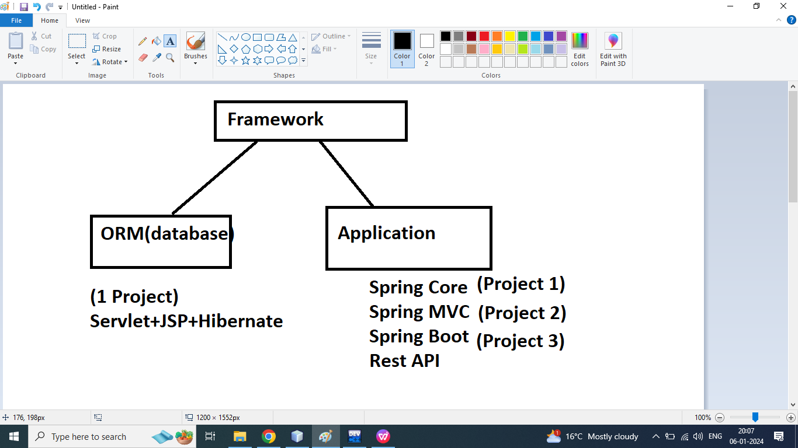

C++

OOPS

Exception Handling

Functions

Data type, variable, Operators, control flow statement, array,String

Core Java

1. Introduction
2. Software Requirement(JDK ,Notepad)
3. IDE: Netbeans, eclipse
4. Install jdk, set path, jvm,jre
5. Java program structure
6. Sample Program say Hello world using java
7. Data type
8. Variable
9. Input and output(Scanner)

MCQ Test

Assignment

Coding Test

Operators

1. Binary
2. Unary
3. Ternary

Arithmetic Operators

Relational

Logical

Bitwise Operator

Conditional Operator

Assignment Operator

Operator Precedence

Operator Associativity

MCQ Test

Assignment

Coding Test

Control Flow Statement

1. Conditional statement

If

If else

Else if

Nested if

Switch

1. Looping statement
2. While
3. Do while
4. For
5. For each
6. Jumping statement
7. Break
8. Continue

Logical Program

Pattern Program

MCQ Test

Assignment

Coding Test

Array

1D Array

2D Array

MCQ Test

Assignment

Coding Test

String

StringBuffer

StringBuilder

MCQ Test

Assignment

Coding Test

OOPS Concept

Class

Object

Access specifier

Constructor

Encapsulation

Inheritance

Polymorphism

Abstraction

static

final

Interface

Multiple inheritance through interface

MCQ Test

Assignment 1

Assignment 2

Coding Test

Package

Exception Handling

MCQ Test

Assignment

Coding Test

UI Swing

Q1.How to set Path In java Programming?

Ans:

C:

Program Files

Java

Jdk 1.8

Bin

Copy the url path

C:\Program Files\Java\jdk1.8.0_60\bin

Write click on My Computer

Click on Properties



Click on Advanced System Setting



Click on Enviorement Variable



Search Path in System Variables



Click on Edit after select the Path Variable

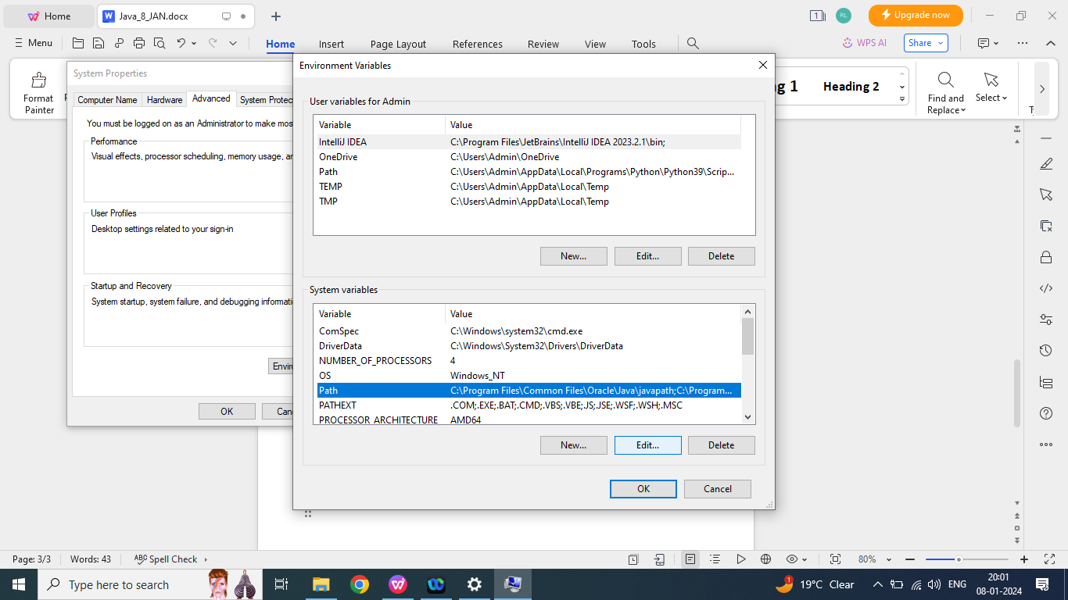

Click on Edit

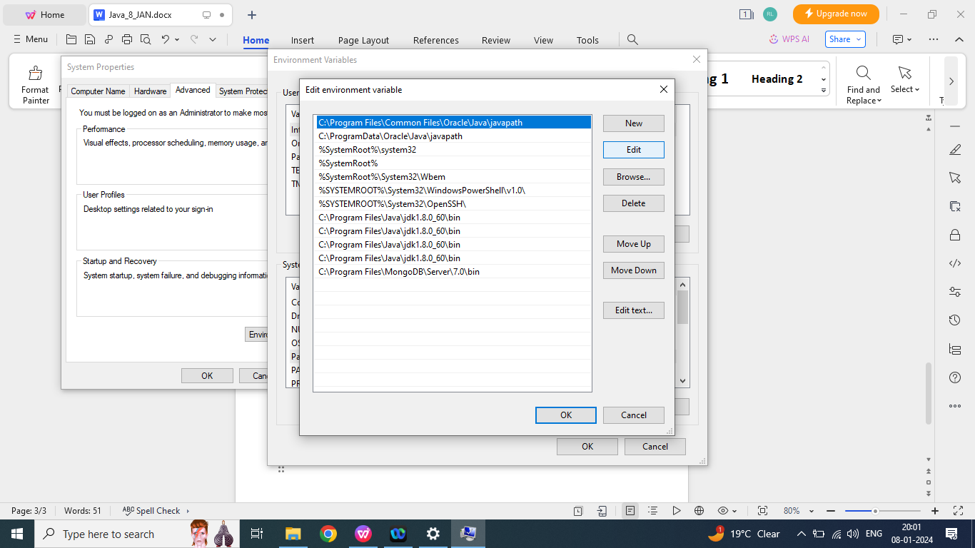

Paste the path in the last

C:\Program Files\Java\jdk1.8.0_60\bin

final click and OK

Q2. How to check our path is SET or not?

Ans:

Step1:

Will goto command prompt

Step2: type javac and press Enter

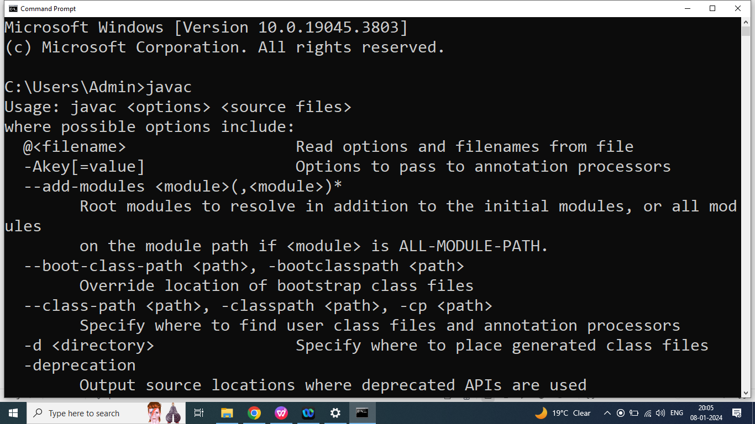

Q3. How to use Online Compiler in java?

Ans:

Java online Compiler GDB

<https://www.onlinegdb.com/online_java_compiler>

Q3. What is the Structure of java program?

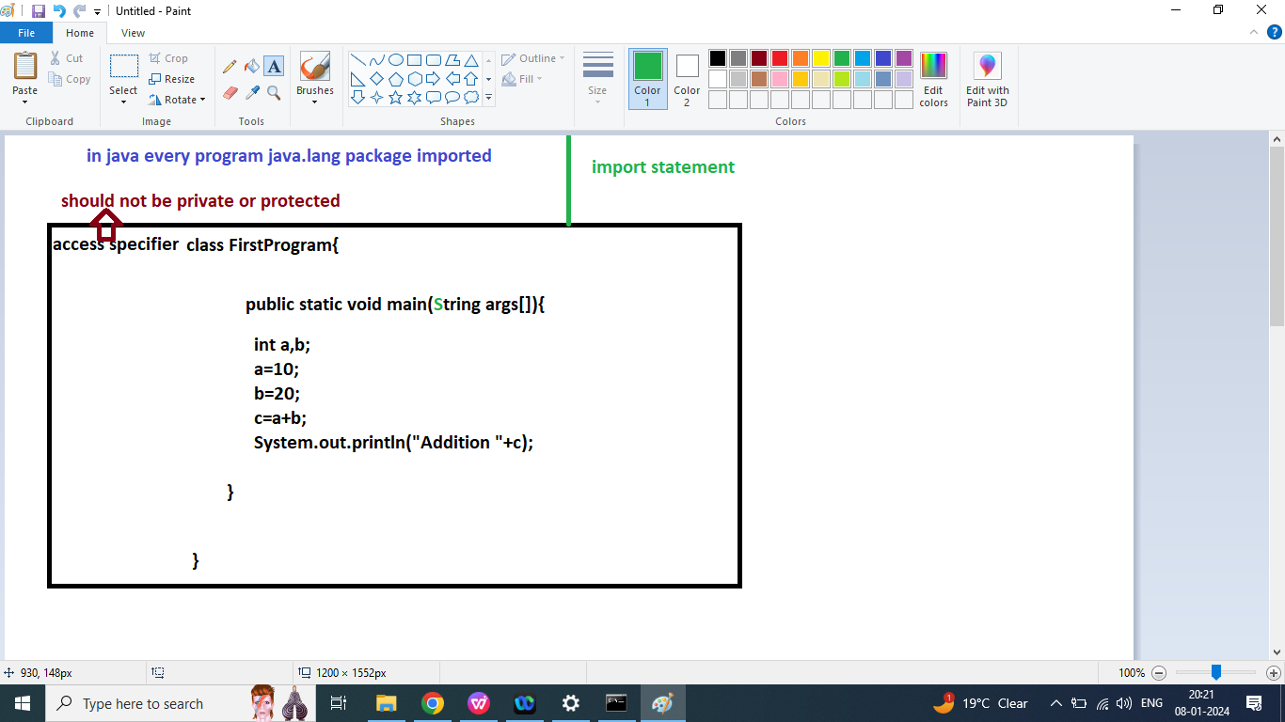

Q1.Explain Java Program Structure?

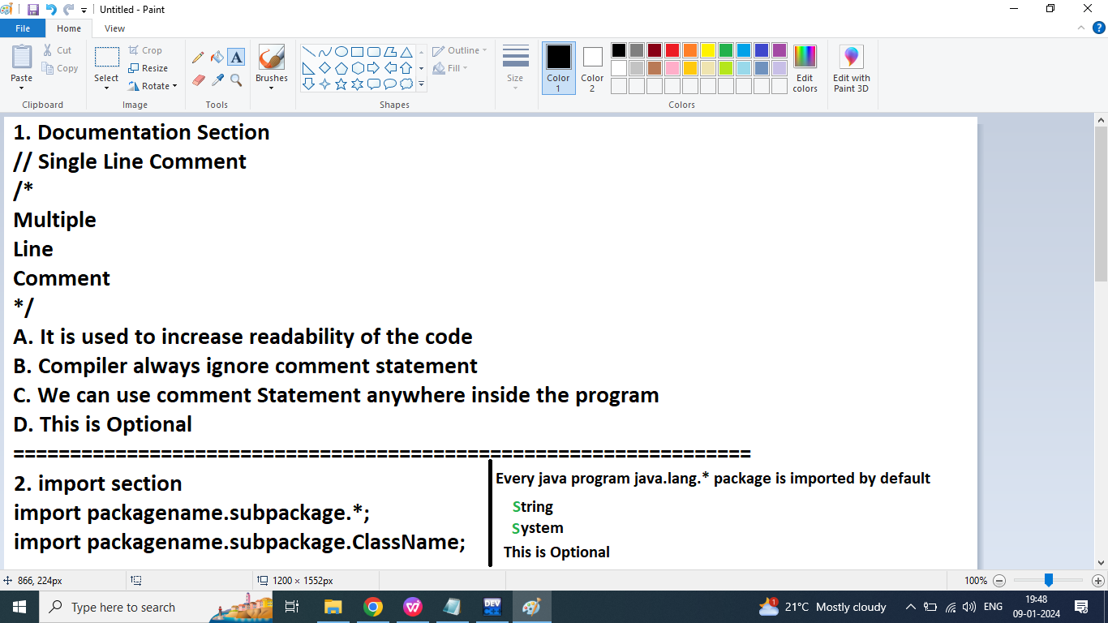

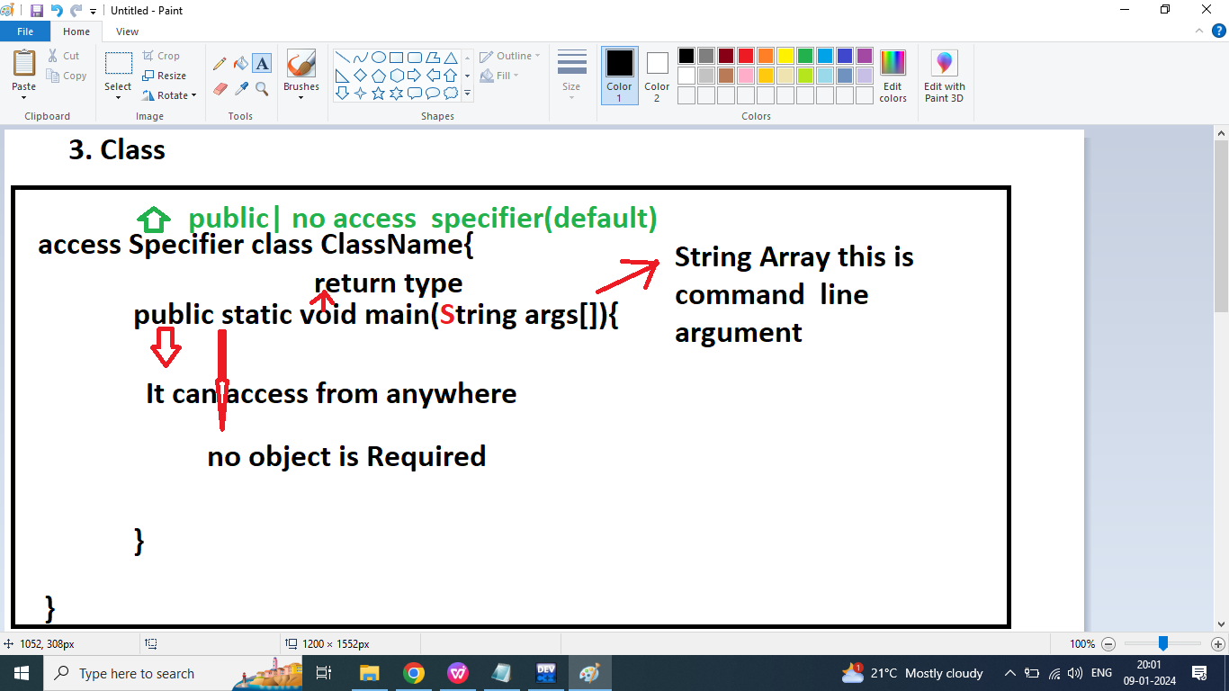

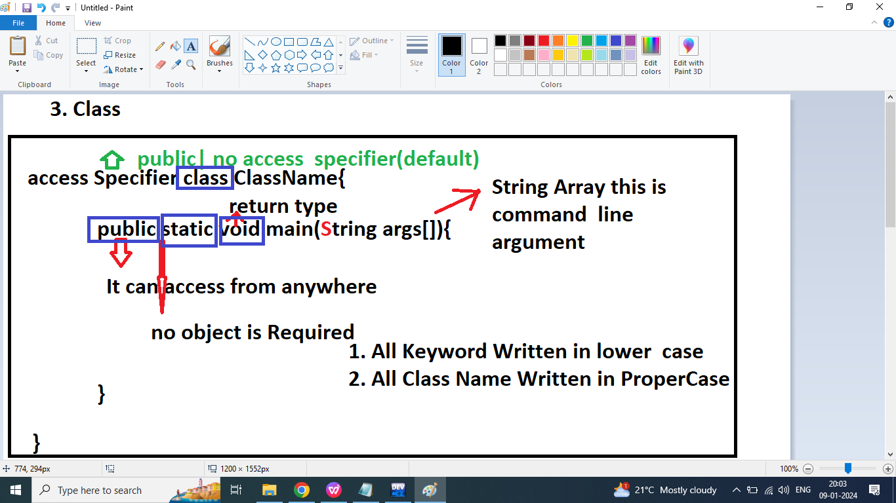

Q3. Explain System.out.println()?

Ans: if we want to print anything on the console then we should go for System.out.println()?

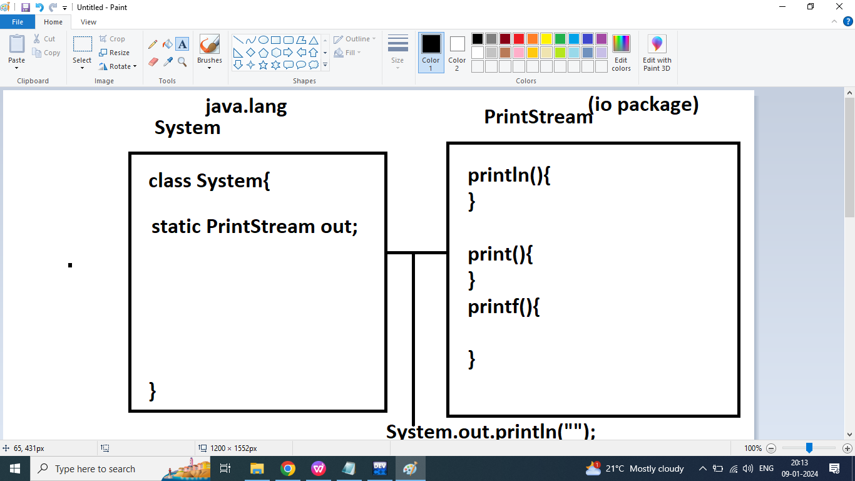

Q3. Write a java program to print Hello World on the Screen?



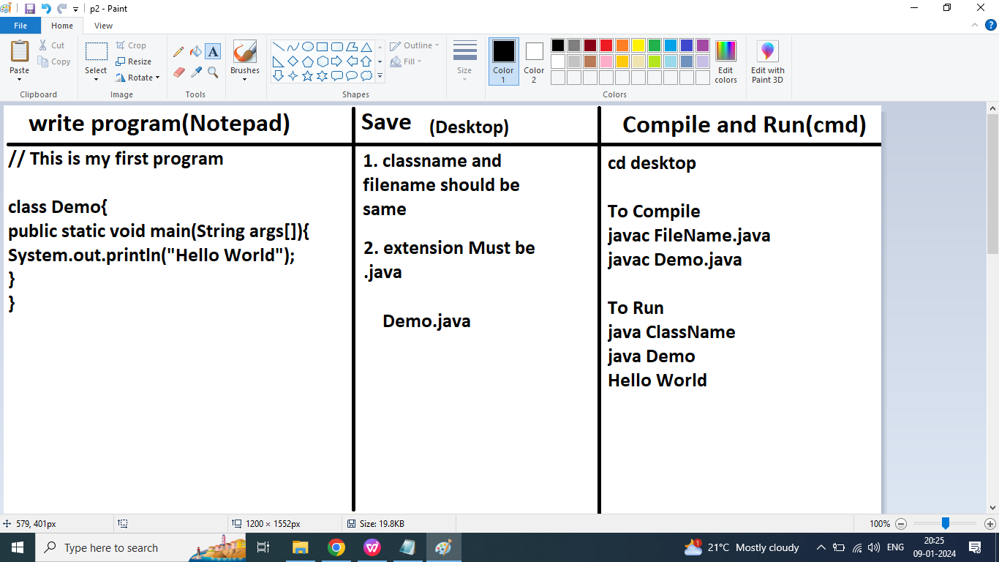

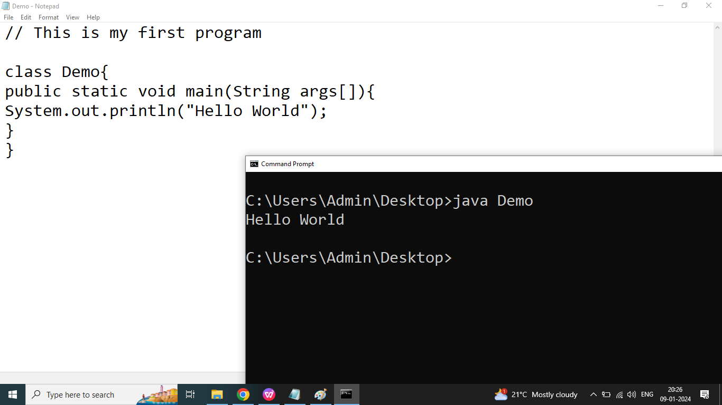

Q1. Write a Java program to print Hello World on the screen.

Hello World

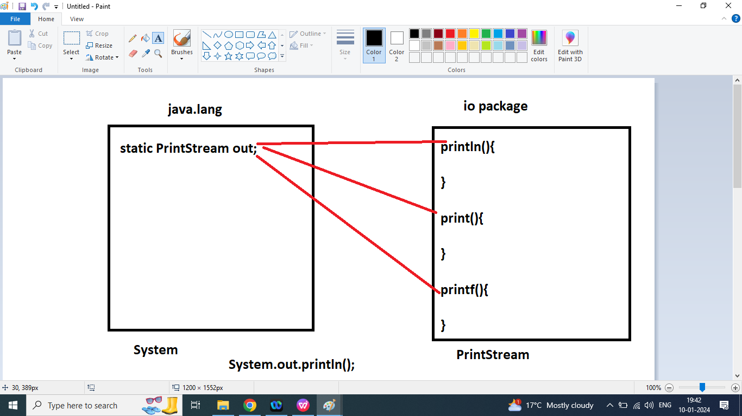

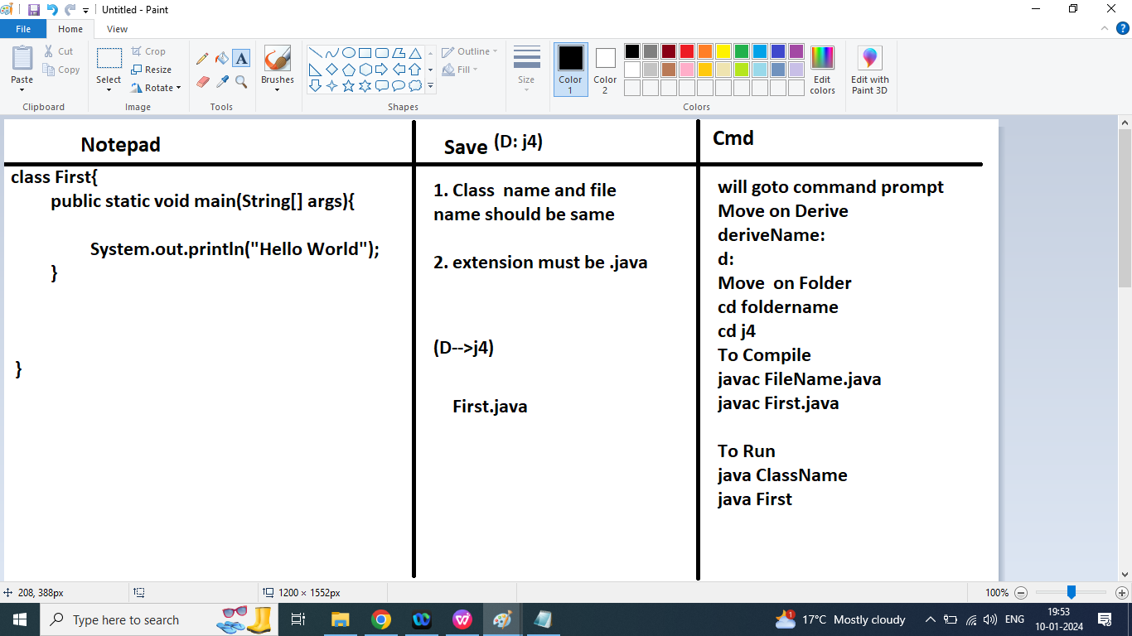

Q2. Write a java program to print your Introduction on the Screen.

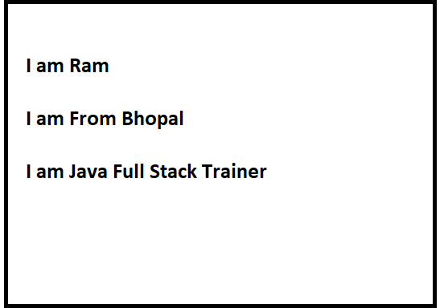

Q1. Write a java program to print Message using printf()?

Hello World

%d : int

%f: float

%lf : double

%c: char

%s : String

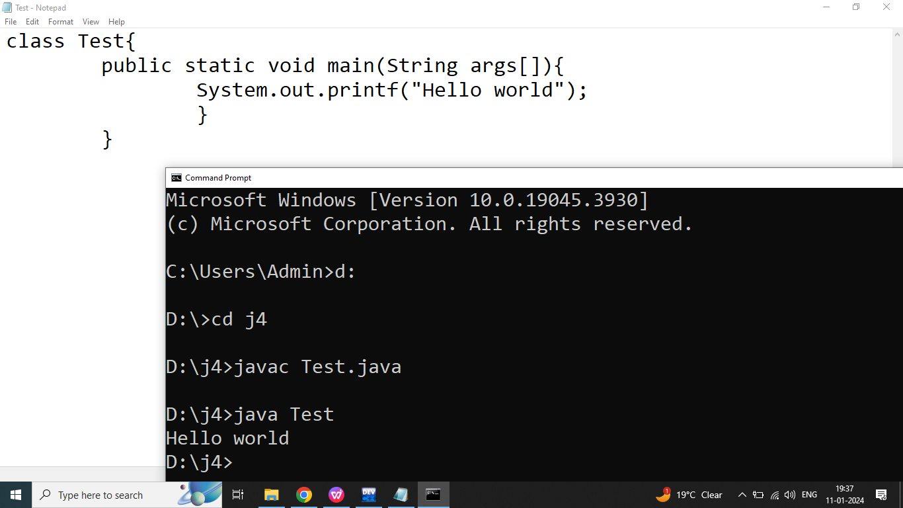

Q2. Explain Data type in java programming?

Ans:

Data type can specify what type data can be store and how many bytes memory could be allocated.

The mostly used data type in java programming

1. int--->Integer 4 byte

If we want to store whole number then we should go for int

Example:

Age , RollNumber , Subject marks, year,days,months

1. float ---->Float 4 byte

If we want to store real number upto 6 decimal places then we should go for float.

Example:

Percentage, average,

float a=2.5f;

Note: In java every real number treated as double by default.

Literals:

Float: f or F

1. double----->Double 8 byte:

If we want to store real number upto 15 decimal places then we should go for float.

Example:

Amount

double c=12345d;

Literals:

double: d or D

1. char------>Character 2 byte

It can store single character

Character literals :

‘0’

‘+’

‘A’

1. boolean---->Boolean size not fixed

It can store true and false type values

=============================================

Q3. Explain types of data type in java programming?

Ans:

1. Types of data type
2. Pre-defined / Primitive / Built in / Fundamental Data types
3. User defined / Non- Primitive data type
4. String, StringBuffer, StringBuilder, Array,Wrapper classes (Integer, Float, Double,Character,Boolean)

Q4. Explain keywords in java programming?

Ans: Keywords are reserved words that have a special meaning to java compiler.

abstract

assert

boolean

byte

break

case

continue

class

catch

default

=======================================>

Q1.Explain Keywords in Java?

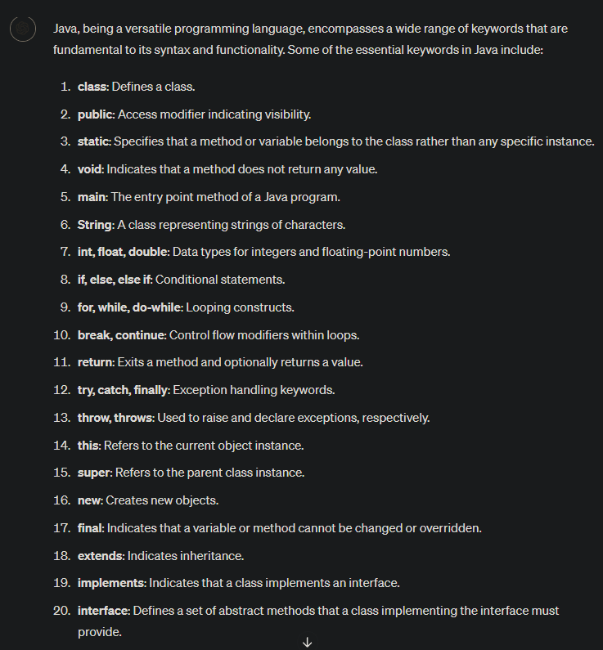

Ans:

data type

1. int

2. char

3. float

4. double

5. boolean

6. byte

7. long

8. short

9. true

10. false

11. null

control flow statement

if

else

switch

case

default

break

continue

while

do

for

oops concepts:

1. class

2. return

3. private

4. public

5. protected

6. static

7. final

8. interface

9.abstract

10. void

Exception Handling

1. try

2. catch

3. throw

4. throws

5. finally

Note:

1. All keywords written in lower case

2. use space after keywords

public static void main

3. Identifier name should not be keyword.

Q2. Explain Identifier in java programming?

Ans: Identifier is a name given by the programmer. Identifier is may be name of variable, name of method, name of class, name of object, name of array.

Rules of Identifier

1. Identifier name may be combination of alphabet and digits but first character must be an alphabet

Example:

int num;//valid

int num123;//valid

int num 123;//invalid

int 123num;//invalid

int a;//valid

int A;//valid

int num@12345;//invalid

Rule2:

In java programming _ and $ is also consider alphabets. So we can use any place inside identifier.

Example:

int num 123;//invalid

int num-data;//invalid

int num_123;//valid

int num$123; //valid

int __;//valid

int aa; // valid

int $;//valid

int 123;//invalid

int _123;///valid

Rule 3: In java Programming Identifier name should not be keyword.

int iF;//valid

int if;//invalid

Rule 4: We can use Class name and Interface name as a Identifier.

int String;

int System;

Q3. Explain Variable in java programming?

Ans:

Variable is a temporary memory location it is used to store a value.

Variable must be initialize before using it.

Value of variable may be changed during execution of the program.

Variable have 4 state

1. Declare:

Syntax:

Data type variable Name;

int num1;

int num2;

int num3;

1. Initialize

num1=10;

num2=20;

1. Operation

num3=num1+num2;

1. Print value of the variable

System.out.println(“Message : ”+variable);

System.out.println(variableName);

OR

System.out.print(“Message : ”+variable);

System.out.print(variableName);

OR

System.out.printf(“Message : format specifier ”,variable);

Q1. Write a java program to print sum of two numbers.

Number 1 : 12

Number 2: 13

Addition : 25

// Addition program without input

class Add{

public static void main(String args[]){

int n1;

int n2;

int n3;//declare

n1=12;

n2=13;

//Initialization

n3=n1+n2;

//Operation

System.out.println("Number 1 : "+n1);

System.out.println("Number 2 : "+n2);

System.out.println("Additon : "+n3);

}

}

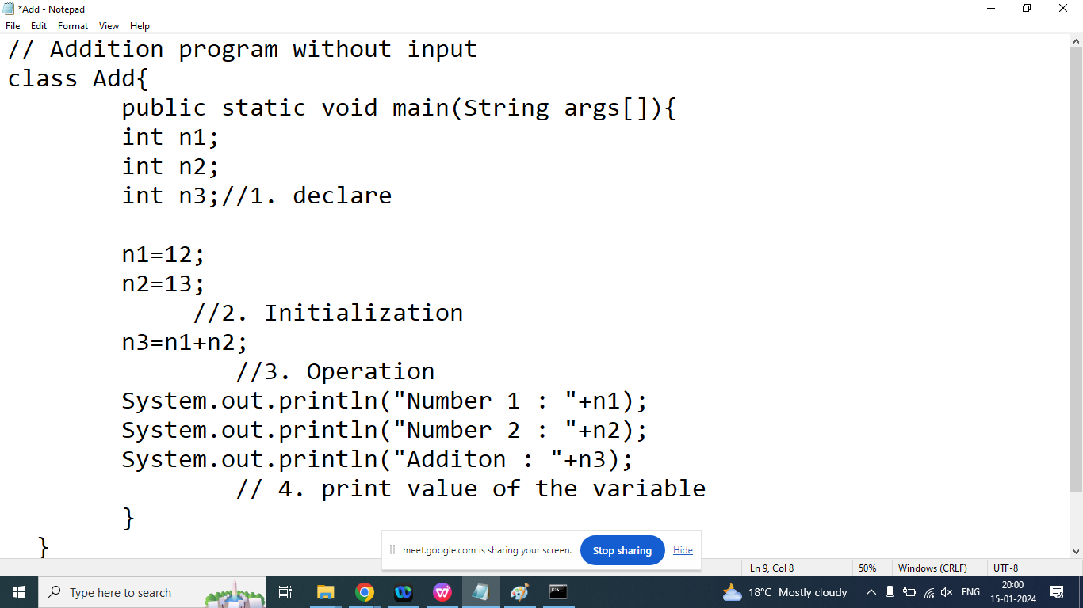

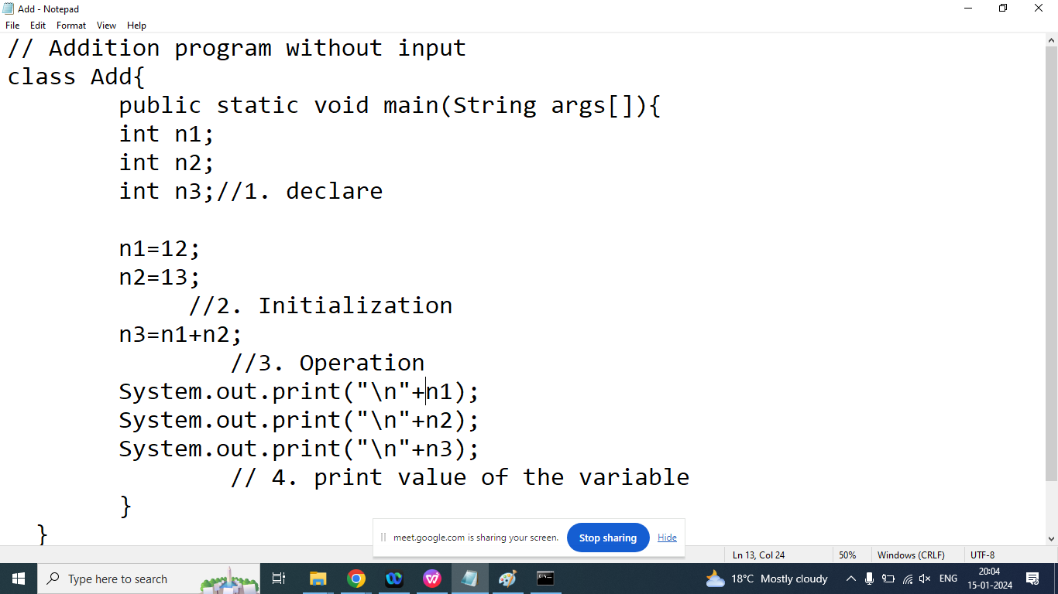

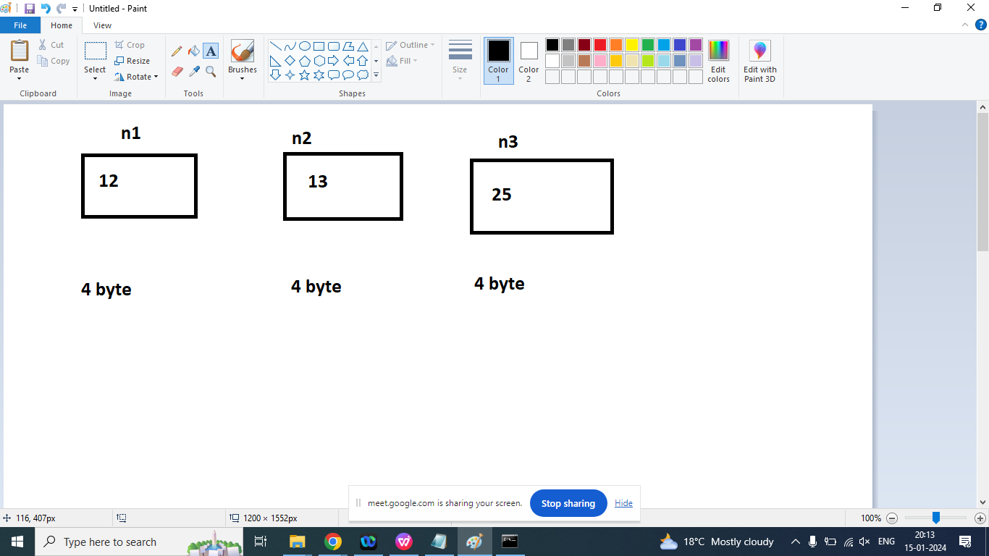

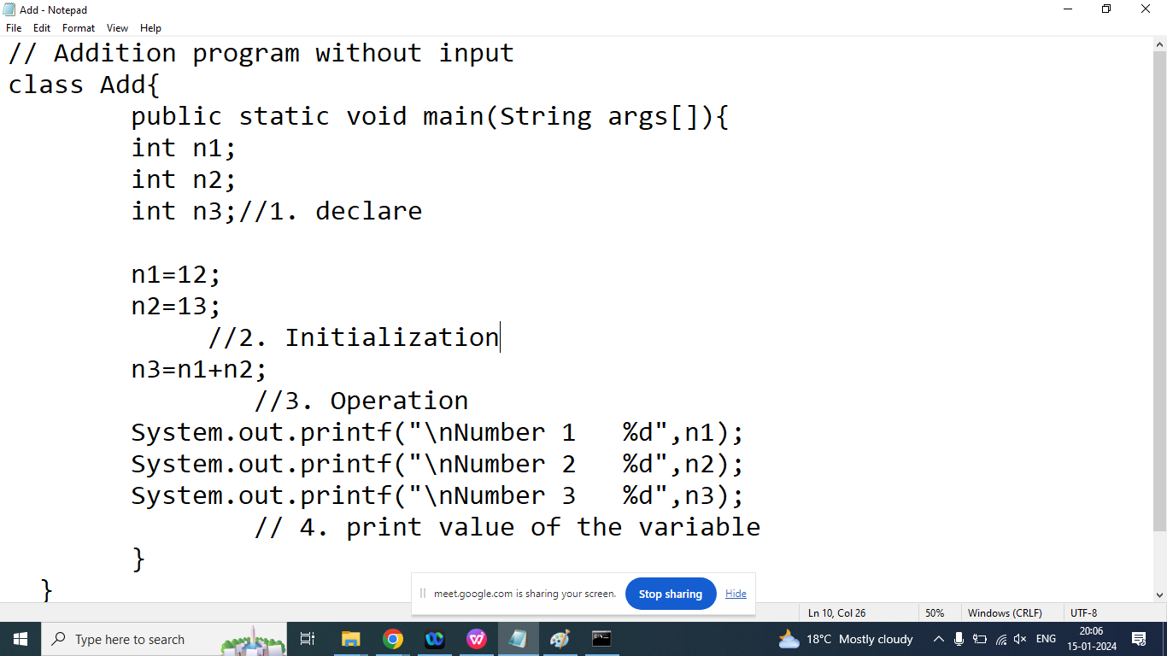

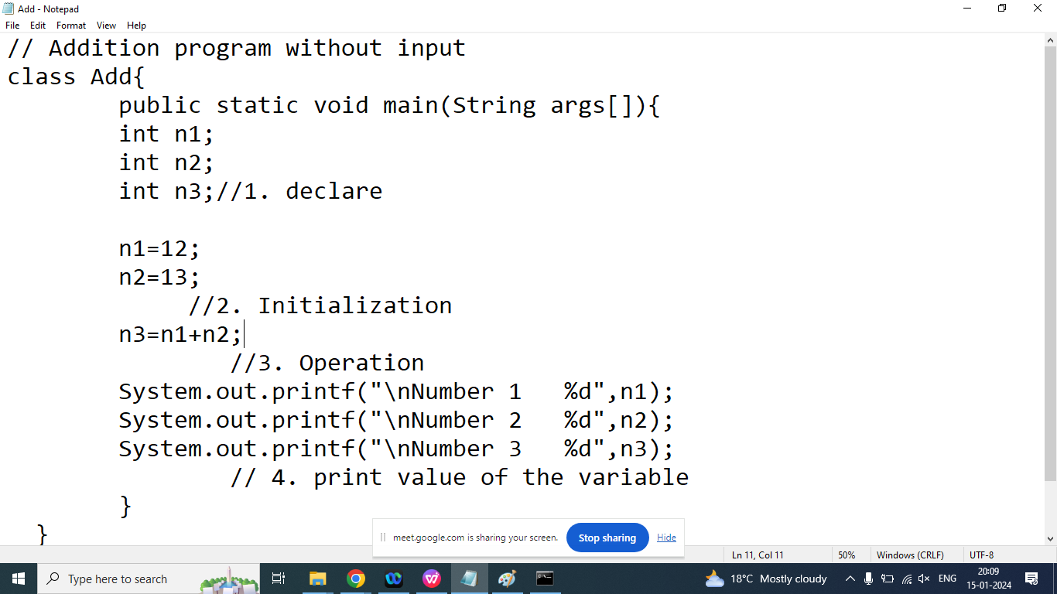

Q2. Write a Java program to calculate area and circumference of Circle?

Radius: 2.0

Area of Circle: 12.56

Circumference of Circle: 12.56

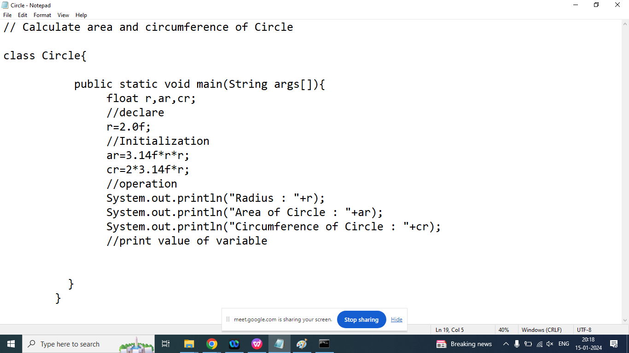

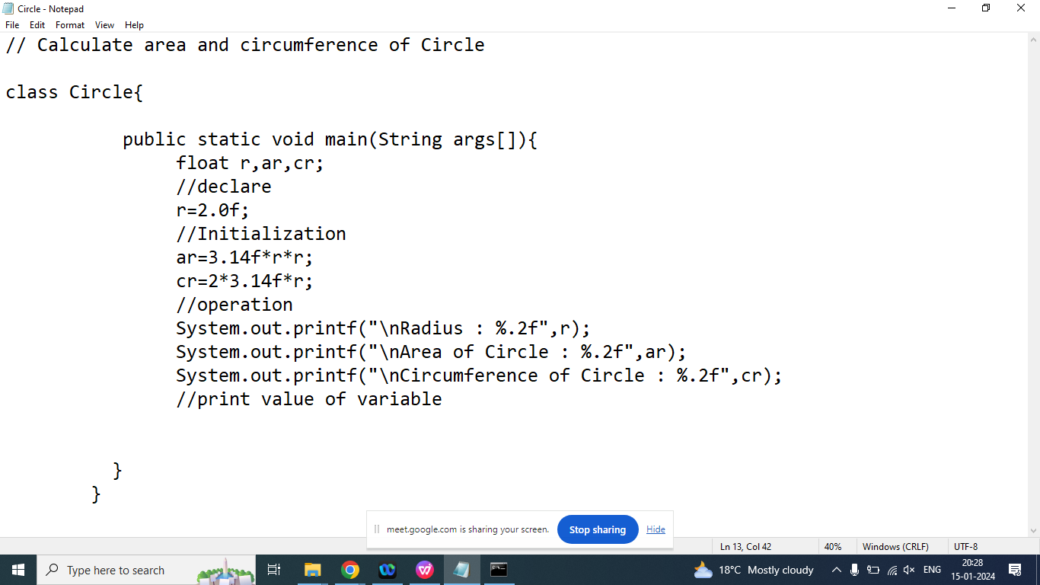

Q1. Write a java program to print details of the Student

Student Name : Aman

Student Section: A

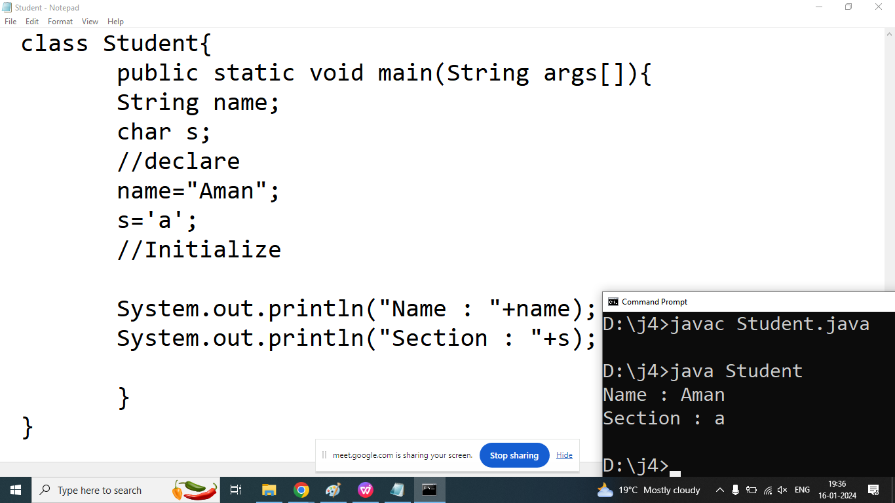

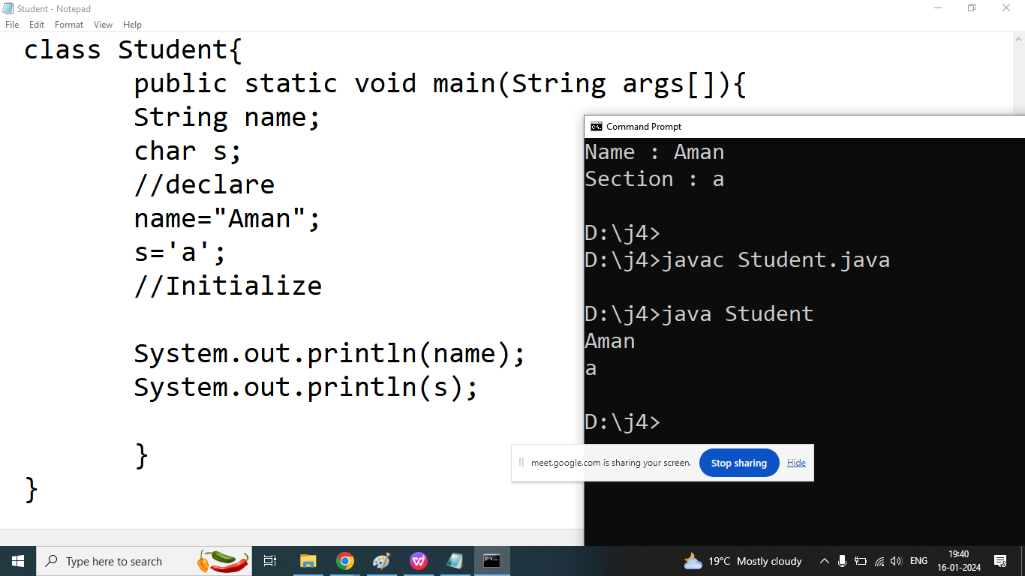

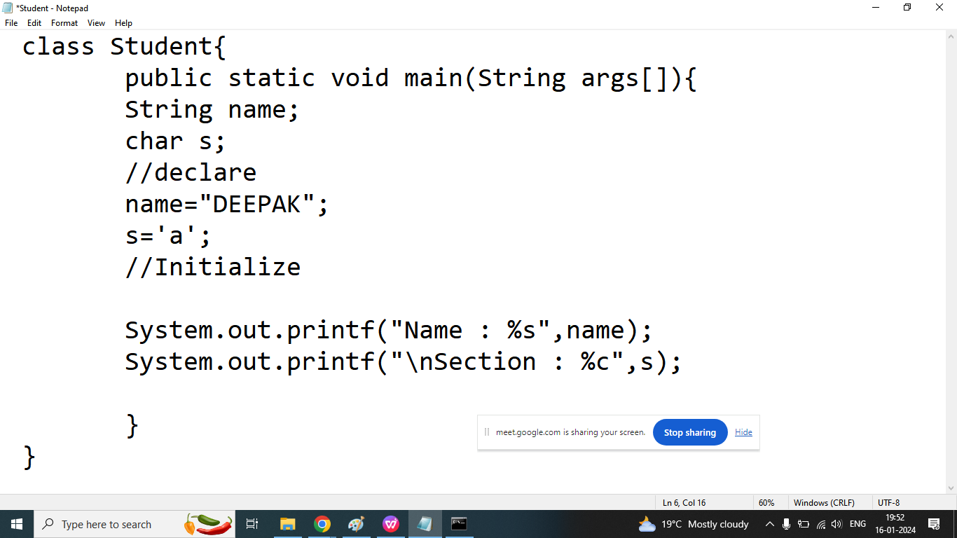

Q3.How to take input from the user in java using Scanner class?

Ans:

If we are taking input from the user then we should go for Scanner class

Scanner class is a features of java 5.

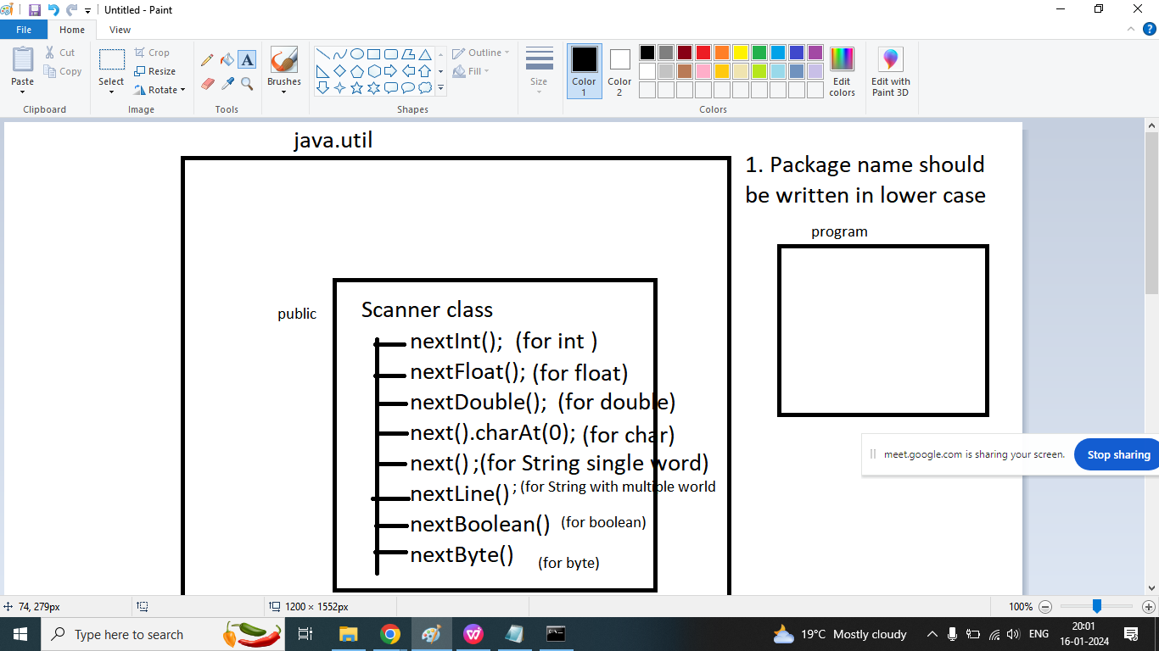

If we are taking input from the user then we should follow 3 steps

Step1: import Scanner class in your program(before class)

There are Two ways to import class in our program

1. Import all classes or interfaces

import java.util.*;

1. Import specific class in our program

import java.util.Scanner;

**Step2:** Create an object of Scanner class(inside main)

Syntax:

ClassName obj=new ClassName(Parameter);

**Scanner** sk=new **Scanner**(**System**.in);

Step3: call method of Scanner class via object (sk)

int a=sk.nextInt();

float b=sk.nextFloat();

double c=sk.nextDouble();

String word=sk.next();

String sentence=sk.nextLine();

char d=sk.next().charAt(0);

Q1. Write a java program to print sum of two numbers.

Enter Number 1: 100

Enter Number 2: 200

Addition : 300

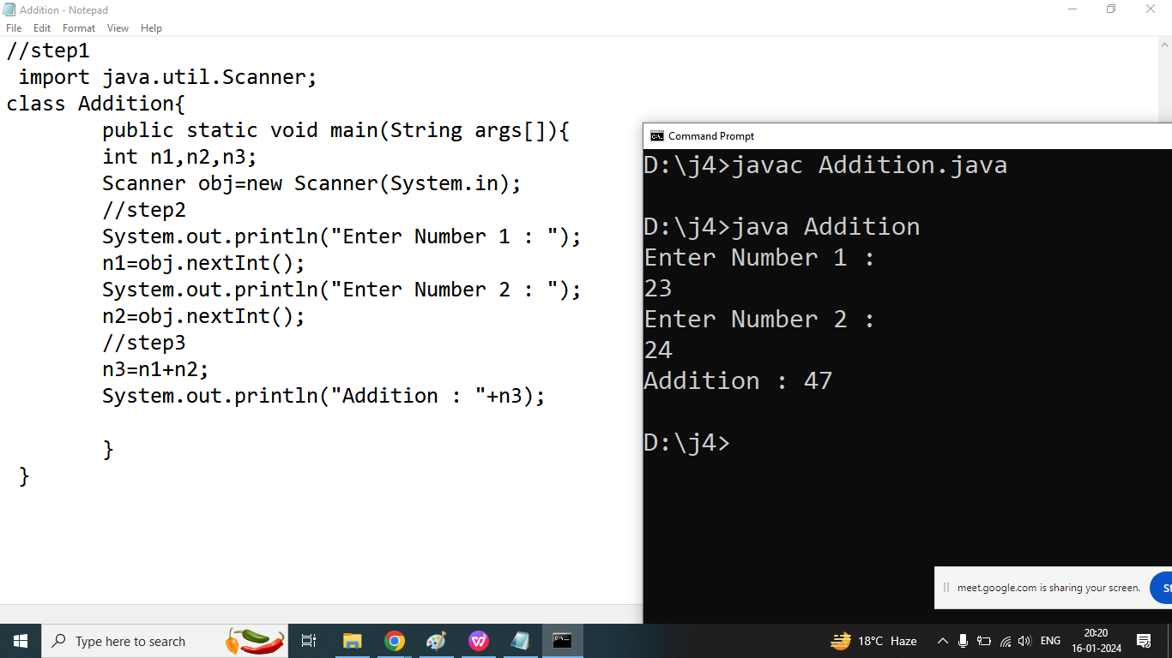

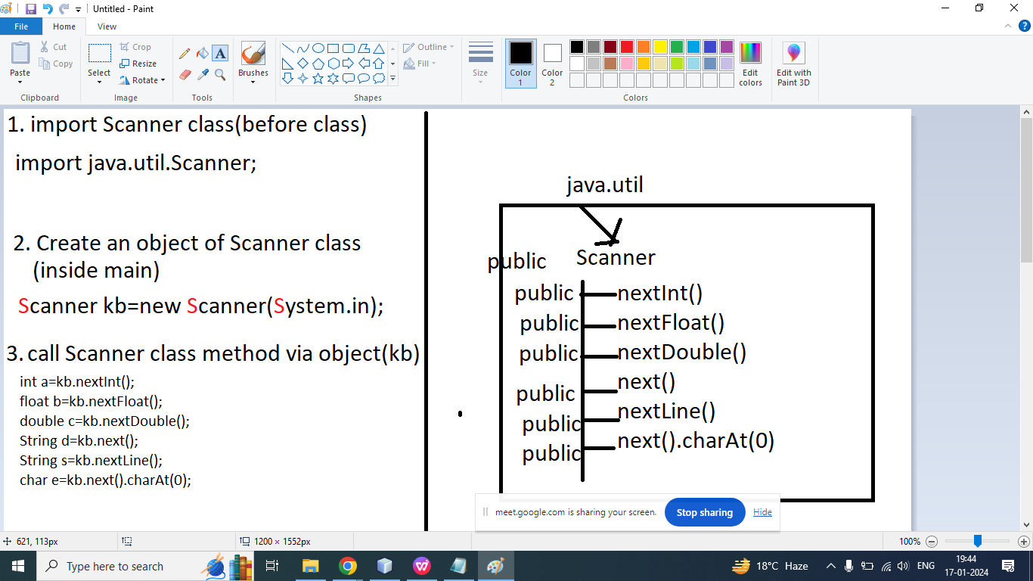

Q2. Write a Java program to take input radius from the user and calculate area and circumference of Circle.

Enter Radius: 2.0

Area : 12.56

Circumference : 12.56

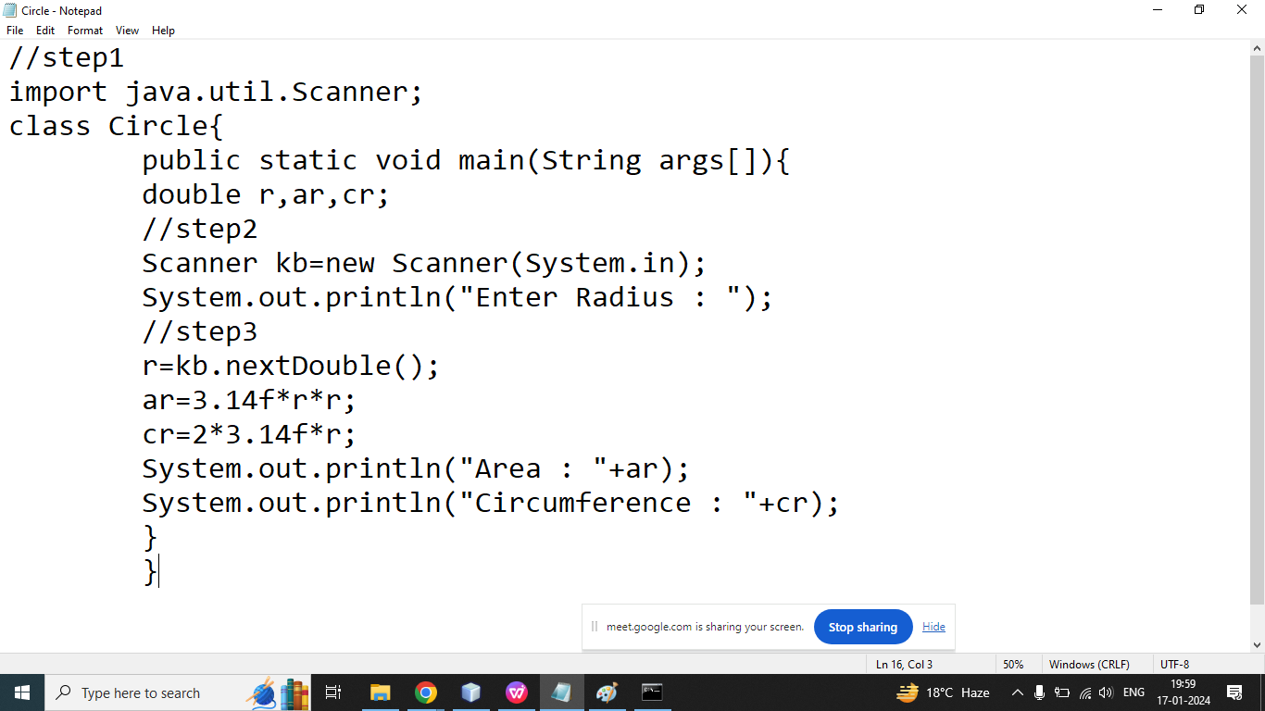

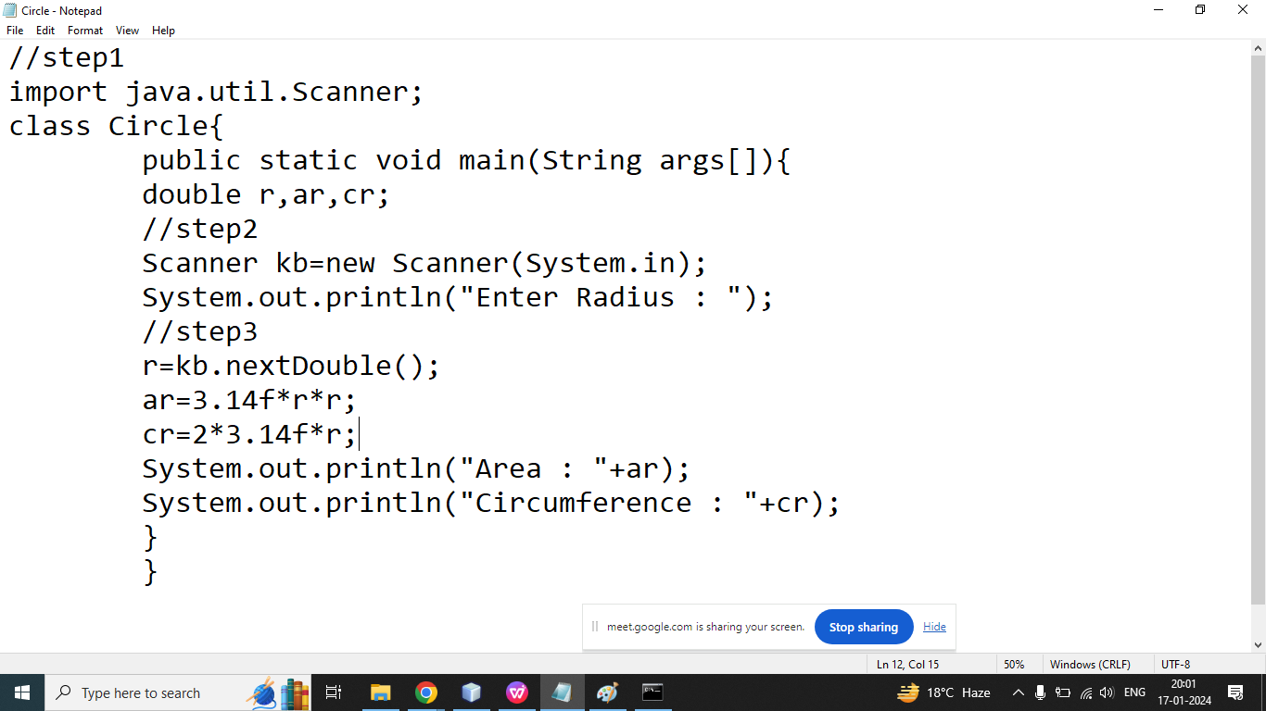

Q3. Write a java program to take students information from the user and print it

Enter Email ID: [aman@gmail.com](mailto:aman@gmail.com)

Enter Student Full Name: Sanjay Kumar Jain

Enter Section: A

Name : Sanjay Kumar Jain

Section : A

Email: [aman@gmail.com](mailto:aman@gmail.com)

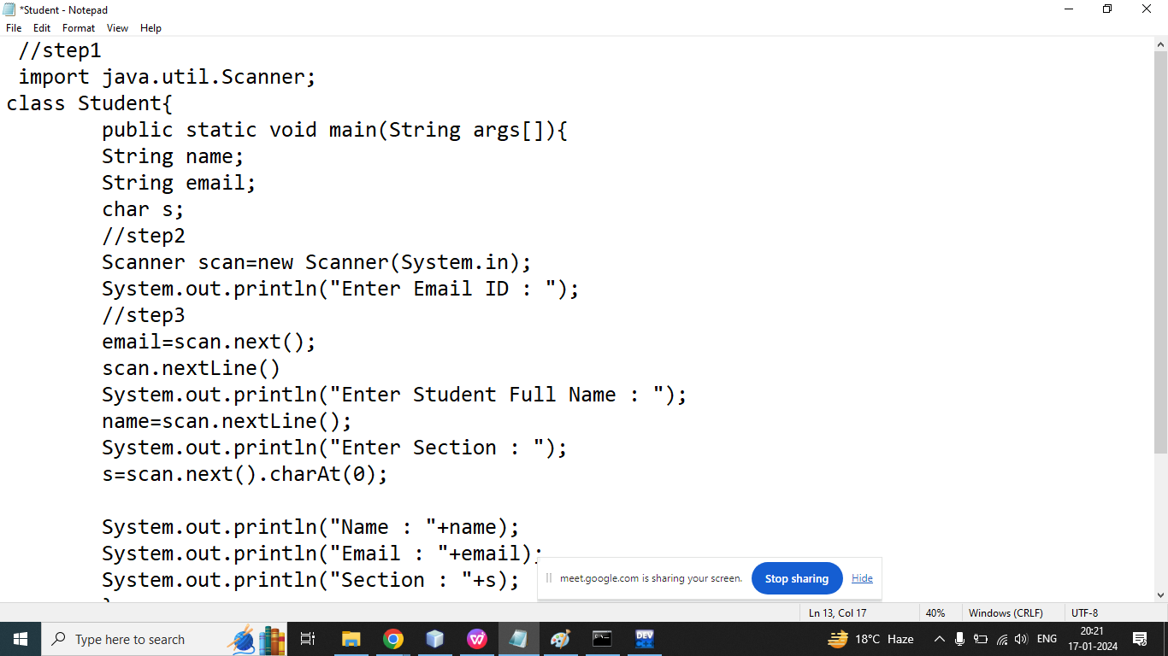

Q4. Write a java program to take employee Information from the user and print it on the Screen.

Enter EMPNO : 101

Enter Salary : 12344.56

Enter Grade: A

Enter Dept: 10

Enter Name: Aman

Employee Details:

EMPNO : 101

Salary : 12344.56

Grade: A

Dept: 10

Name: Aman

Q1. Write a java program to take student information from the user and calculate percentage and total marks.

Enter Name: Aman

Enter Enrollment No: 0103CS

Enter Maths Marks: 67

Enter Chemistry Marks: 56

Enter Physics Marks: 49

Enter Hindi Marks: 78

Enter English Marks: 67

Enter Section : A

Name: Aman

Enrollment No: 0103CS

Maths Marks: 67

Chemistry Marks: 56

Physics Marks: 49

Hindi Marks: 78

English Marks: 67

Section : A

Total Marks:

Percentage:

//step1

import java.util.Scanner;

class Student{

public static void main(String args[]){

//step2

Scanner j=new Scanner(System.in);

System.out.println("Enter Name : ");

String name=j.nextLine();

System.out.println("Enter Enrollment : ");

String en=j.nextLine();

System.out.println("Enter Maths Marks: ");

int m=j.nextInt();

System.out.println("Enter Chemistry Marks : ");

int c=j.nextInt();

System.out.println("Enter Physics Marks: : ");

int p=j.nextInt();

System.out.println("Enter Hindi Marks: : ");

int h=j.nextInt();

System.out.println("Enter English Marks: : ");

int e=j.nextInt();

System.out.println("Enter Section : ");

char s=j.next().charAt(0);

System.out.println("Name : "+name);

System.out.println("Enrollment No : "+en);

System.out.println("Maths Marks: "+m);

System.out.println("Chemistry Marks : "+c);

System.out.println("Physics Marks: : "+p);

System.out.println("Hindi marks : "+h);

System.out.println("English Marks "+e);

int total=p+c+m+h+e;

System.out.println("Total Marks : "+total);

float per=total/5.0f;

System.out.println("Percentage : "+per);

}

}

Q3. Write a java program to swap two number using third variable.

Enter Value of A: 10

Enter Value of B: 20

Before Swapping

A= 10 B=20

After Swapping

A= 20 B=10

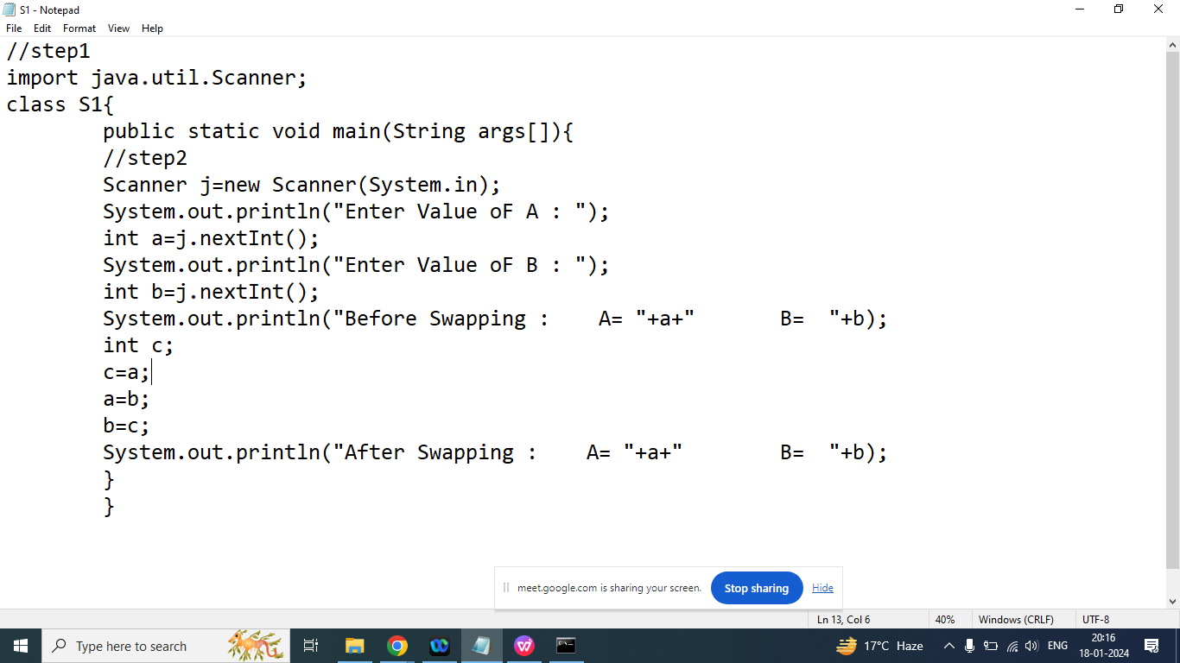

Q3. Write a java program to swap two number without using third variable.

Enter Value of A: 10

Enter Value of B: 20

Before Swapping

A= 10 B=20

After Swapping

A= 20 B=10

//step1

import java.util.Scanner;

class S1{

public static void main(String args[]){

//step2

Scanner j=new Scanner(System.in);

System.out.println("Enter Value oF A : ");

int a=j.nextInt();//10

System.out.println("Enter Value oF B : ");

int b=j.nextInt();//20

System.out.println("Before Swapping : A= "+a+" B= "+b);

a=a+b;//a=30

b=a-b;//b=10

a=a-b;//a=20

System.out.println("After Swapping : A= "+a+" B= "+b);

}

}

====================================

//step1

import java.util.Scanner;

class S1{

public static void main(String args[]){

//step2

Scanner j=new Scanner(System.in);

System.out.println("Enter Value oF A : ");

int a=j.nextInt();//7

System.out.println("Enter Value oF B : ");

int b=j.nextInt();//5

System.out.println("Before Swapping : A= "+a+" B= "+b);

a=a^b;//a=2

/*

a=7==>0111

b=5==>0101

^ 0010

*/

b=a^b;

/*

a=2;

a==>2===>0010

b==>5===>0101

^ 0111==>7===b=7

*/

a=a^b;

/*

a=2===>0010

b=7===>0111

^ 0101====>5===>a

*/

System.out.println("After Swapping : A= "+a+" B= "+b);

}

}

Q1. Write a java program to convert given amount into smallest possible bank notes.

Enter Amount: 1388

Notes of 100: 13

Notes of 50: 1

Notes of 20: 1

Notes of 10: 1

Notes of 5: 1

Notes of 2: 1

Notes of 1:1

import java.util.Scanner;

class N{

public static void main(String args[]){

int a,n,rm;

Scanner sk=new Scanner(System.in);

System.out.println("Enter Amount : ");

a=sk.nextInt();//1388

n=a/100;

System.out.println("Notes of 100 : "+n);

rm=a-n*100;

n=rm/50;

System.out.println("Notes of 50 : "+n);

rm=rm-n*50;

n=rm/20;

System.out.println("Notes of 20 : "+n);

rm=rm-n*20;

n=rm/10;

System.out.println("Notes of 10 : "+n);

rm=rm-n*10;

n=rm/5;

System.out.println("Notes of 5 : "+n);

rm=rm-n*5;

n=rm/2;

System.out.println("Notes of 2 : "+n);

rm=rm-n*2;

n=rm/1;

System.out.println("Notes of 1 : "+n);

}

}

import java.util.Scanner;

class N{

public static void main(String args[]){

int a,n,rm;

Scanner sk=new Scanner(System.in);

System.out.println("Enter Amount : ");

a=sk.nextInt();//1388

n=a/100;

System.out.println("Notes of 100 : "+n);

a=a%100;

n=a/50;

System.out.println("Notes of 50 : "+n);

a=a%50;

n=a/20;

System.out.println("Notes of 20 : "+n);

a=a%20;

n=a/10;

System.out.println("Notes of 10 : "+n);

a=a%10;

n=a/5;

System.out.println("Notes of 5 : "+n);

a=a%5;

n=a/2;

System.out.println("Notes of 2 : "+n);

a=a%2;

n=a/1;

System.out.println("Notes of 1 : "+n);

}

}

Q2.Explain Operators in java programming?

ANs:

Operators are symbol that tells to the compiler to perform some specific operations

Types of operators on the basis of number of operand

1. Binary Operator:
2. Unary Operator:
3. Ternary Operator:

Types of operators on the basis of functionalities

1. Arithmetic operator[+,-,*,/,%,++,--]
2. Relational operator[>,<,>=,<=,==,!=]
3. Logical operator [&&, ||,!]
4. Bitwise Operator[&,|,^,<<,>>,~]
5. Conditional Operator [? : ]
6. Assignment Operator[=,+=,-=,*=,/=]
7. Operator Precedence
8. Operators Associativity

Q3. Explain % modulo operator in Java programming?

Ans:

Ans:

If we want to find reminder then we should go for modulo operator

Syntax:(%)

First Operand % Second Operand

4%10===>4

0%10===>0

50%23=>4

35%5==>0

Note: if first operand is less than second operand then reminder always will first operand

Syntax:(/)

First Operand / Second Operand

4/10===>0

0/10===>0

50/23==>2

35/5=>7

Example:

Write a java program to print last digit of any number.

Enter Any Number : 123

Last Digit is : 3

import java.util.Scanner;

class N{

public static void main(String args[]){

int n,last;

Scanner sk=new Scanner(System.in);

System.out.println("Enter Any Number: ");

n=sk.nextInt();

last=n%10;

System.out.println("Last Digit : "+last);

}

}

Q2.Write a java program to print second last digit of the given number.

Enter Any Number : 123

Second Last Digit: 2

Q1. Explain Pre-Increment and Post Increment?

Ans:

Post Increment:

In case of post increment first original value of variable used in the expression, after executing complete expression value of variable will increase and this incremented value we can not used inside the expression.

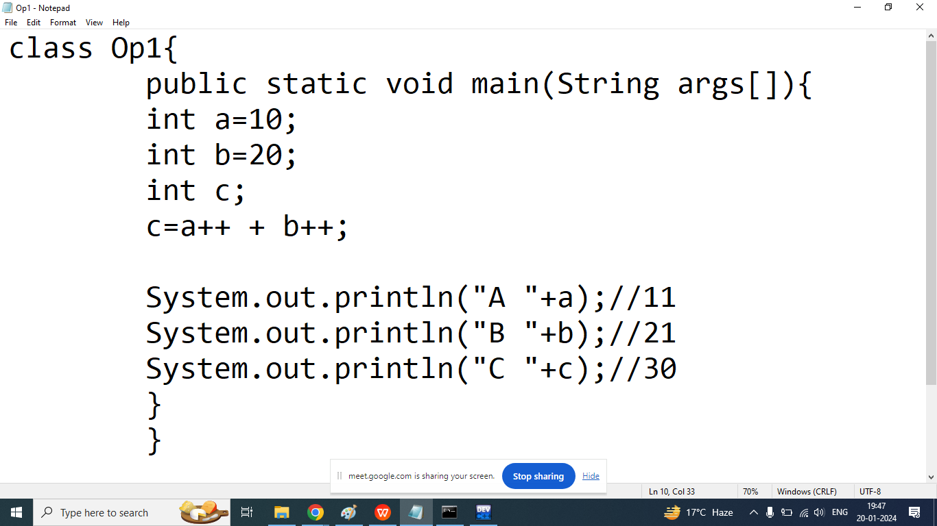

Pre- Increment:

In case of Pre increment first increase the value of variable by 1 and then used this incremented value inside the expression

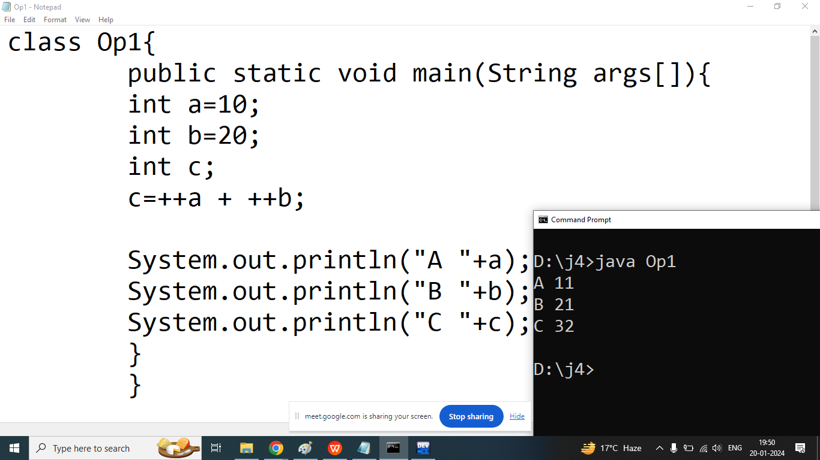

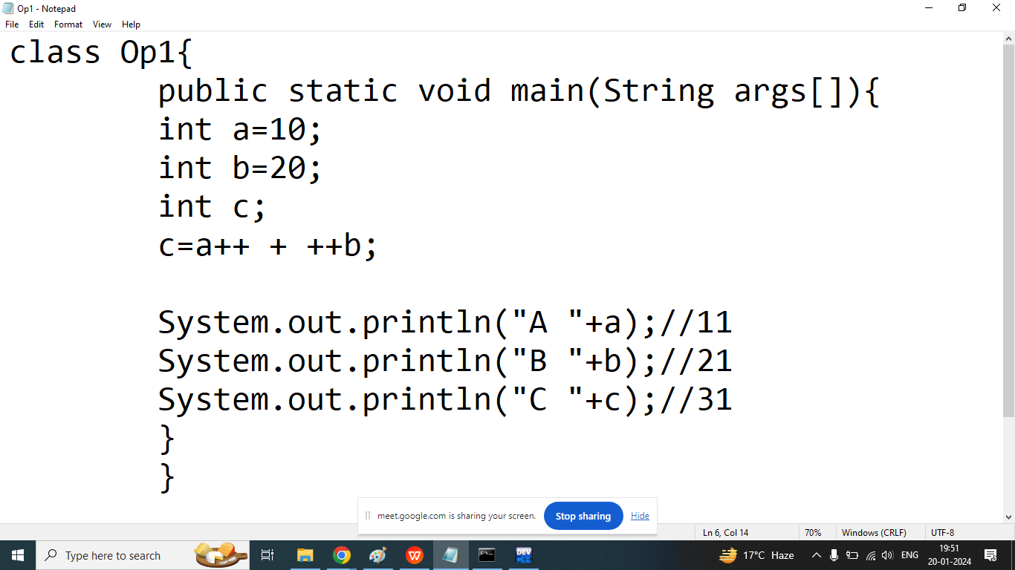

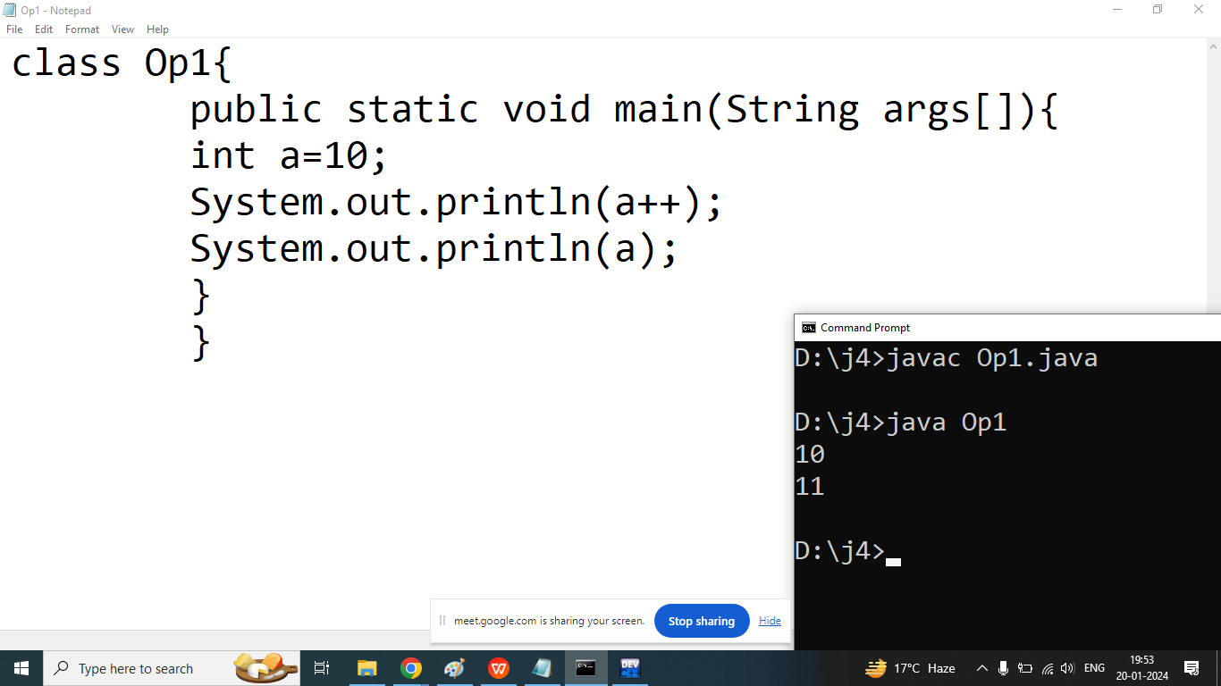

Q2. Explain Relational Operators in java programming?

Ans: if we want to compare something or define some conditions then we should go for relational operators.

We discuss following operators

1. >
2. <
3. >=
4. <=
5. ==
6. !=

Result of all Relational operators are true or false.

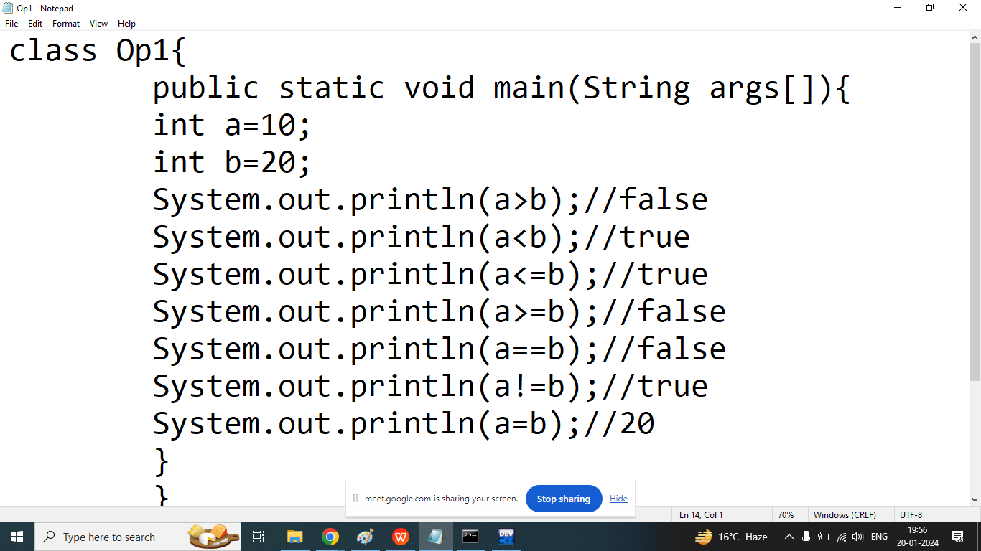

Q3. Explain logical operators in java programming?

Ans:

if we want to combine two or more conditions then we should go for logical operators.

We discuss following logical operators in java

1. Logical AND(&&): Return true if all conditions under considerations are true
2. Logical OR(||): Return true if one or more than one or all conditions under considerations are true
3. Logical NOT(!): return true if condition is false.

Note: Result of all logical operators are true or false.

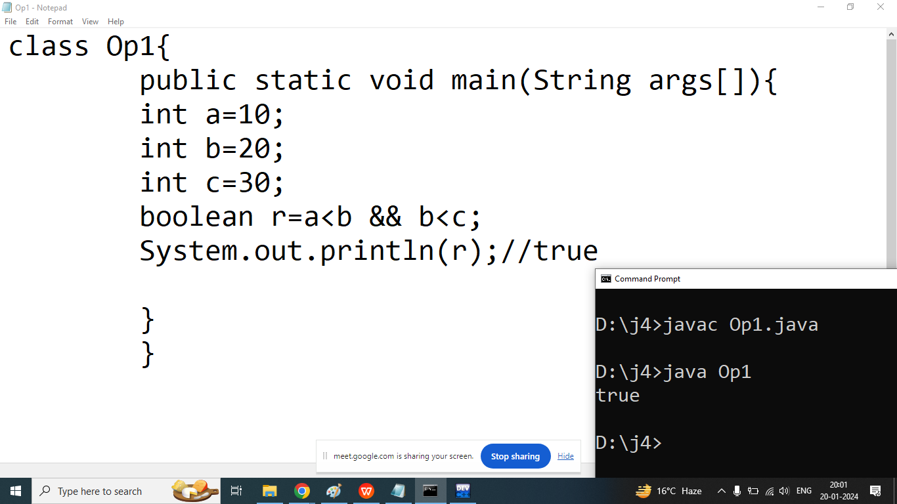

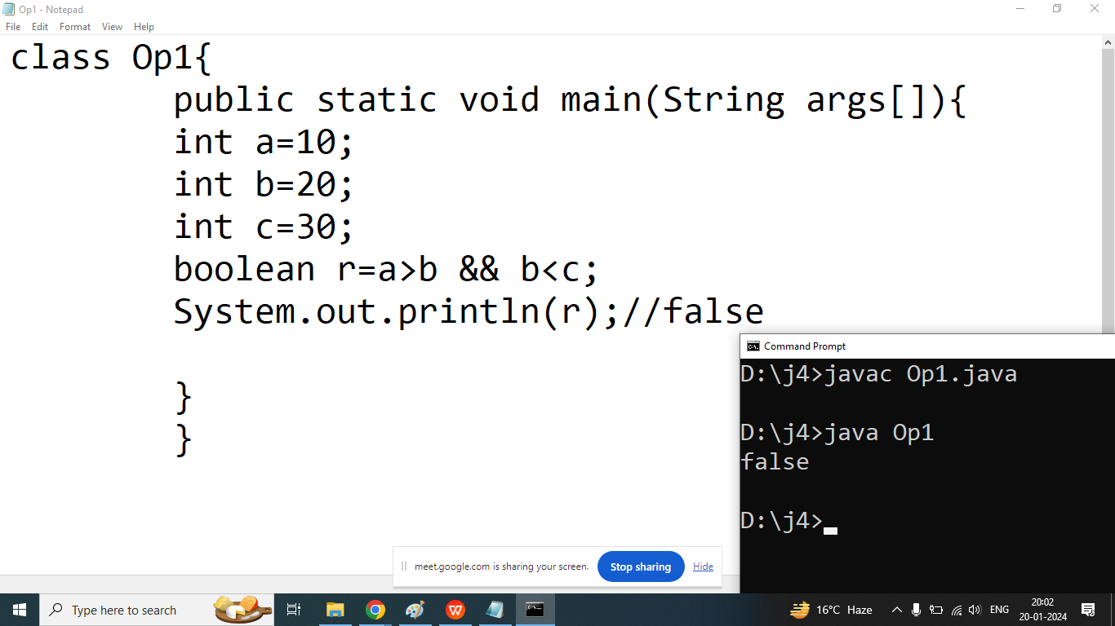

Example: Logical OR

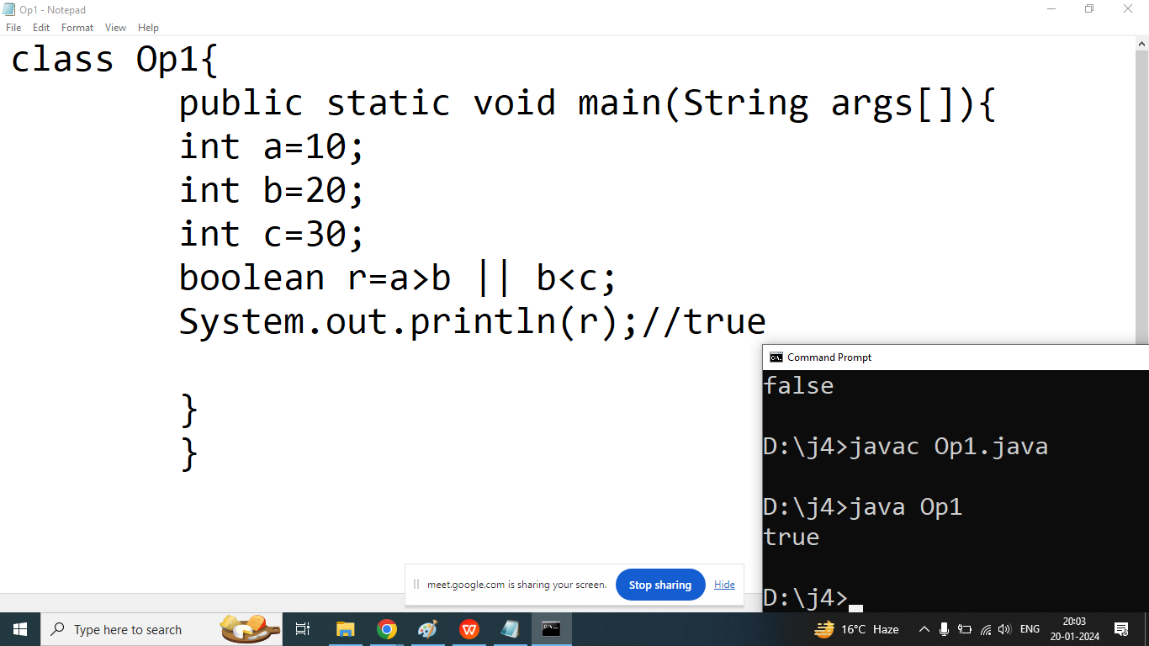

Example Logical NOT

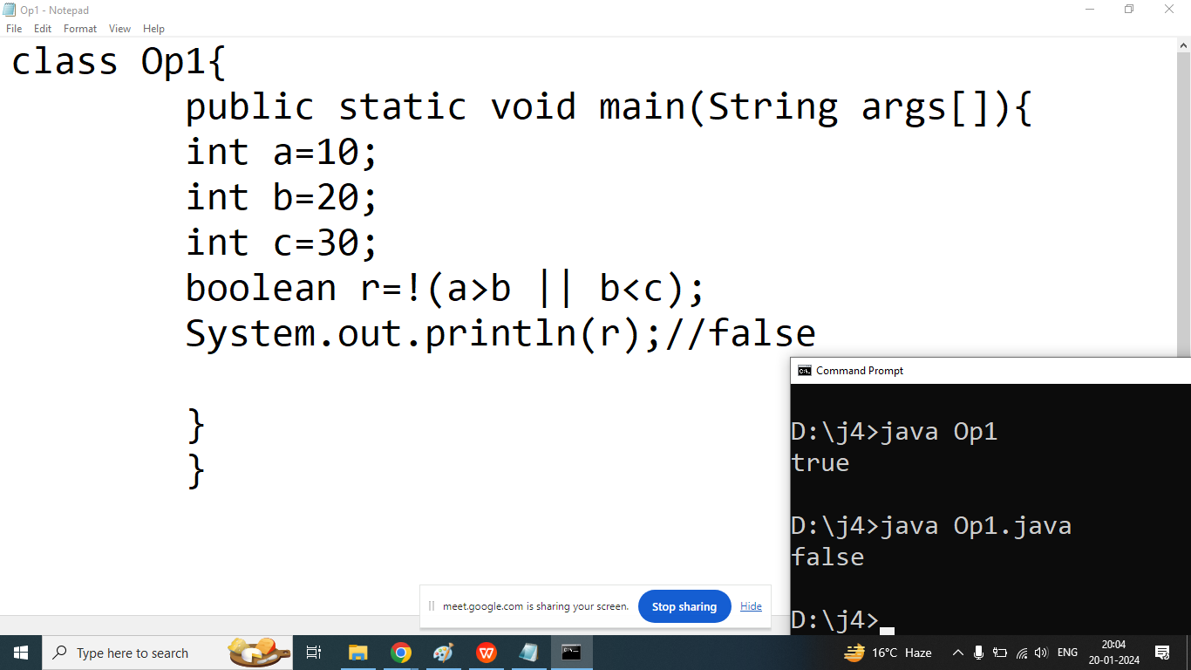

Q4. Explain bitwise operator in java programming?

Ans: if we want to perform bit by bit manipulation then we should go for bitwise operators.

We discuss 6 bitwise operator in java

1. Bitwise AND (&)
2. Bitwise OR (|)
3. Bitwise XOR(^)
4. Bitwise Left Shift Operator(<<)
5. Bitwise Right Shift Operator(>>)
6. Bitwise NOT operator(~)

| DECIMAL | BINARY |
| --- | --- |
| 0 | 0000 |
| 1 | 0001 |
| 2 | 0010 |
| 3 | 0011 |
| 4 | 0100 |
| 5 | 0101 |
| 6 | 0110 |
| 7 | 0111 |
| 8 | 1000 |
| 9 | 1001 |

==================================

Q1. Explain Bitwise AND(&) Operator in java?

Ans: it takes two bit a time and perform some operation

It will return 1 if both bits are 1 otherwise it will return 0.

int a=7;//0111

int b=5;//0101

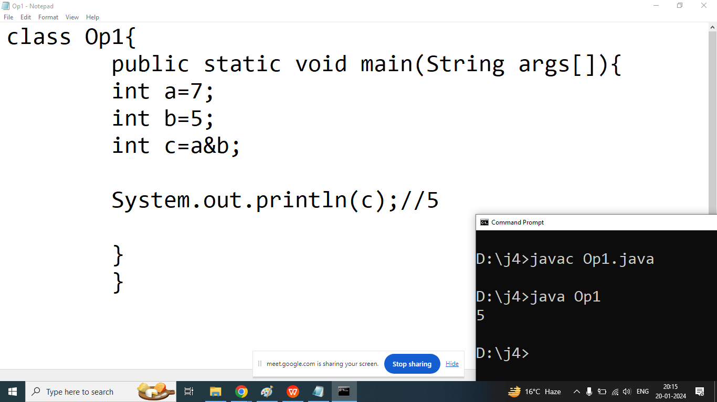

Q2. Explain bitwise OR (|) operator in java?

Ans:

Result of bitwise OR is 1 when 1 or both bits are 1 otherwise 0.

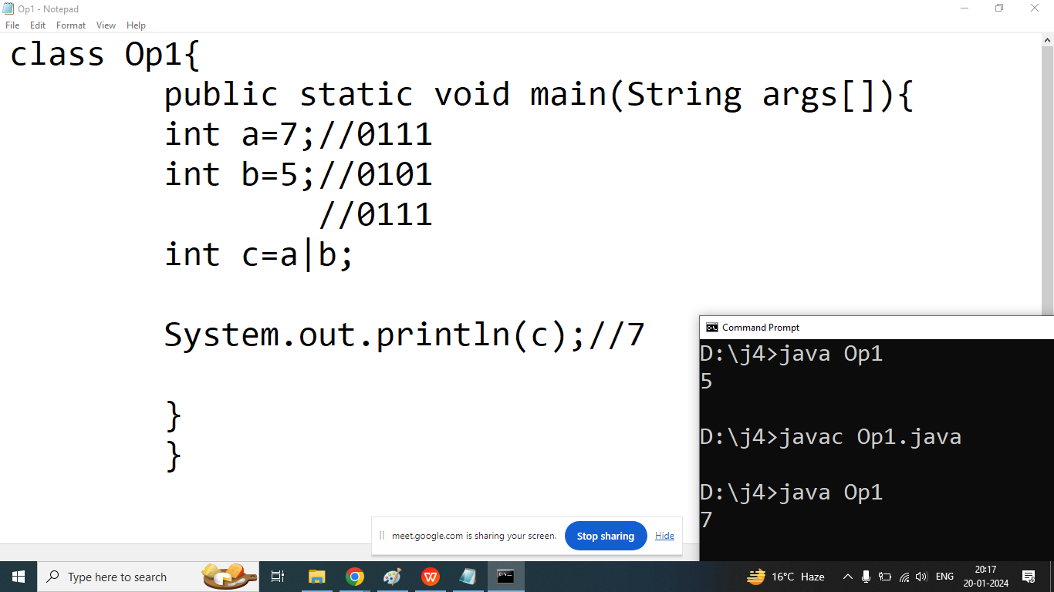

Q3. Explain Bitwise XOR(^) operator in java?

Ans:

Result of Bitwise XOR operator is 1 when both bits are different from each other.

Result of Bitwise XOR operator is 0 when both bits are same

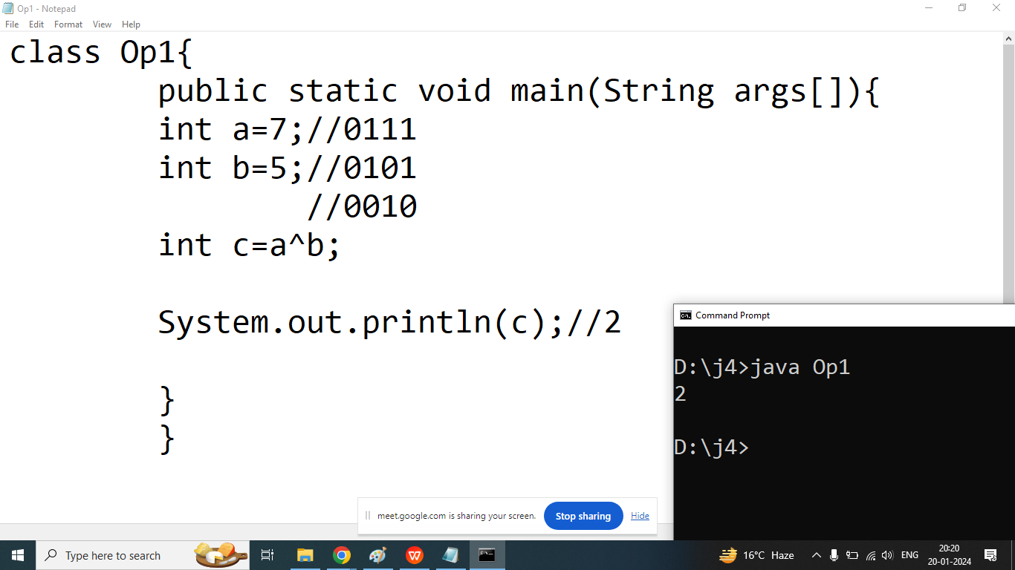

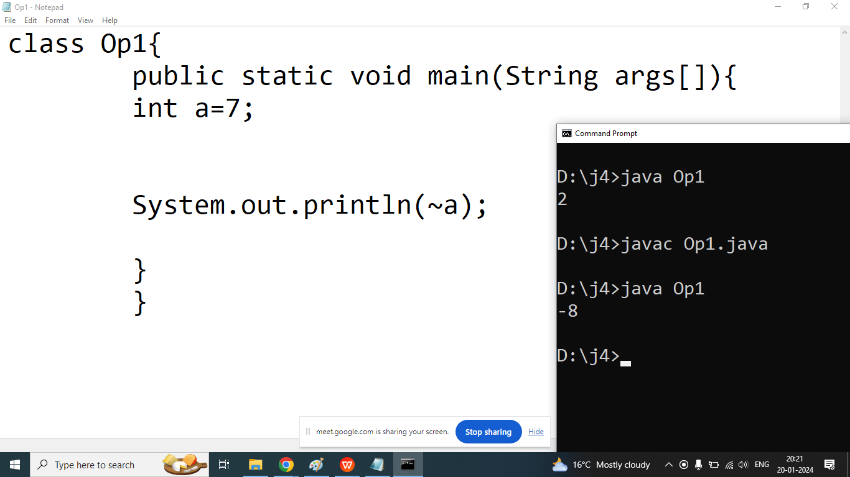

|  |  |  |  | 8 | 4 | 2 | 1 |
| --- | --- | --- | --- | --- | --- | --- | --- |
|  |  |  |  | 0 | 1 | 1 | 0 |
|  |  |  |  | 1 | 0 | 0 | 1 |
|  |  |  |  | -8 | 0 | 0 | 1 |

1 means negative number

0 means positive number

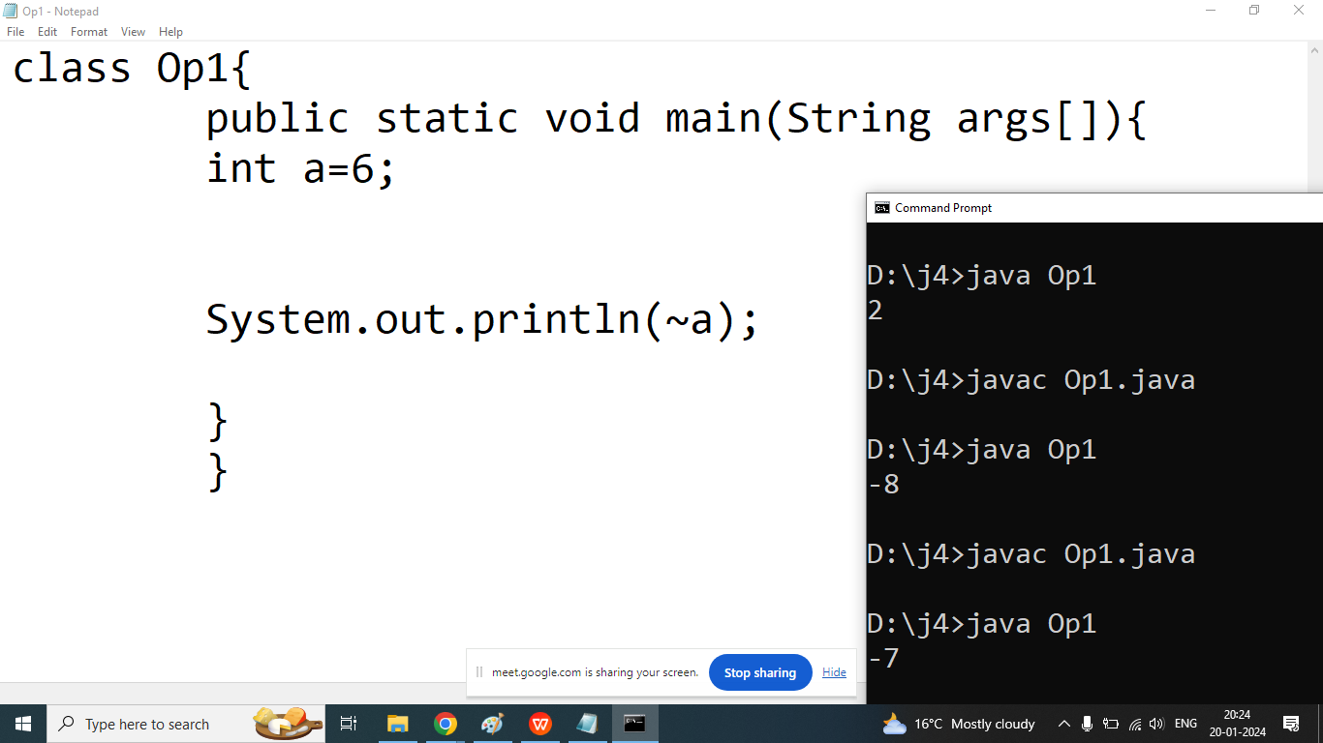



1. Write a Java program to convert a given integer (in seconds) to hours, minutes and seconds.

Test Data :

Input seconds: 25300 Expected Output:

There are:

H:M:S - 7:1:40

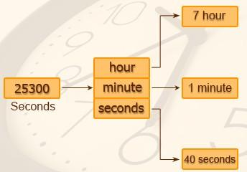

1. Write a java program to convert a given integer (in days) to years, months and days, assumes that all months have 30 days and all years have 365 days. Test Data : Input no. of days: 2535

Expected Output:

6 Year(s)

11 Month(s)

15 Day(s)

.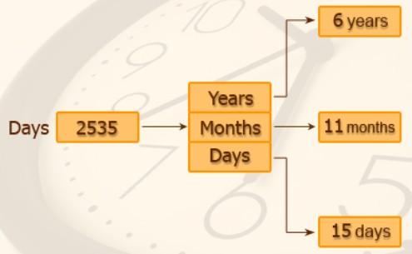



Q3. Write a java program that read 5 numbers and sum of all odd values between them

Test Data :

Input the first number: 11 Input the second number: 17 Input the third number: 13 Input the fourth number: 12 Input the fifth number: 5 Expected Output:

Sum of all odd values: 46

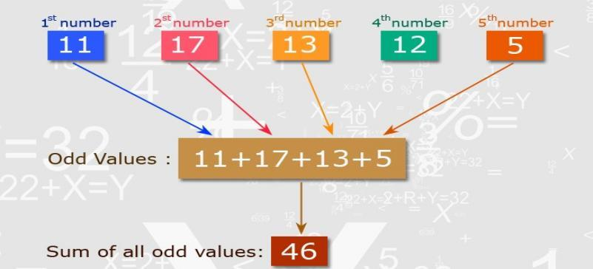

Q4. Write a Java program that reads two integers and checks whether they are multiplied or not.

Test Data :

Input the first number: 5 Input the second number: 15 Expected Output: Multiplied!

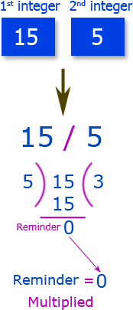

1. Write a Java program that reads an integer between 1 and 12 and print the month of the year in English.

Test Data :

Input a number between 1 to 12 to get the month name: 8 Expected Output:

August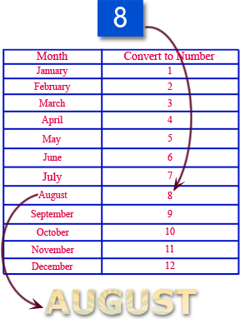

1. Write a java program that read 5 numbers and counts the number of positive numbers and negative numbers. Test Data :

Input the first number: 5



Input the second number: -4 Input the third number: 10 Input the fourth number: 15 Input the fifth number: -1 Expected Output:

Number of positive numbers: 3 Number of negative numbers: 2

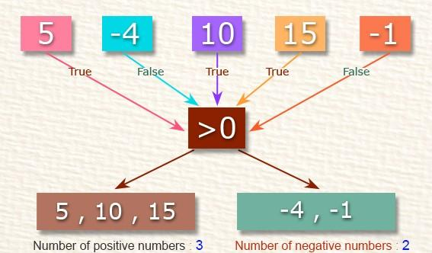

1. Write a java program that read 5 numbers and counts the number of positive numbers and print the average of all positive values.

Test Data :

Input the first number: 5 Input the second number: 8 Input the third number: 10 Input the fourth number: -5 Input the fifth number: 25 Expected Output:

Number of positive numbers: 4

Average value of the said positive numbers: 12.00

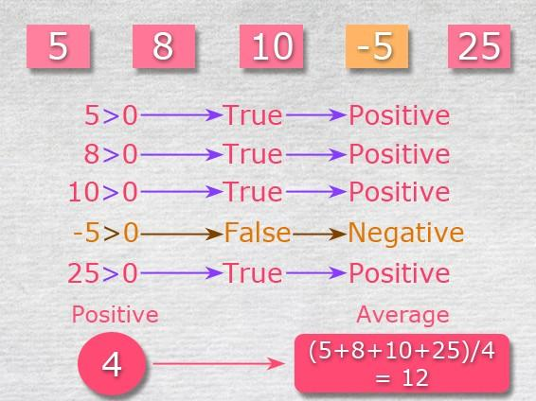

8. Write a java program that read 5 numbers and sum of all odd values between them.

Test Data :

Input the first number: 5 Input the second number: 7 Input the third number: 9 Input the fourth number: 10 Input the fifth number: 13

Expected Output:

Sum of all odd values: 34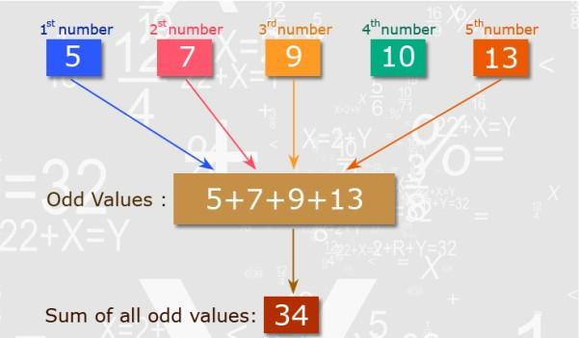

Q9. Write java program that converts

Centigrade to Fahrenheit.

*Expected*

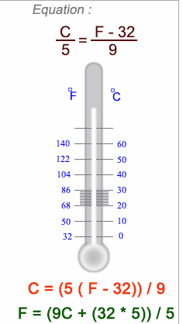

10. Write a java program that converts kilometers per hour to miles per hour

*Expected Output* :

Input kilometers per hour: 15 9.320568 miles per hour

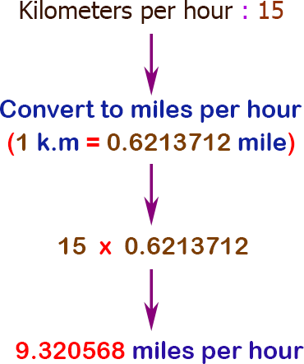

Q11. Write a java program to check two given integers, and print true if one of them is 30 or if their sum is 30 else print false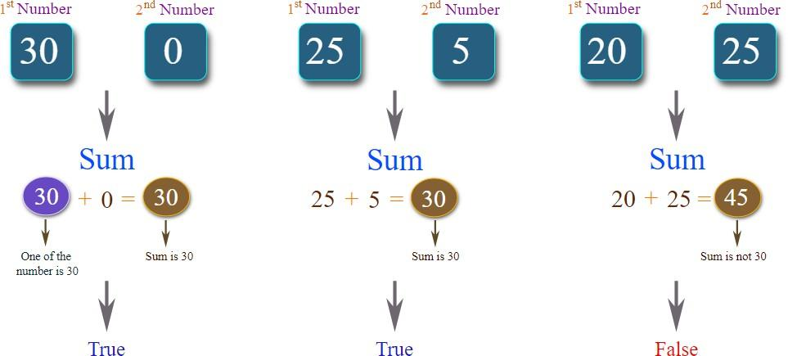

Q13. Write a java program to integral quotient and remainder of a division

Input numerator : 2500 Input denominator : 235

quotient = 10, remainder = 150

Q1. Explain Bitwise Left Shift Operator(<<) in java programming?

Ans: In java Bitwise left shift operator is used to shift binary sequence on the basis of specified places.

Syntax:

First Operand << Second Operand

First Operand: Number whose bits are shifted

Second Operand: Number of places to be shifted.

Example:

int x;

x=4;

int y=x<<1;

Sout(y);

|  | 0 | 1 | 0 | 0 |
| --- | --- | --- | --- | --- |
| 0 | 1 | 0 | 0 | -- |
| 0 | 1 | 0 | 0 | 0 |

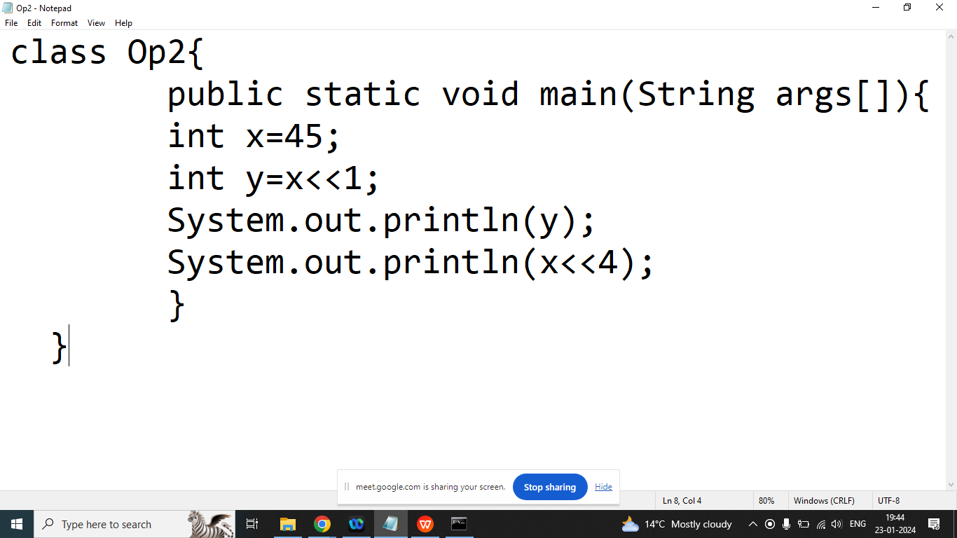

Q2. Explain Bitwise Right Shift Operator(>>) in java programming?

Ans: In java Bitwise right shift operator is used to shift binary sequence on the basis of specified places.

Syntax:

First Operand >> Second Operand

First Operand: Number whose bits are shifted

Second Operand: Number of places to be shifted.

Example:

int x;

x=8;

int y=x>>1;

Sout(y);

| 1 | 0 | 0 | 0 |
| --- | --- | --- | --- |
| - | 1 | 0 | 0 |
| 0 | 1 | 0 | 0 |

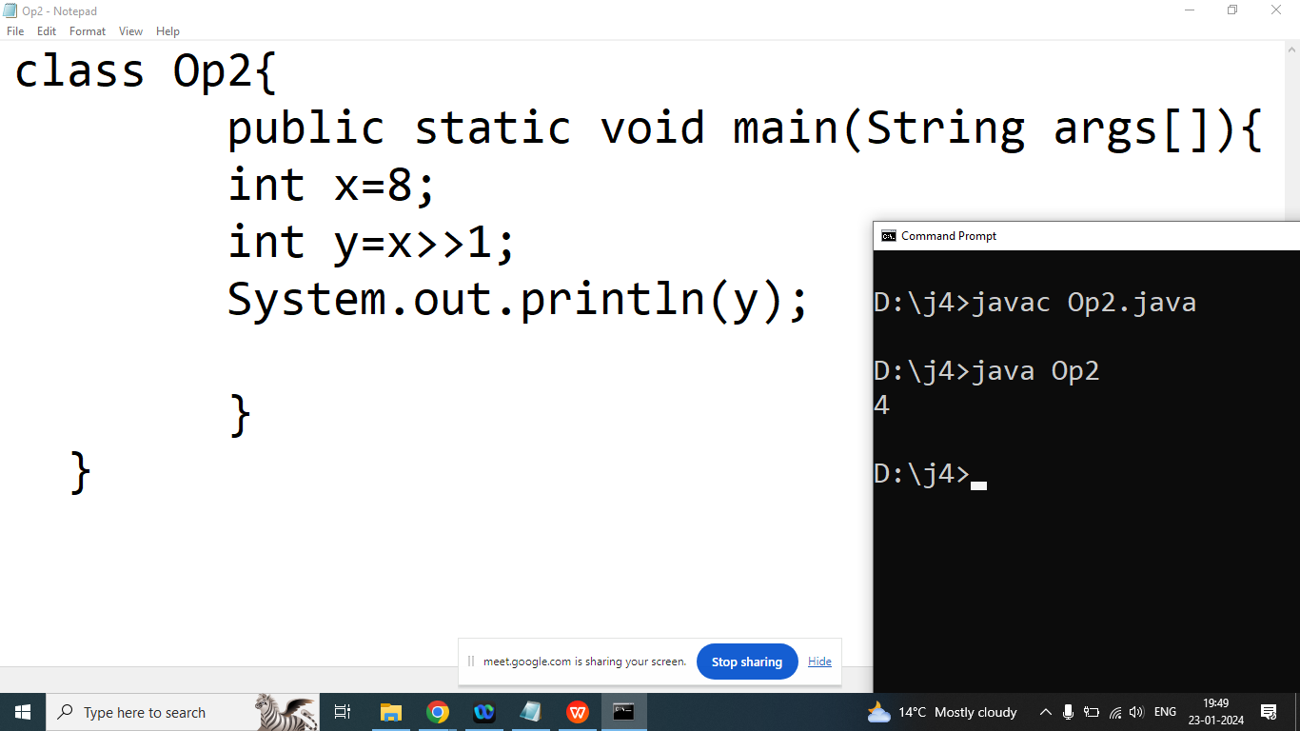

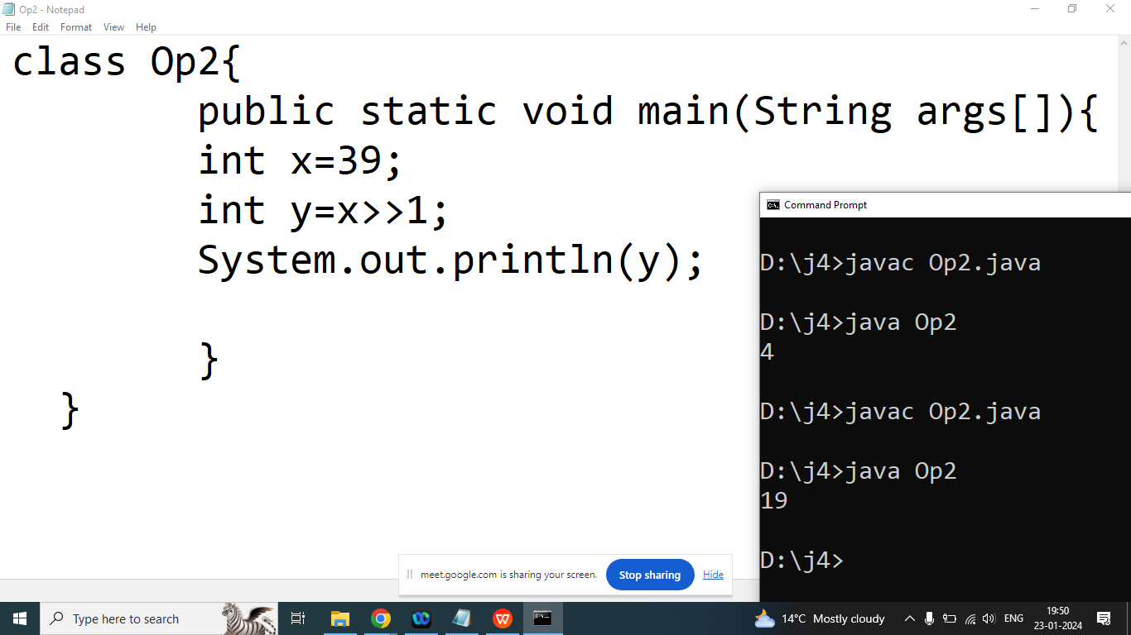

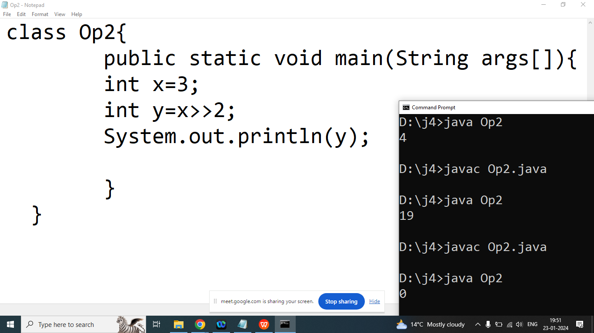

Q3.Explain Ternary Operator in Java Programming?

Ans:

Syntax:

Result=Expression 1 ? Expression 2 : Expression 3;

In above Syntax Expression 1 is boolean condition if Expression 1 evaluated true then Expression 2 will executed else Expression 3 executed.

Q3. Write a java program to check given number is Positive or negative

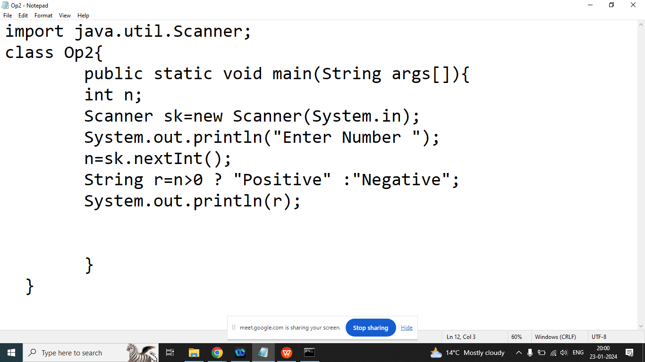

import java.util.Scanner;

class Op2{

public static void main(String args[]){

int n;

Scanner sk=new Scanner(System.in);

System.out.println("Enter Number ");

n=sk.nextInt();

String r=n>0 ? "Positive" :"Negative";

System.out.println(r);

}

}

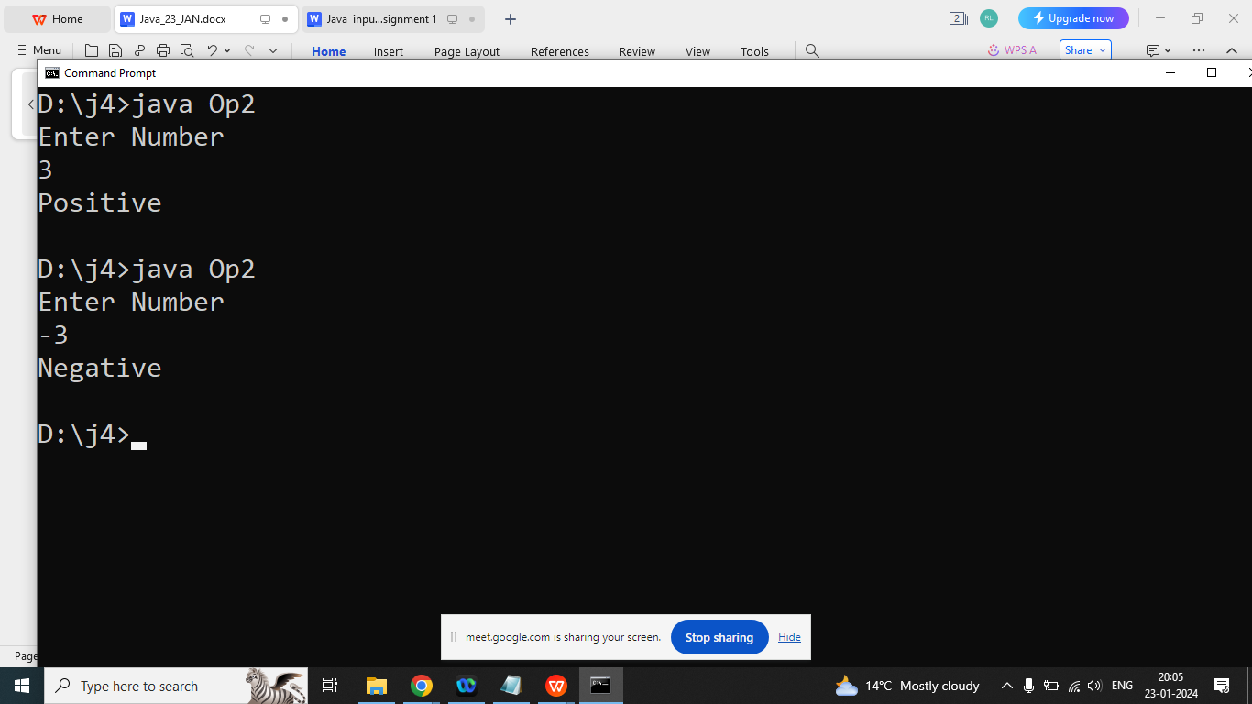

Q2. Explain Precedence of an Operator in java programming?

Ans:

Precedence of an operator come into picture when we need to decide which operator evaluated first when expression having multiple operators.

Operator having high precedence will evaluated first.

Example:

int x=23*2+3;

System.out.println(x);

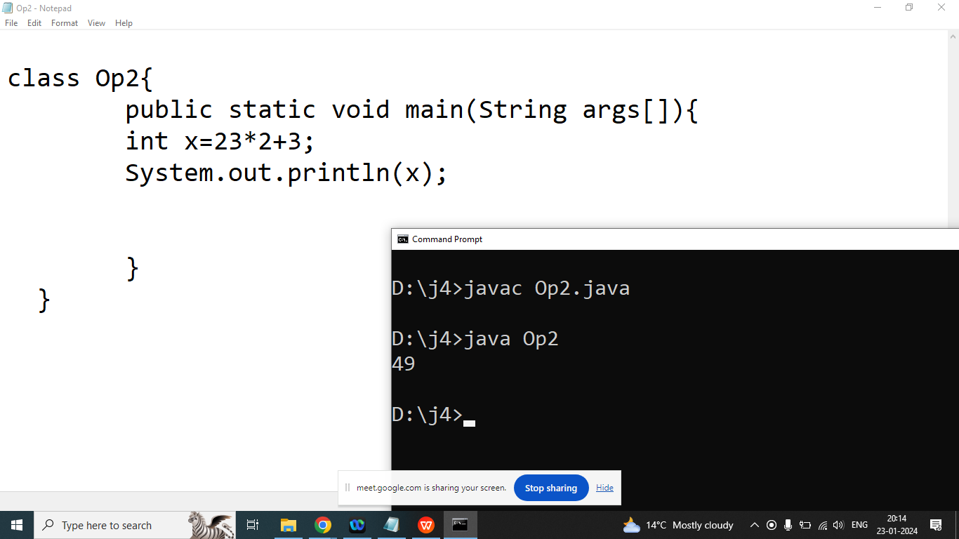

Q3. Explain Associativity of an operator in java?

Ans:

/ * % L To R

+ - L To

> <

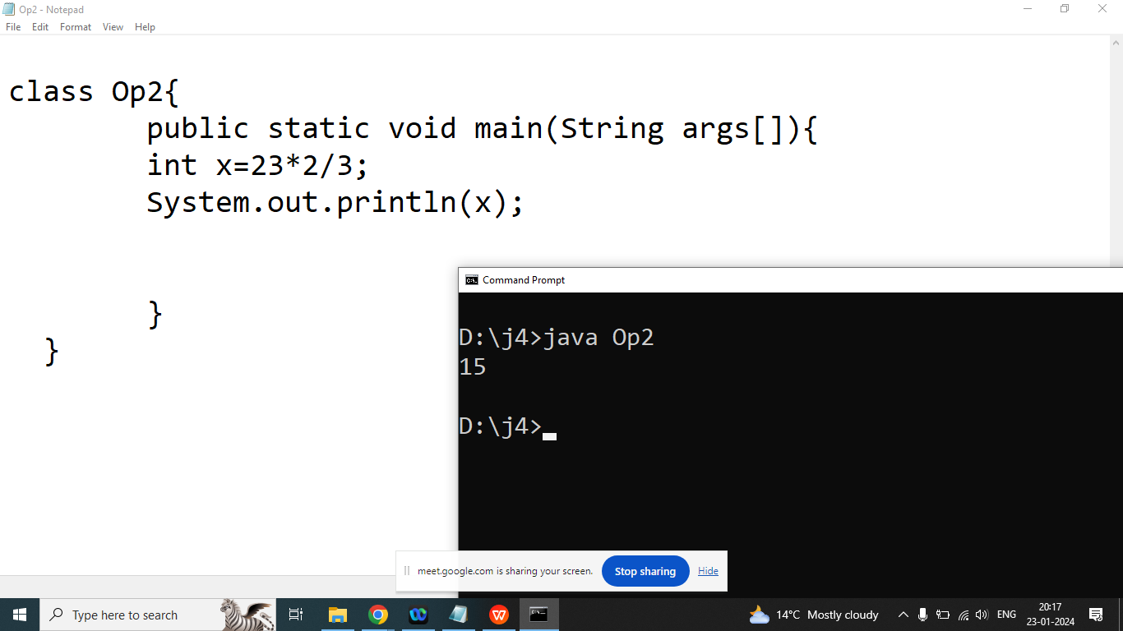

Right To Left

Ternary operator

Logical NOT Operator

Bitwise Not

Q1.Explain Control Flow Statement in java?

Control flow statements in Java are constructs used to control the flow of execution within a program. They determine the order in which statements are executed based on certain conditions or loops. These statements include:

1. Conditional Statements:
   * if: Executes a block of code if a specified condition is true.
   * else: Executes a block of code if the preceding if condition is false.
   * else if: Allows for the evaluation of multiple conditions if the preceding if condition is false.
   * switch: Evaluates an expression and executes code based on a matching case label.
2. Looping Statements:
   * for: Executes a block of code a fixed number of times.
   * while: Executes a block of code as long as a specified condition is true.
   * do-while: Executes a block of code once, and then repeats the execution as long as a specified condition is true.
   * break: Terminates the loop it is within.
   * continue: Skips the current iteration of a loop and proceeds to the next iteration.
3. Branching Statements:
   * return: Exits from the current method and optionally returns a value.
   * break: Exits from the innermost loop or switch statement.
   * continue: Skips the remaining code within a loop and proceeds to the next iteration.
   * throw: Throws an exception manually.
   * try-catch-finally: Used for exception handling. The try block contains code that may throw an exception, and the catch block catches and handles the exception. The finally block contains code that will be executed regardless of whether an exception is thrown.
4. Logical Program
5. Pattern program

Search Program

1. Number based program
2. String Based Program
3. Array Based Program

Q2. Explain if statement in java programming?

Ans:

Statement of if will executed when given condition evaluated true.

Syntax:

if(condition){

//statement1 of if

//statement2 of if

}

OR

if(condition)

//statement 1

//statement 2

Write a java program to compare two number.

Enter A : 10

Enter B: 20

import java.util.Scanner;

class C1{

public static void main(String args[]){

int a,b;

Scanner sk=new Scanner(System.in);

System.out.println("Enter Value of A : ");

a=sk.nextInt();//10

System.out.println("Enter Value of B : ");

b=sk.nextInt();//20

if(a>b)

System.out.println("A is Greater");

System.out.println("if-1");

if(b>a)

System.out.println("B is Greater");

System.out.println("if-2");

if(a==b)

System.out.println("A and B are Equal");

System.out.println("if-3");

}

}

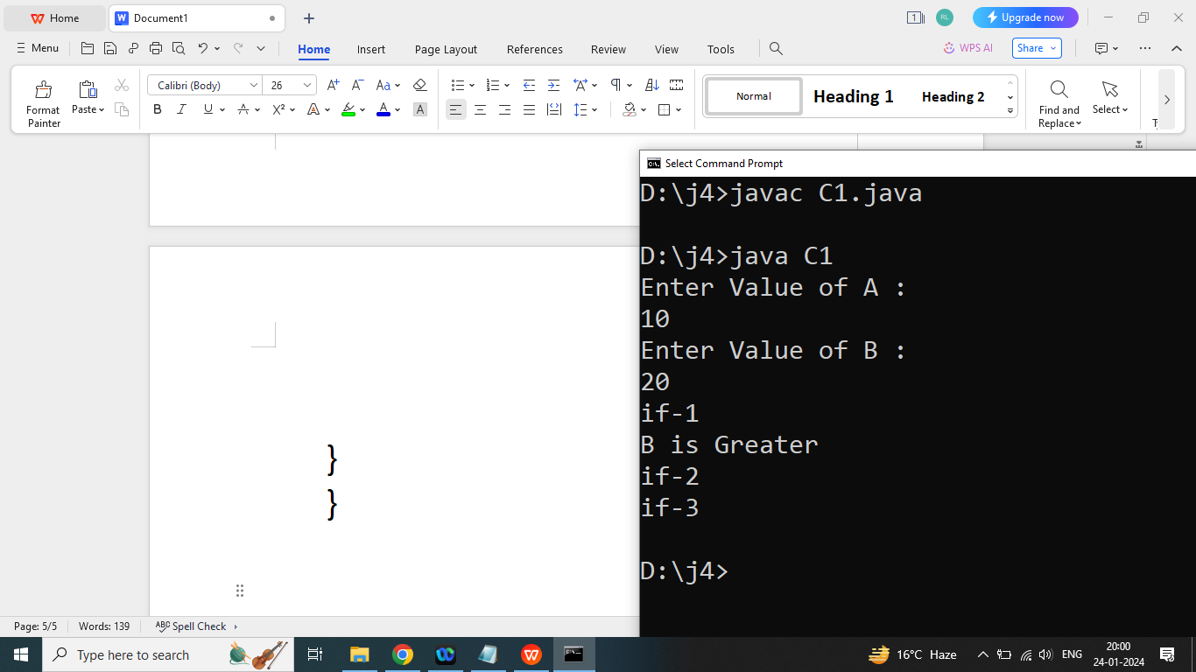

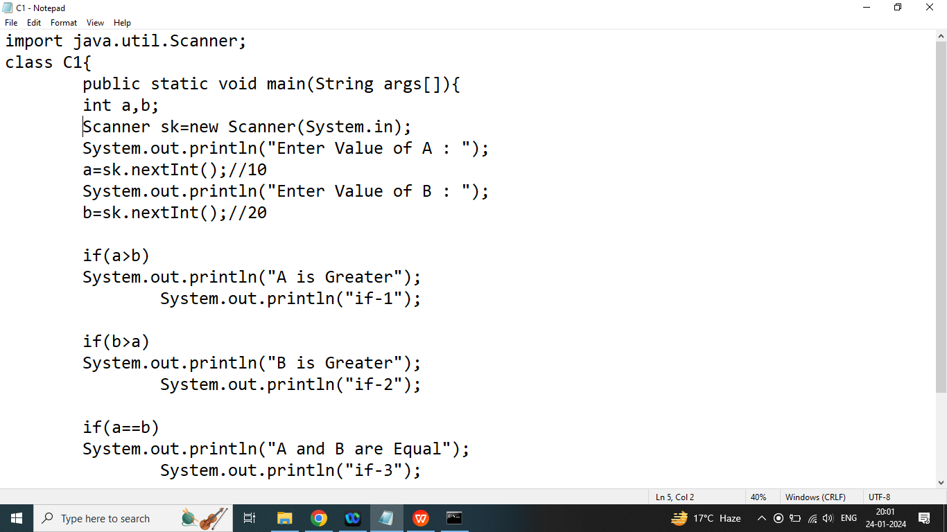

import java.util.Scanner;

class C1{

public static void main(String args[]){

int a,b;

Scanner sk=new Scanner(System.in);

System.out.println("Enter Value of A : ");

a=sk.nextInt();//10

System.out.println("Enter Value of B : ");

b=sk.nextInt();//20

if(a>b){

System.out.println("A is Greater");

System.out.println("if-1");

}

if(b>a){

System.out.println("B is Greater");

System.out.println("if-2");

}

if(a==b){

System.out.println("A and B are Equal");

System.out.println("if-3");

}

}

}

Q2. Explain if else statement in java programming?

Ans:

If we have exactly two possibilities and we want to select only one then we should go for the if else statement.

Syntax:

if(condition){

//statement of if

}

else{

//statement of else

}

Q2. Write a java program to check if a given number is even or odd.

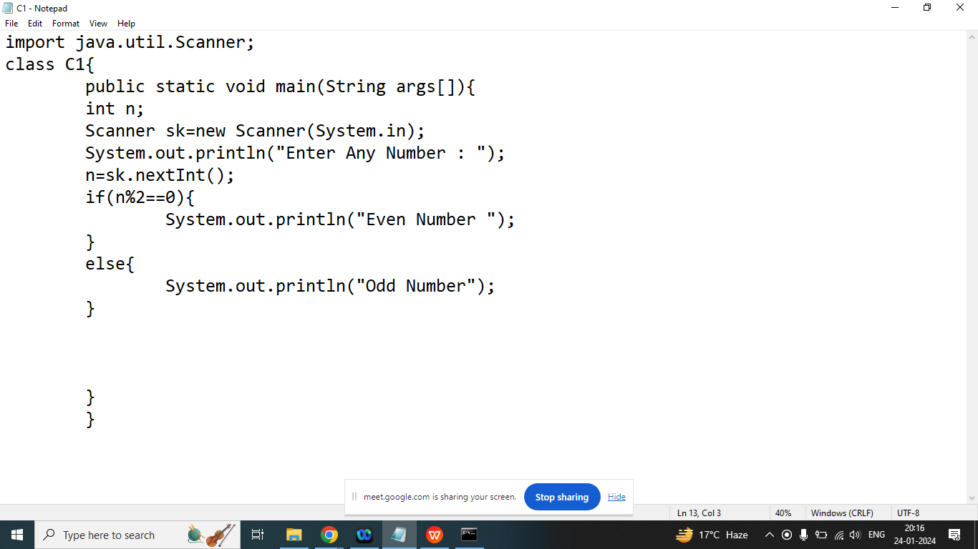

Q3. Write a java program to check if a given character is a vowel or not.

Enter Any Character : b

It is not a vowel

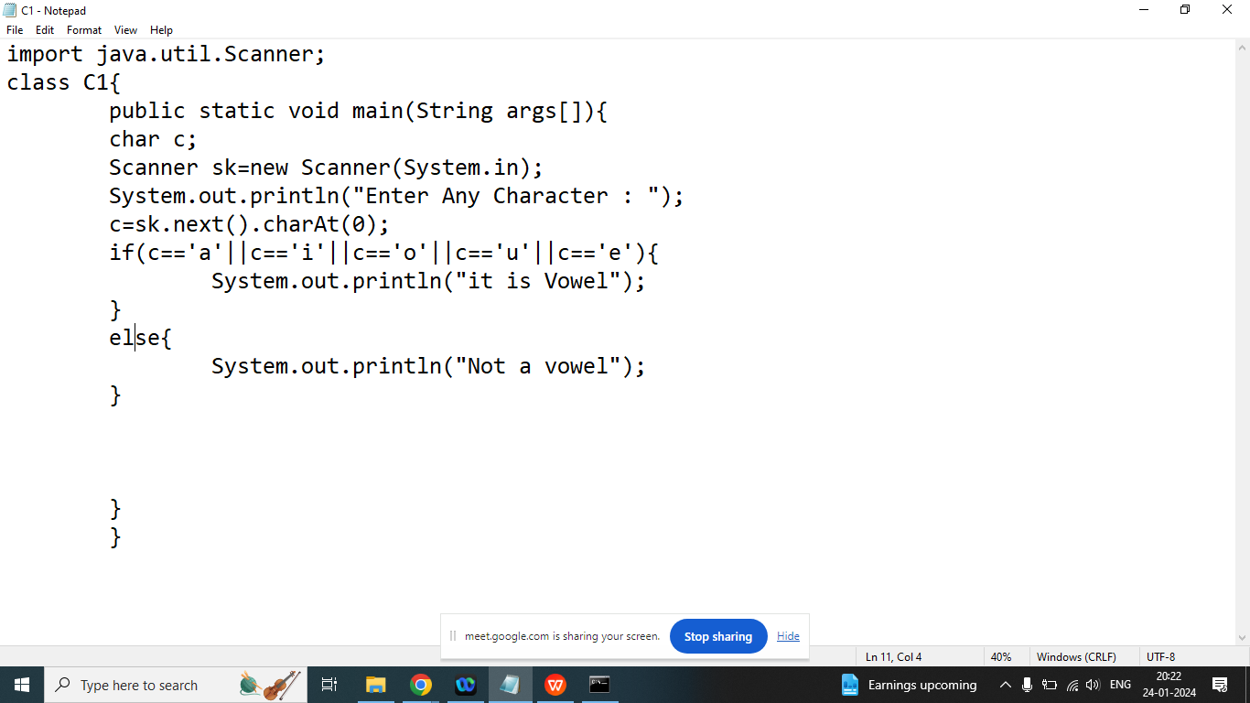

Q1. Explain else if statement in java programming?

Ans:

If we have more than two possibilities and we want to select only one at a time then we should go for else if statement.

else if always use after if.

Syntax:

if(condition1){

//statement 1

}

else if(condition2){

//statement 2

}

else if(condition3){

//statement 3

}

else if(condition4){

//statement 4

}

else{

//statement 5

}

Example:

Write a java program to check if a given character is Uppercase, lower case , digits and special character.

Enter Any Character : &

Special character

import java.util.Scanner;

class Op3{

public static void main(String args[]){

char c;

Scanner kb=new Scanner(System.in);

System.out.println("Enter Any Character : ");

c=kb.next().charAt(0);

if(c>='a && c<='z'){

System.out.println("lower case");

}

else if(c>='A && C<='Z'){

System.out.println("upper case");

}

else if(c>='0'&&c<='9'){

System.out.println("digit");

}

else{

System.out.println("Special Character : ");

}

}

}

Q2. Explain nested if in java programming?

Ans:

If we use if inside another if is known as nested if.

if(condition1){//outer if

if(condition1_1){//inner if

//statement 1

}

}

else if(condition2){

if(condition2_2){

//statement 2

}

}

Q3. Write a java program to check given character is upper case or lower case without using logical operator.

import java.util.Scanner;

class Op3{

public static void main(String args[]){

char c;

Scanner kb=new Scanner(System.in);

System.out.println("Enter Any Character : ");

c=kb.next().charAt(0);//a

if(c>='a'){

if(c<='z'){

System.out.println("lower case");

}

}

else if(c>='A'){

if(c<='Z'){

System.out.println("Upper Case");

}

}

}

}

Q1. Explain switch statement in java programming?

Ans:

If we want to select one option out of multiple conditions then we should go for switch.

We cannot define duplicate case in switch statement

We cannot use variable to define condition

We cannot used float or double type variable or constant in a switch.

Default is optional

Syntax:

switch(variable/constant/expression/method call){

case constant/expression:

//statement

break;

case constant/expression:

//statement

break;

case constant/expression:

//statement

break;

case constant/expression:

//statement

break;

default:

}

Q2. Write a java program to check given character is vowel or not without using relational operator and logical operators.

OR

Write a java program to check given character is vowel or not using switch.

import java.util.Scanner;

class T1{

public static void main(String args[]){

char c;

Scanner scan=new Scanner(System.in);

System.out.println("Enter Any Character : ");

c=scan.next().charAt(0);

switch(c){

case 'a':

case 'A':

System.out.println("It is vowel");

break;

case 'e':

case 'E':

System.out.println("It is vowel");

break;

case 'i':

case 'I':

System.out.println("It is vowel");

break;

case 'o':

case 'O':

System.out.println("It is vowel");

break;

case 'u':

case 'U':

System.out.println("It is vowel");

break;

default:

System.out.println("This is not a vowel");

}

}

}

Q2. Write a java program to check given number is even or odd without using if else and ternary operator.

OR

Write a java program to check given number is even or odd using switch

import java.util.Scanner;

class T1{

public static void main(String args[]){

int n;

Scanner scan=new Scanner(System.in);

System.out.println("Enter Any Number : ");

n=scan.nextInt();

switch(n%2){

case 0:

System.out.println("Even Number");

break;

case 1:

System.out.println("odd Number");

break;

}

}

}

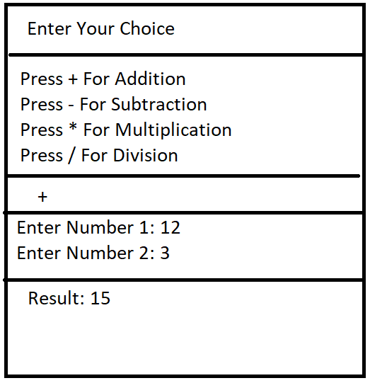

Q3. Explain looping statement in Java programming?

Ans:

We want to repeat some code of block again and again then we should go for looping statement in java

There are 4 loops in java

1. While(Entry Controlled): we don’t know exact number of iteration
2. Do while: (Exit Controlled Loop): execute at least once when condition is false
3. For:(Entry Controlled ): if we know exact number of iteration
4. For each: if we want to retrieve data from any collection object one by one then we should go for for each.

Loop Related:

1. Initialization(starting of the loop): only once
2. Test Condition(Ending of the loop): check every iteration
3. Increment /Decrement:

For Example:

I want to print number from 1 to 5

int a;

//Initialization

a=1;

Test condition: a<=5;

<,<= Increment

++

a=a+2;

a+=2;

For Example:

I want to print number from 1 to 5

int a;

//Initialization

a=5;

Test condition: a>=1;

>,>= Increment

--a;

a=a-2;

1. =2;

======================================

Q3. Explain Syntax of while, do while and for?

Ans:

While:

**Initialization**

while(**Test Condition**){

//statement

**Increment / decrement**

}

Do while:

**Initialization**

do{

//statement

**Increment / decrement**

}while(**Test Condition**);

1. For loop

Syntax:

for(**Initialization;** **Test condition** ; **Increment / decrement**){

//Statement

}

Q1.Write a java program to print table of given number.

Enter Any Number : 2

2 * 1 =2

2 * 2 =4

2 * 3 =6

2 * 4 =8

2 * 5 =10

2 * 6 =12

2 * 7 =14

2 * 8 =16

2 * 9 =18

2 * 10 =20

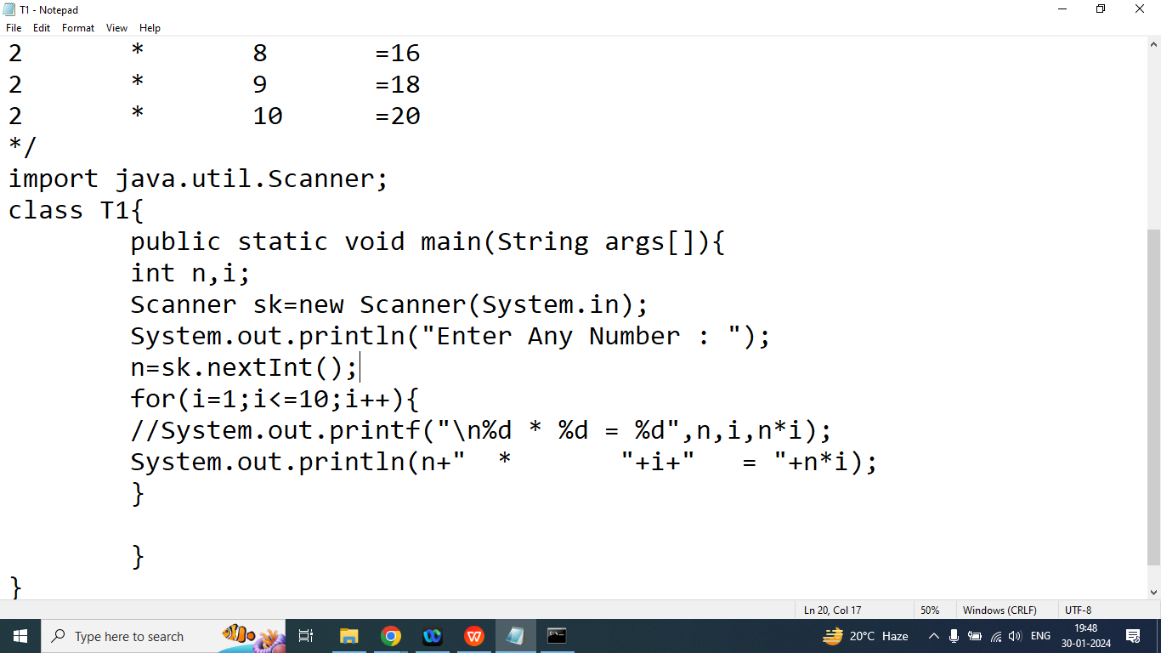

Q2. Write a java program to print sum of n Number

Enter Any Number : 10

Sum of N Number =55

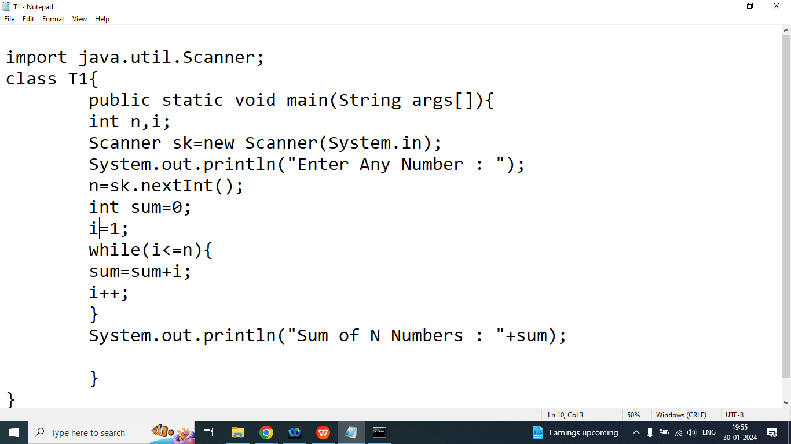

Q3. Write a java program to print number from 1 to 50 which is divisible by 3 and 5.

15

30

45

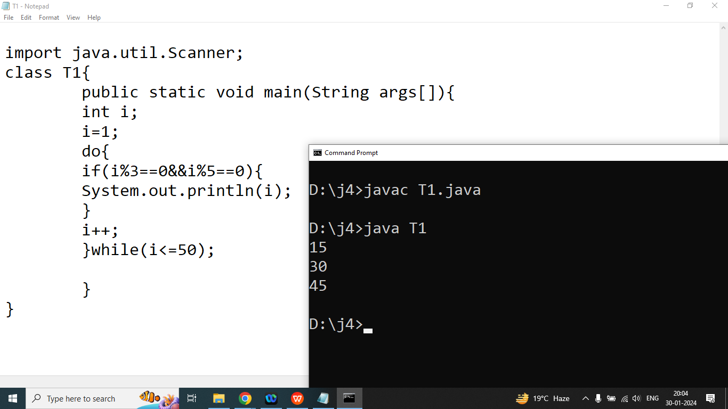

Q4. Write a java program to calculate Factorial of given number.

Enter Any Number : 5

Factorial of 5: 120

1*2*3*4*5=120

5*4*3*2*1=120

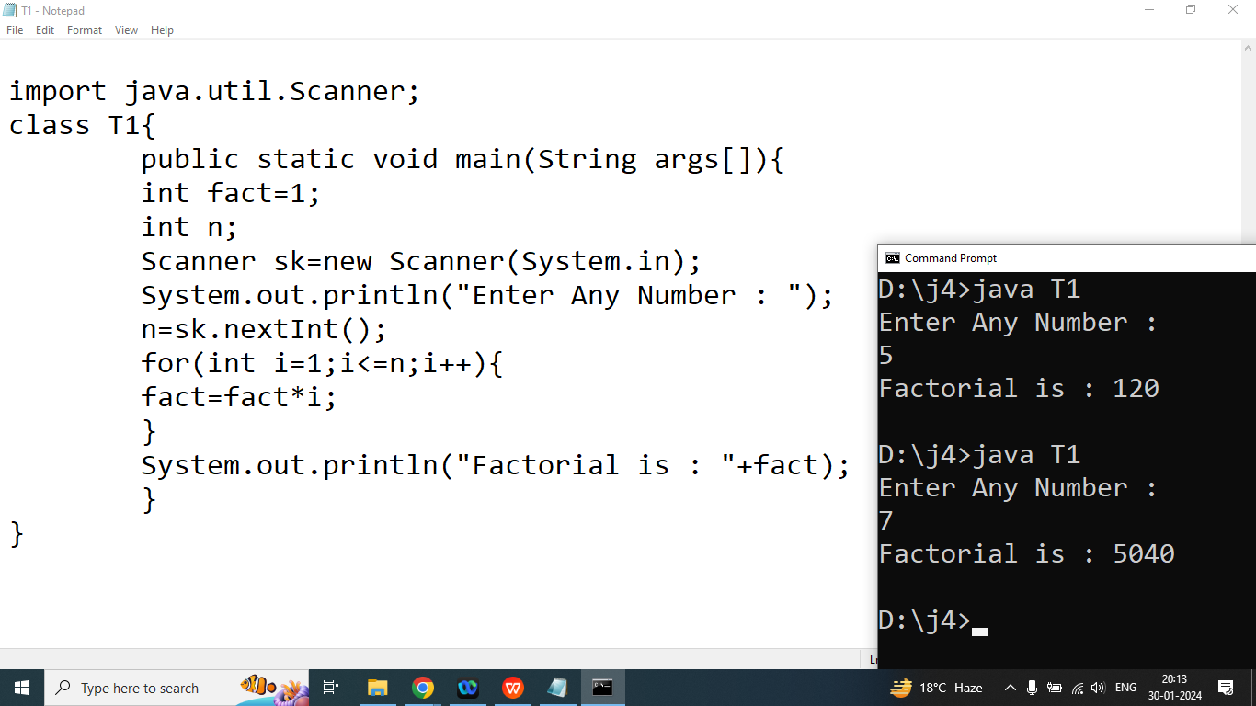

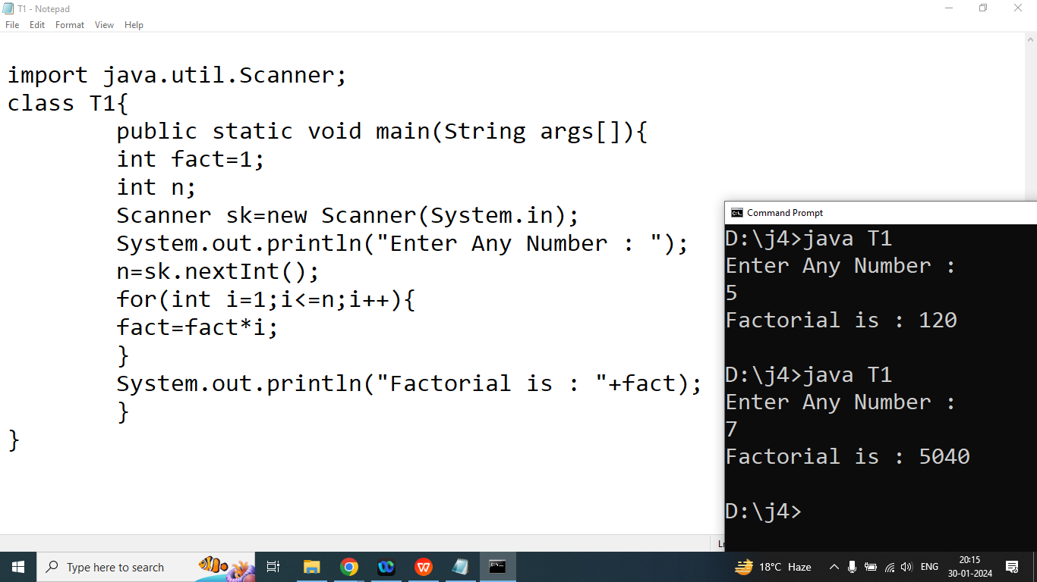

Q6. Write a java program to check given number is Perfect or not.

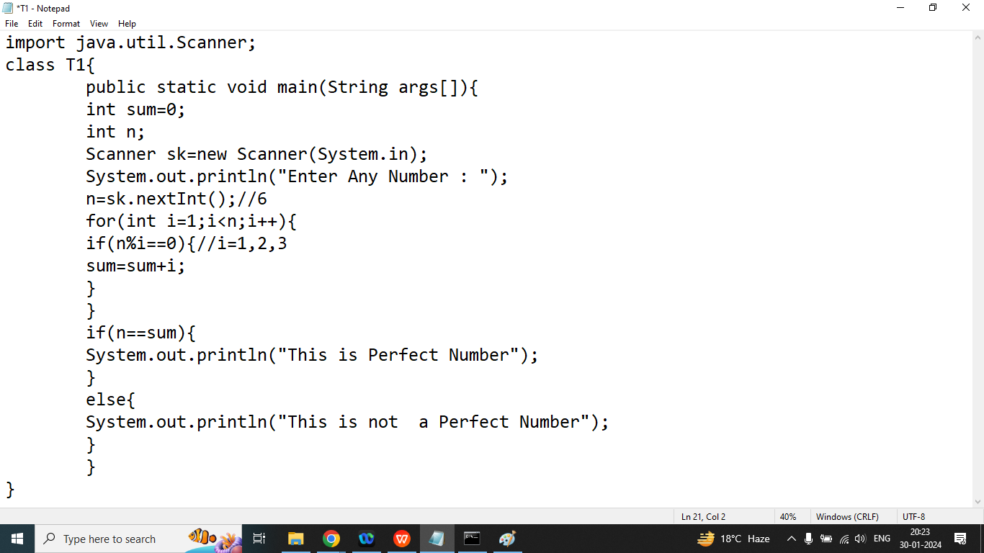

Q1. Write a java program to print sum of digits of the given Number.

Enter Any Number : 123

Sum of digits: 6

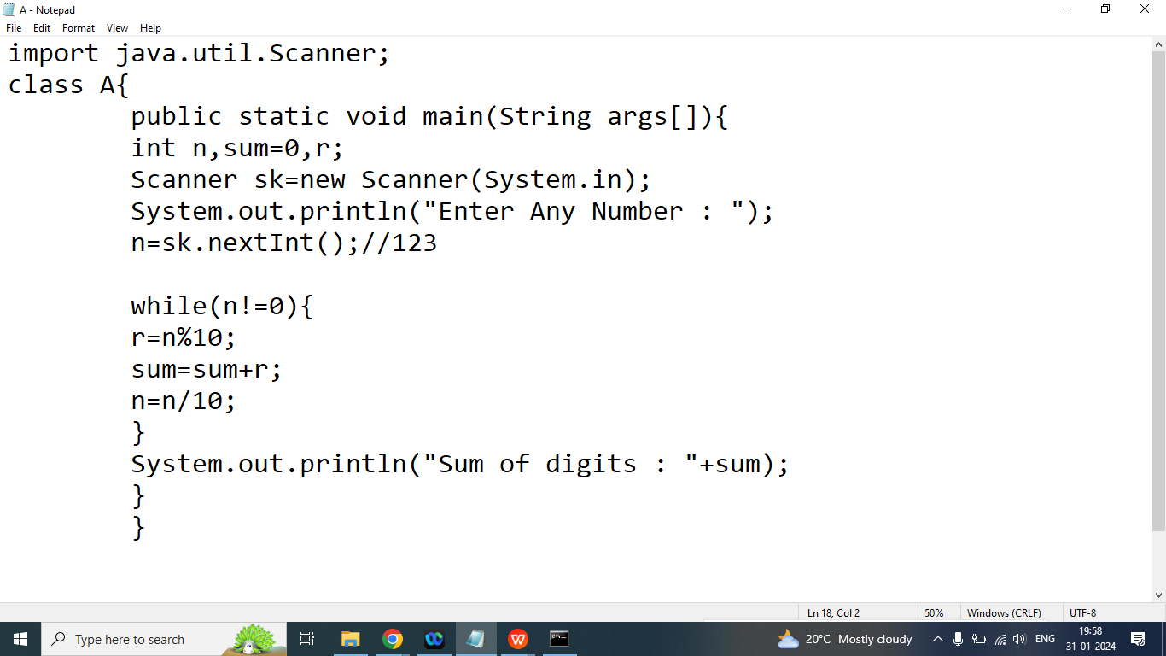

Q1. Write a java program to print sum of all odd digits of the given Number.

Enter Any Number : 12345

Sum of all odd digits: 9

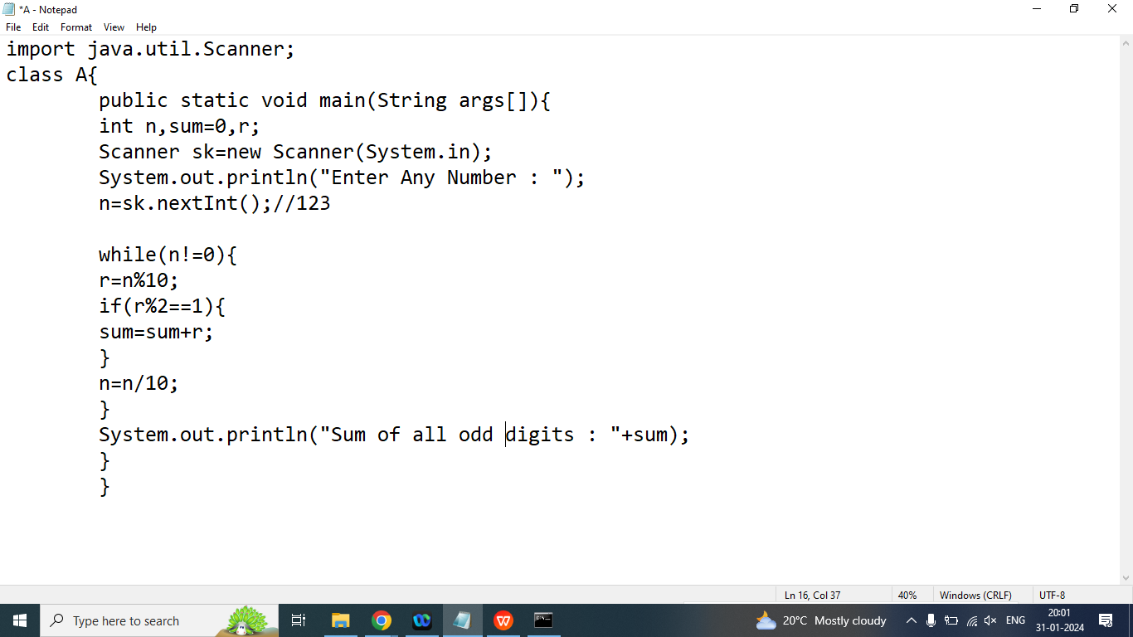

Q1. Write a java program to print maximum digit of the given Number.

Enter Any Number : 3487

Maximum: 8

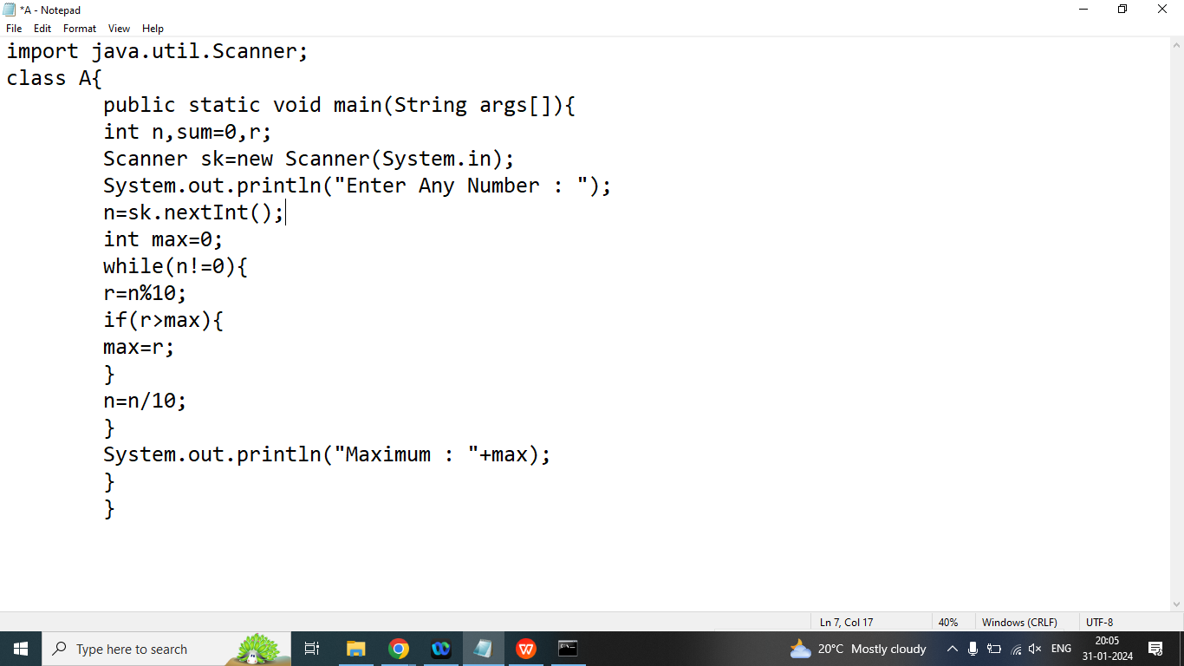

Q1. Write a java program to check given number is Prime or not?

Ans:

Enter any Number : 5

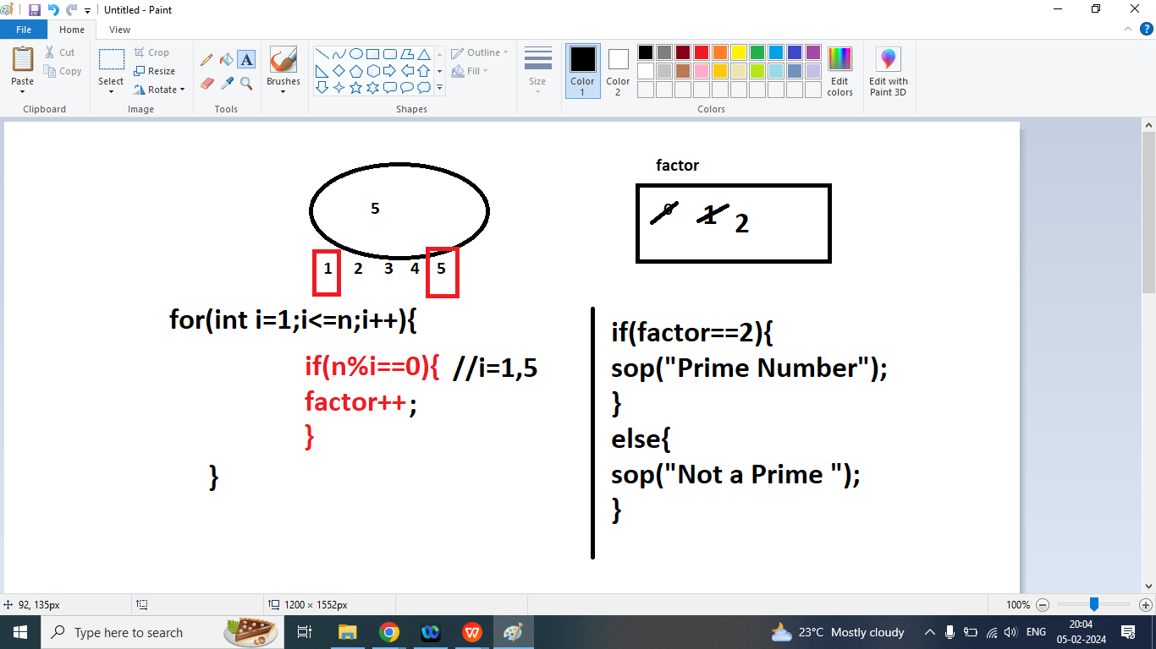

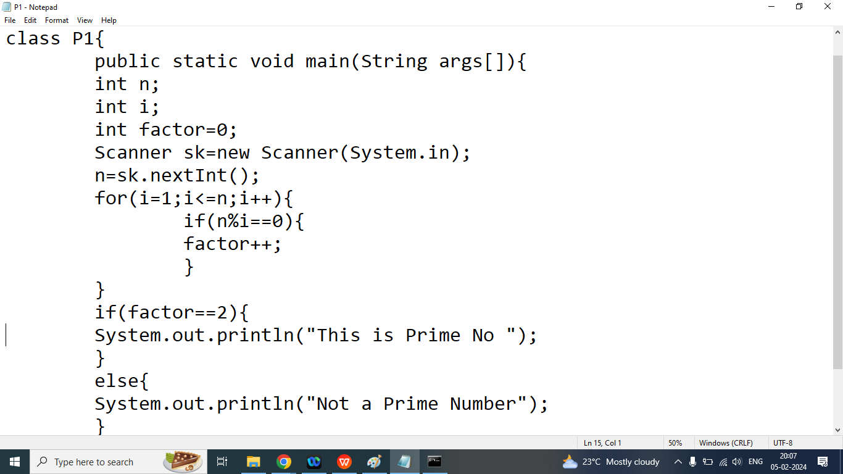import java.util.Scanner;

class P1{

public static void main(String args[]){

int n;

int i;

int factor=0;

Scanner sk=new Scanner(System.in);

n=sk.nextInt();

for(i=1;i<=n;i++){

if(n%i==0){

factor++;

}

}

if(factor==2){

System.out.println("This is Prime No ");

}

else{

System.out.println("Not a Prime Number");

}

}

}

Q2. Write a java program to reverse a given number without using pre- defined function?

Enter Any Number : 123

Reverse Number : 321

import java.util.Scanner;

class P1{

public static void main(String args[]){

int n;

int res=0;

Scanner sk=new Scanner(System.in);

n=sk.nextInt();//123

while(n!=0){//n=0

int r=n%10;//r=2

res=res*10+r;//res=321

n=n/10;//n=0

}

System.out.println("Reverse Number : "+res);

}

}

Q3. Write a java program to check given number is Palindrome or not?

Ans:

Enter Any Number : 1331

This is Palindrome Number

import java.util.Scanner;

class P1{

public static void main(String args[]){

int n,m;

int res=0;

Scanner sk=new Scanner(System.in);

n=sk.nextInt();

m=n;

while(n!=0){

int r=n%10;

res=res*10+r;

n=n/10;

}

if(m==res){

System.out.println("This is Palindrome Number");

}

else{

System.out.println("This is Not a Palindrome Number");

}

}

}

Q1. Explain break statement in java programming?

Ans: if we want to exit from the switch or loop then we should go for break.

Syntax:

Loop/switch(

break;

}

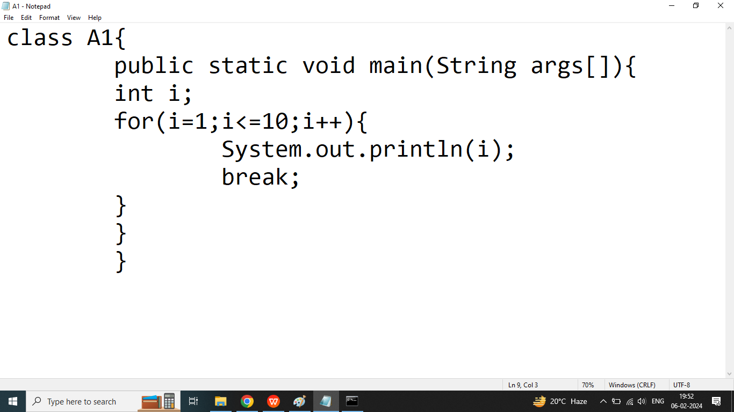

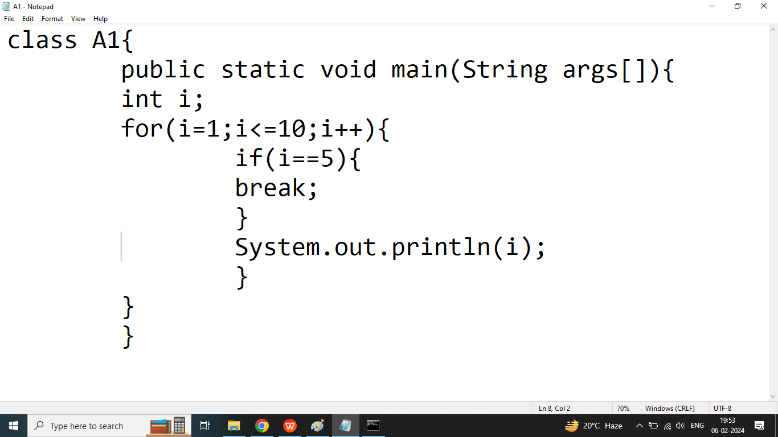

Q2. Explain continue statement in java programming?

Ans: if we want to exit form current iteration then we should go for continue.

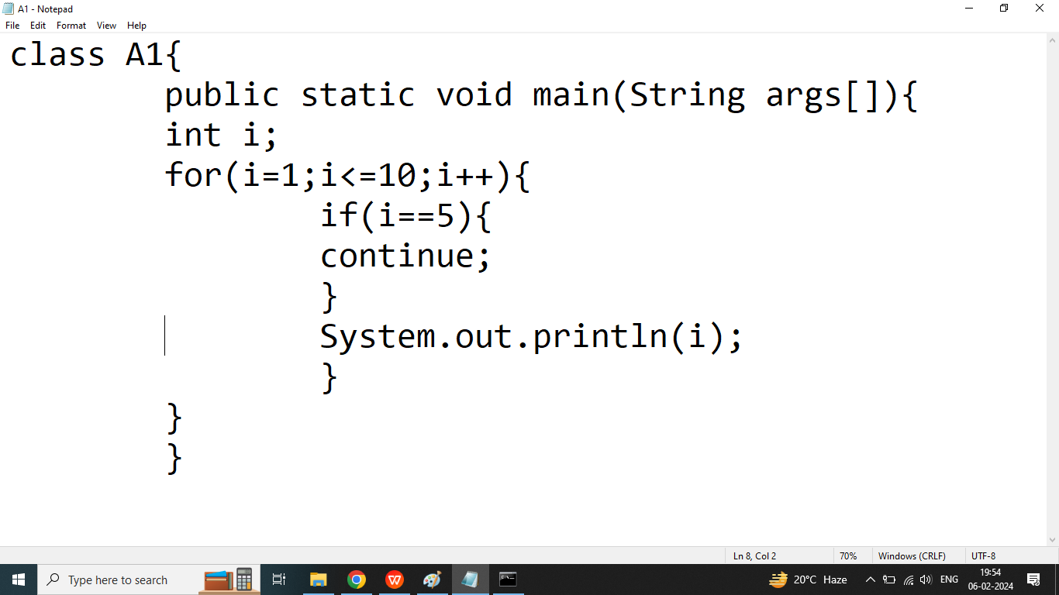

Q4. What will be the output of following program?

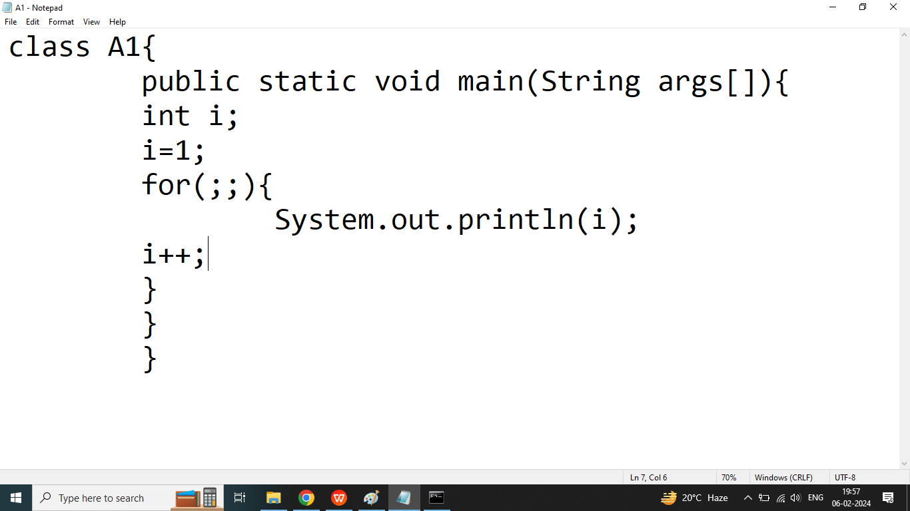

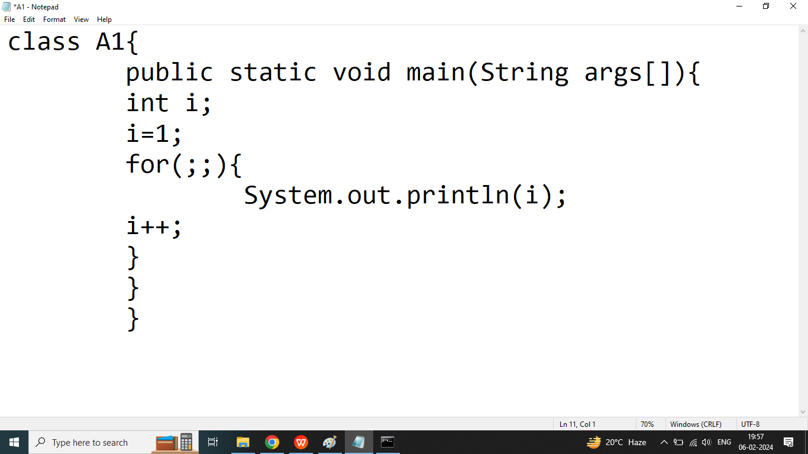

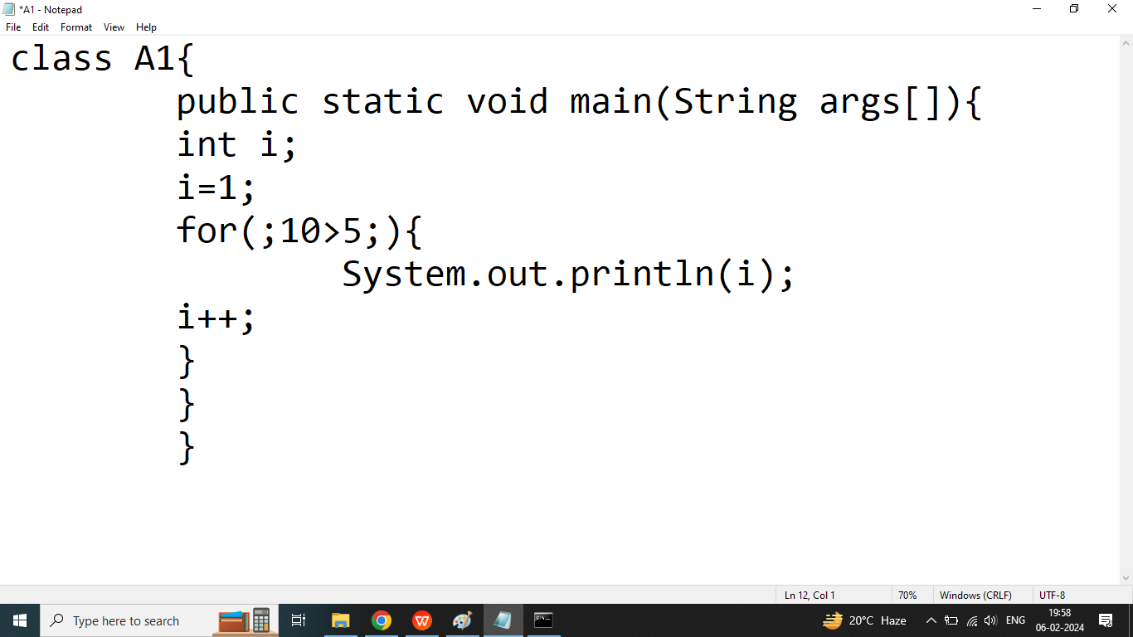

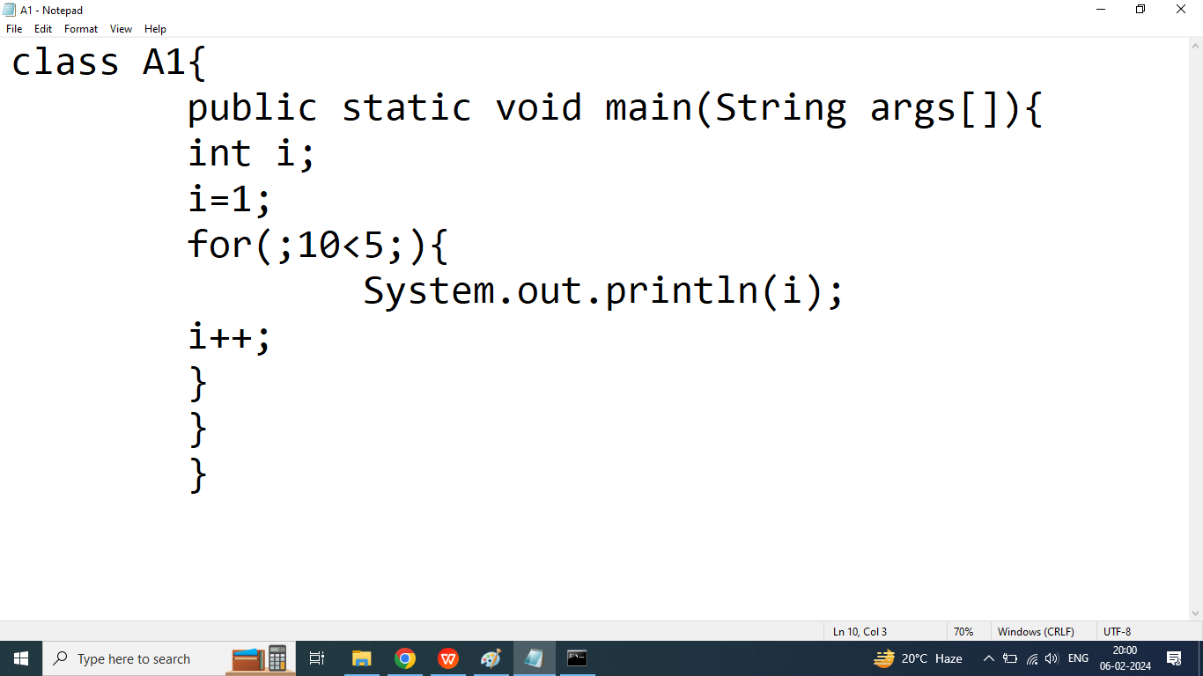

Ans: Compile time error

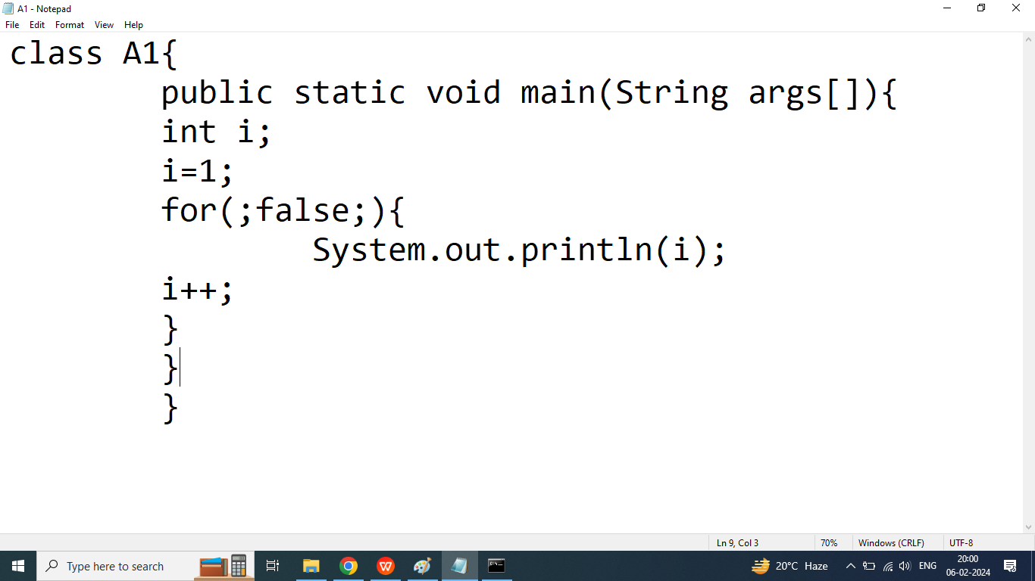

Compile time error

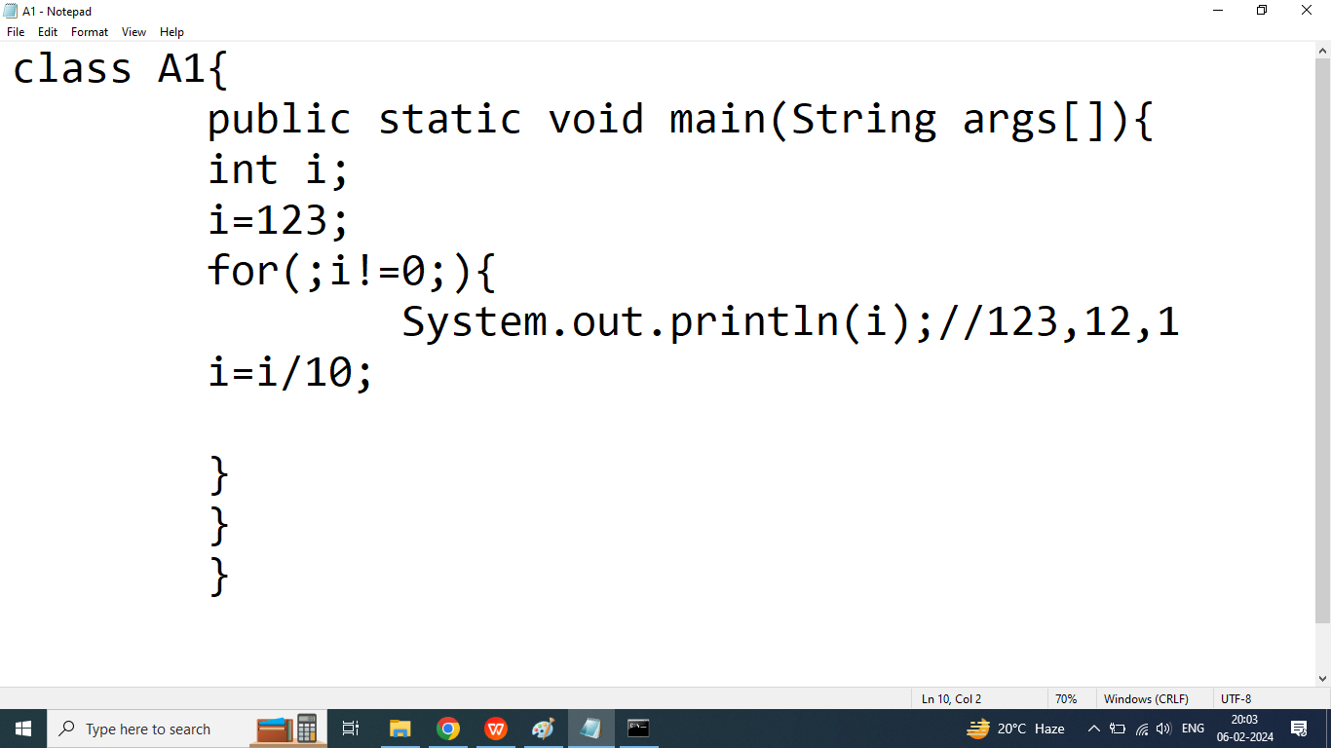

Q2.Write a java program to execute loop infinite time using while or do while

class A1{

public static void main(String args[]) throws Exception{

int i;

i=123;

while(10>4){

System.out.println(i);

Thread.sleep(1000);

i=i*2;

}

}

}

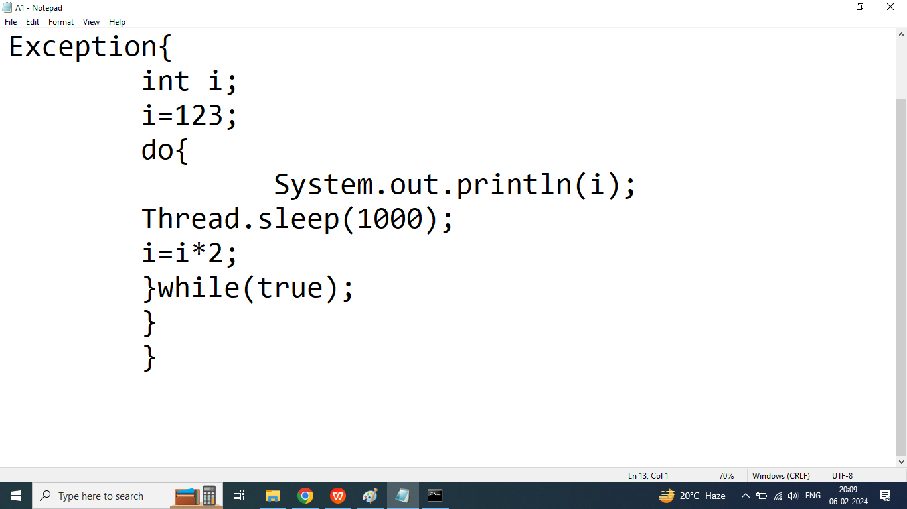

Q3. Explain Array in Java Programming?

Ans:if we want to store multiple values(same type) under single variable then we should go for Array

Array is a collection of similar types of elements

Elements of Array are assigned or assessed by an index

Index always start with 0.

Java does not support negative index

Memory allocation for array is continuous

In java Array is dynamic

Array is fixed in size it means after declaration of the array we cannot increase or decrease size of Array.

Syntax:

Data type arrayName[]=new Datatype[size];

Example:

int num[]=new int[5];

OR

int []num=new int[5];

OR

int[] num=new int[5];

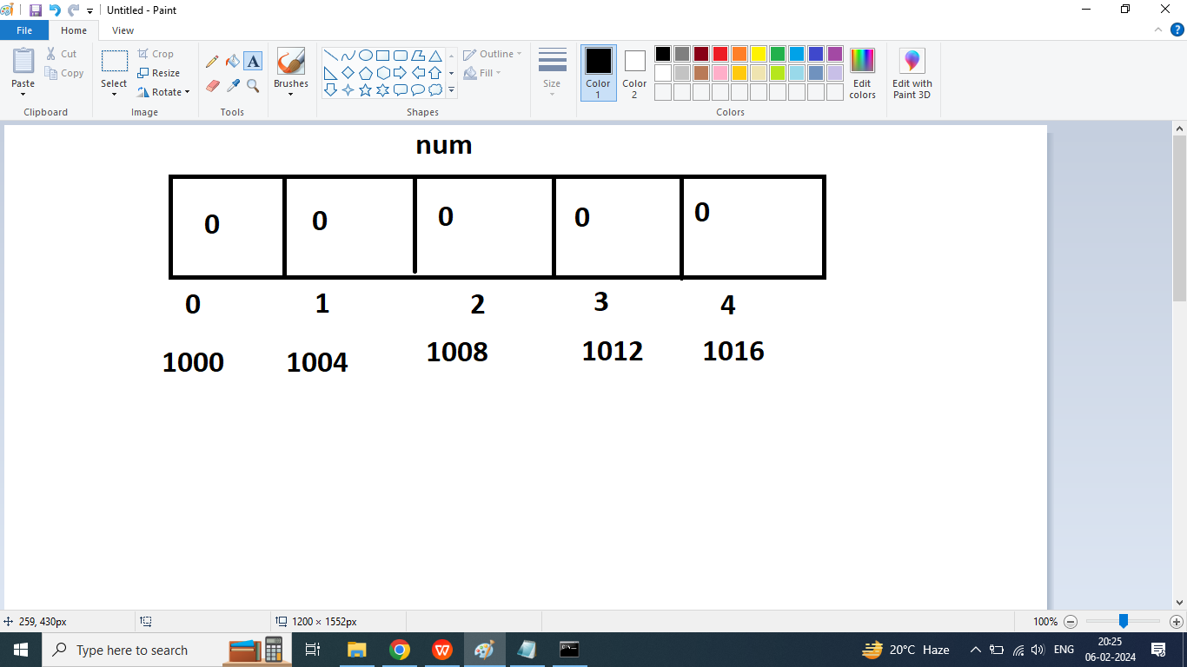

Syntax

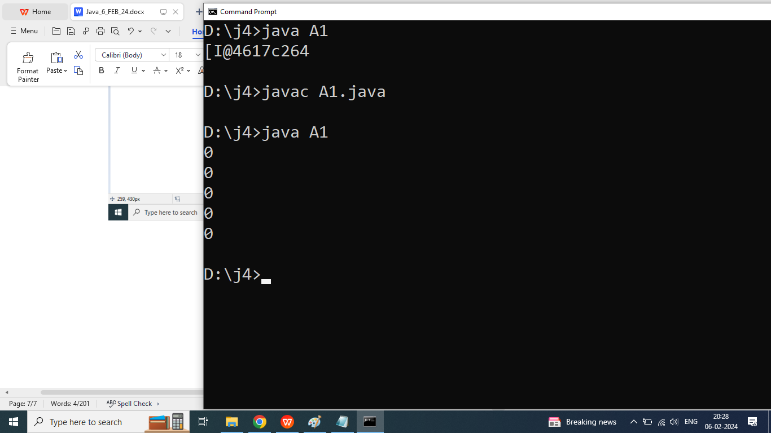

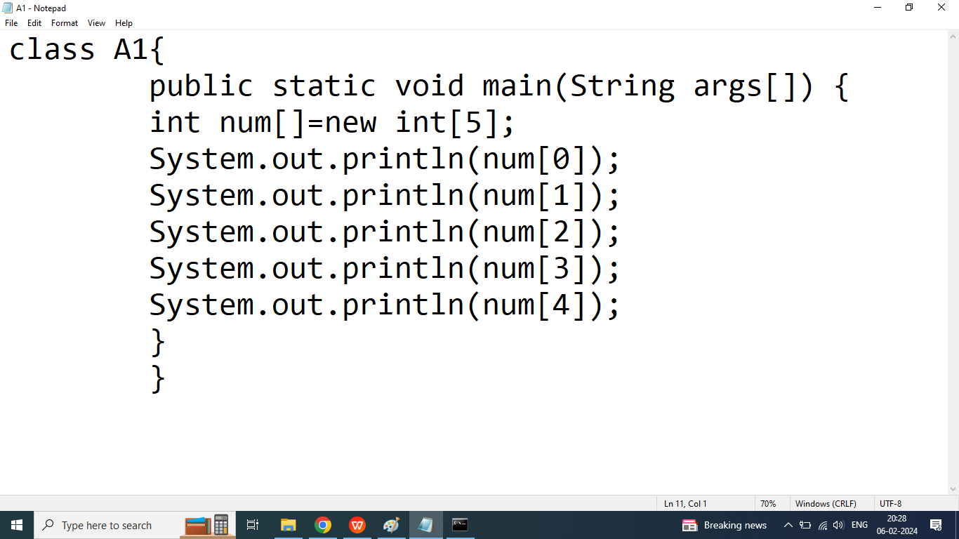

Q1.How to initialize 1d Array in java programming?

Ans:

Syntax:

ArrayName[INDEX]=value;

int arr[]=new int[5];

arr[0]=10;

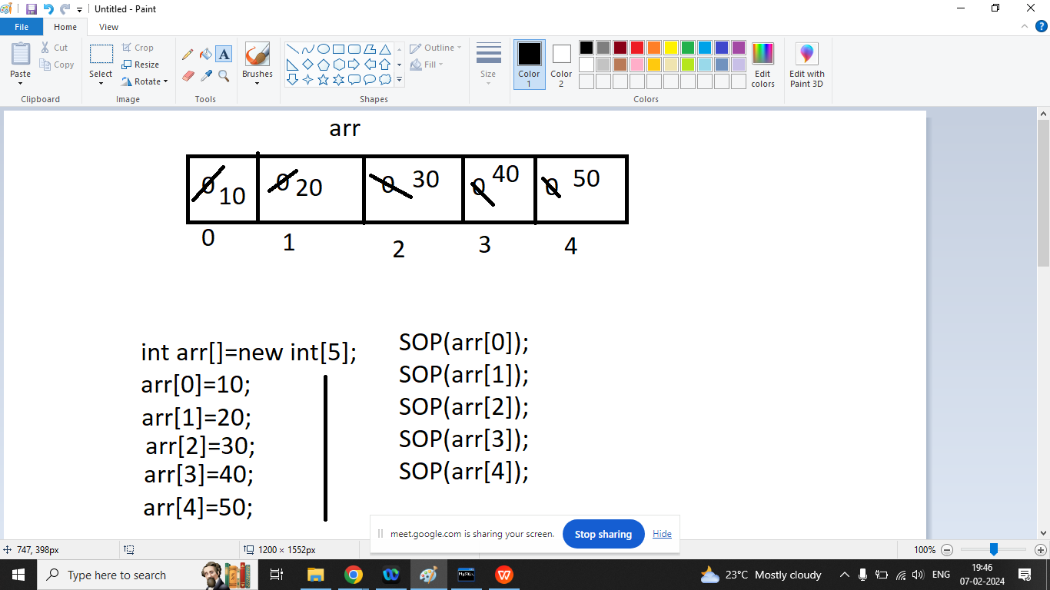

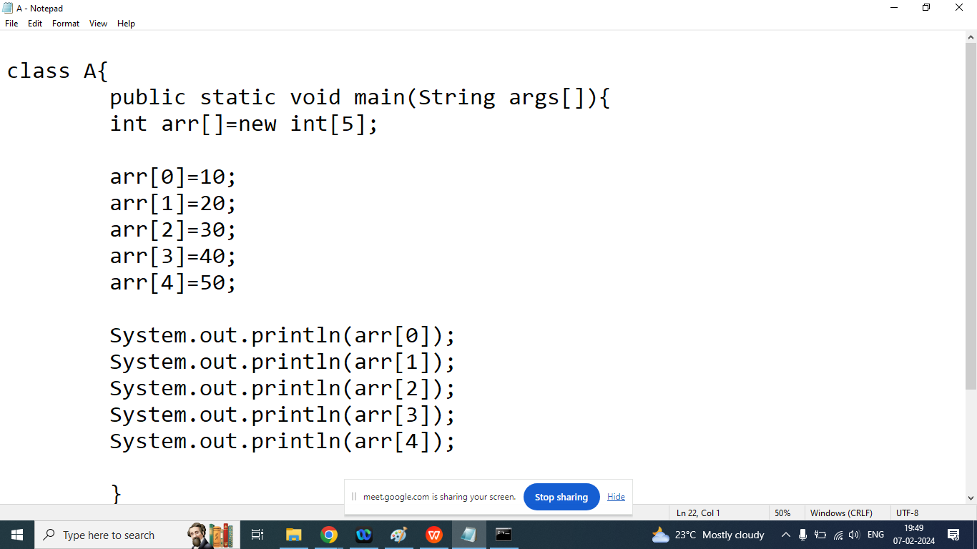

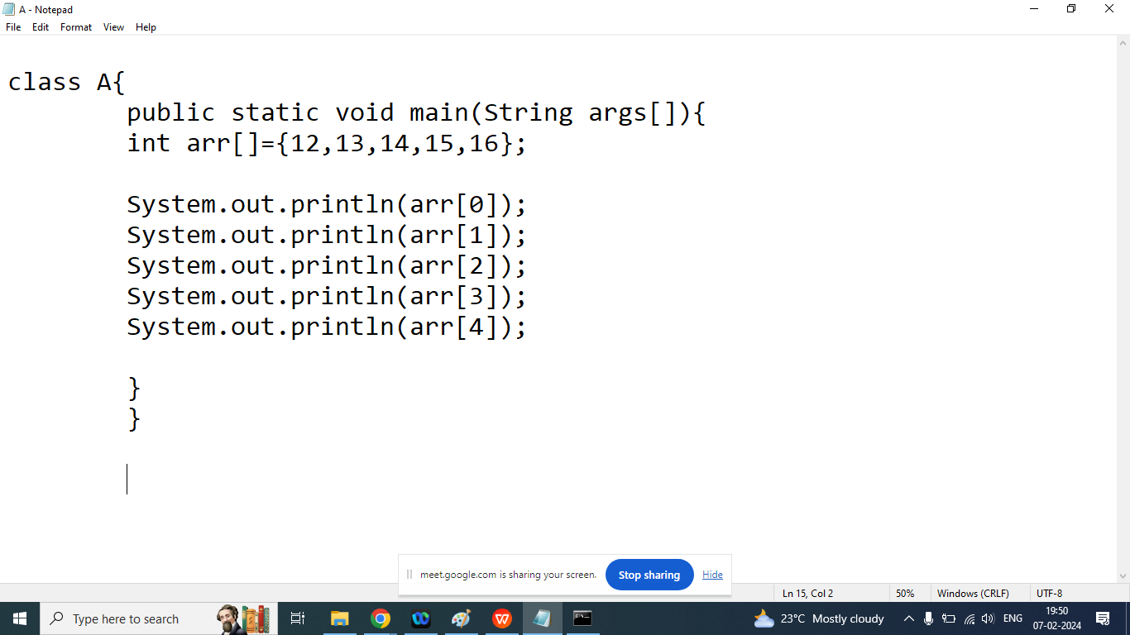

Q3. Explain length property of the array?

Ans:

It will return size of the array or number of elements in the array

Syntax:

arrayName.length

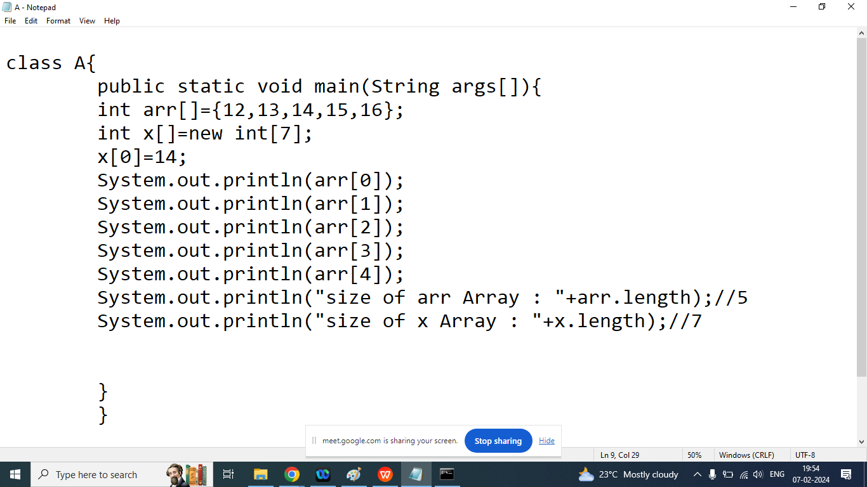

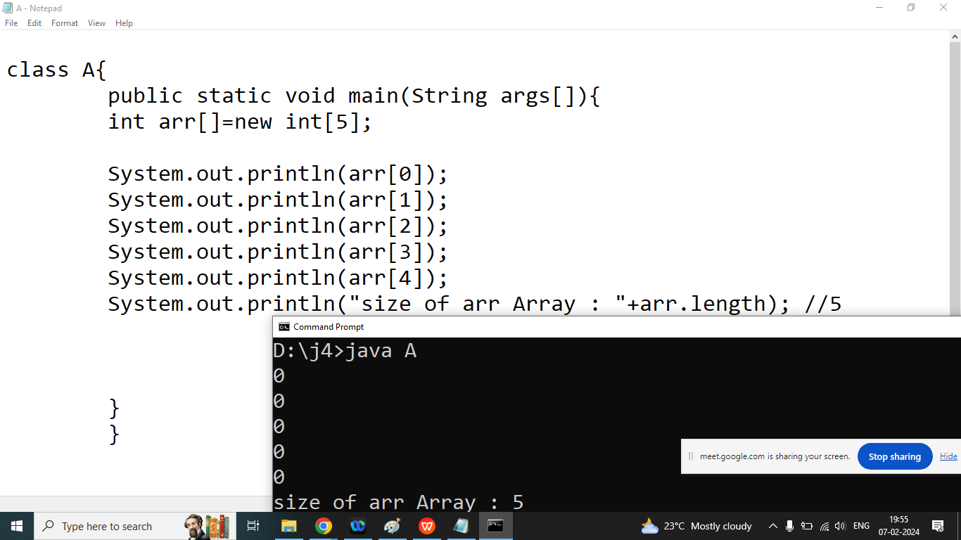

import java.util.Scanner;

class A{

public static void main(String args[]){

int arr[]=new int[5];

Scanner sk=new Scanner(System.in);

System.out.println("Enter Element Index of 0 : ");

arr[0]=sk.nextInt();

System.out.println("Enter Element Index of 1 : ");

arr[1]=sk.nextInt();

System.out.println("Enter Element Index of 2 : ");

arr[2]=sk.nextInt();

System.out.println("Enter Element Index of 3 : ");

arr[3]=sk.nextInt();

System.out.println("Enter Element Index of 4 : ");

arr[4]=sk.nextInt();

System.out.println(arr[0]);

System.out.println(arr[1]);

System.out.println(arr[2]);

System.out.println(arr[3]);

System.out.println(arr[4]);

System.out.println("size of arr Array : "+arr.length); //5

}

}

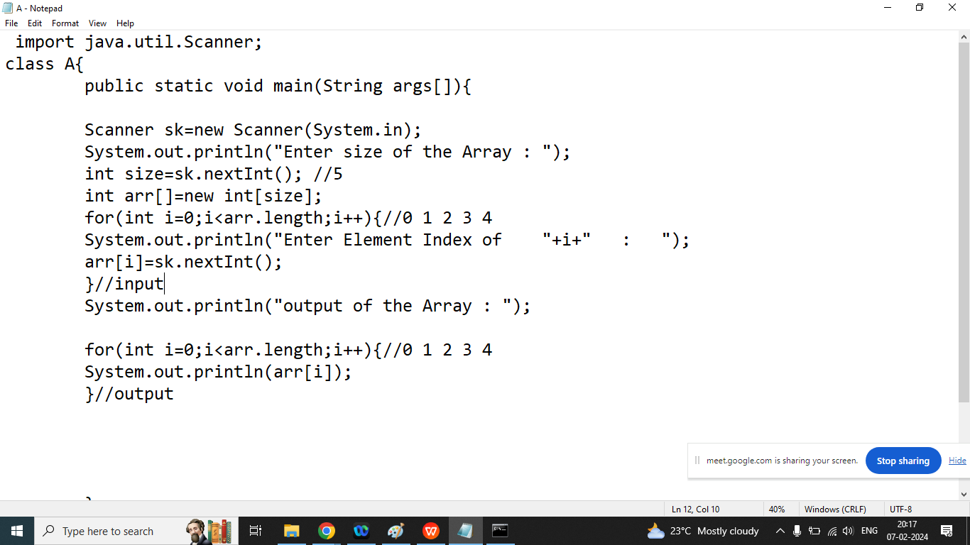

Q4. Write a java program to print array elements in reverse order

Input: arr[10,20,30,40,50]

Reverse Order: 50 40 30 20 10

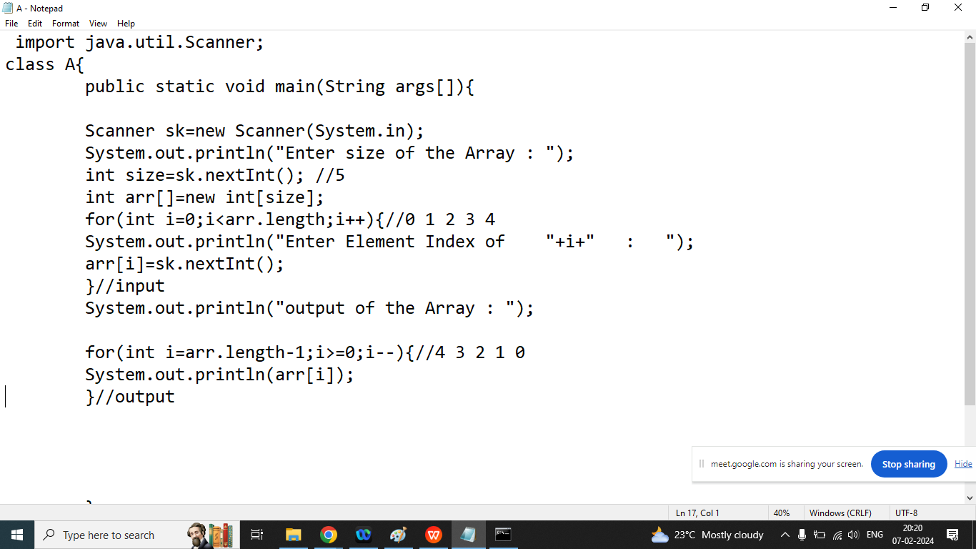

Q5. Write a java program to print even index element of the array.

Input: arr[10,20,30,40,50]

Even Index :10 30 50

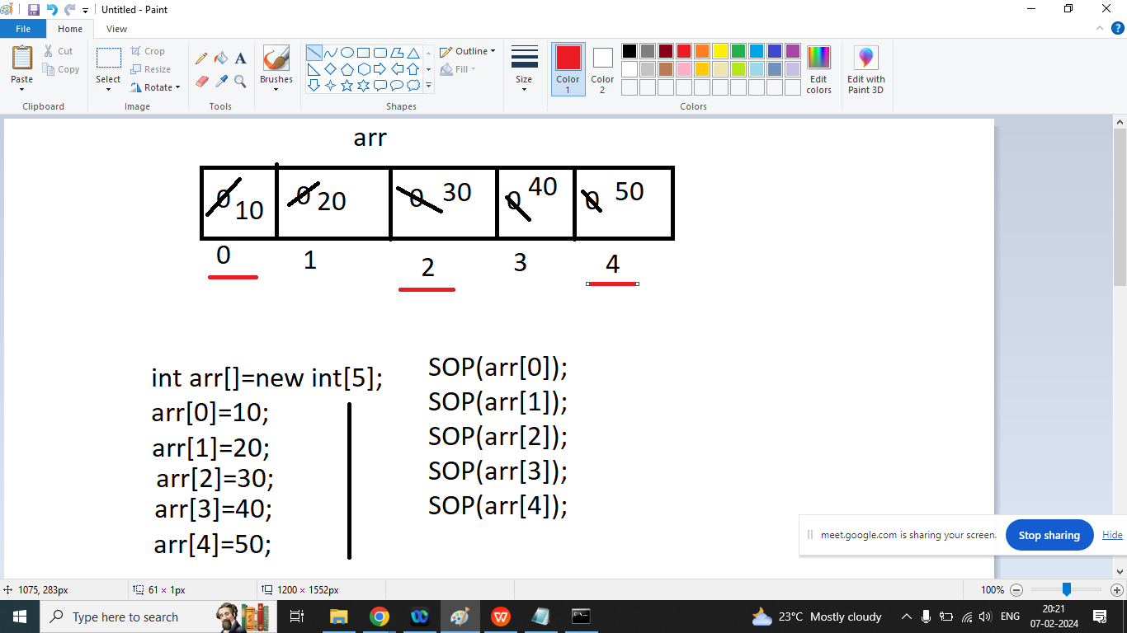

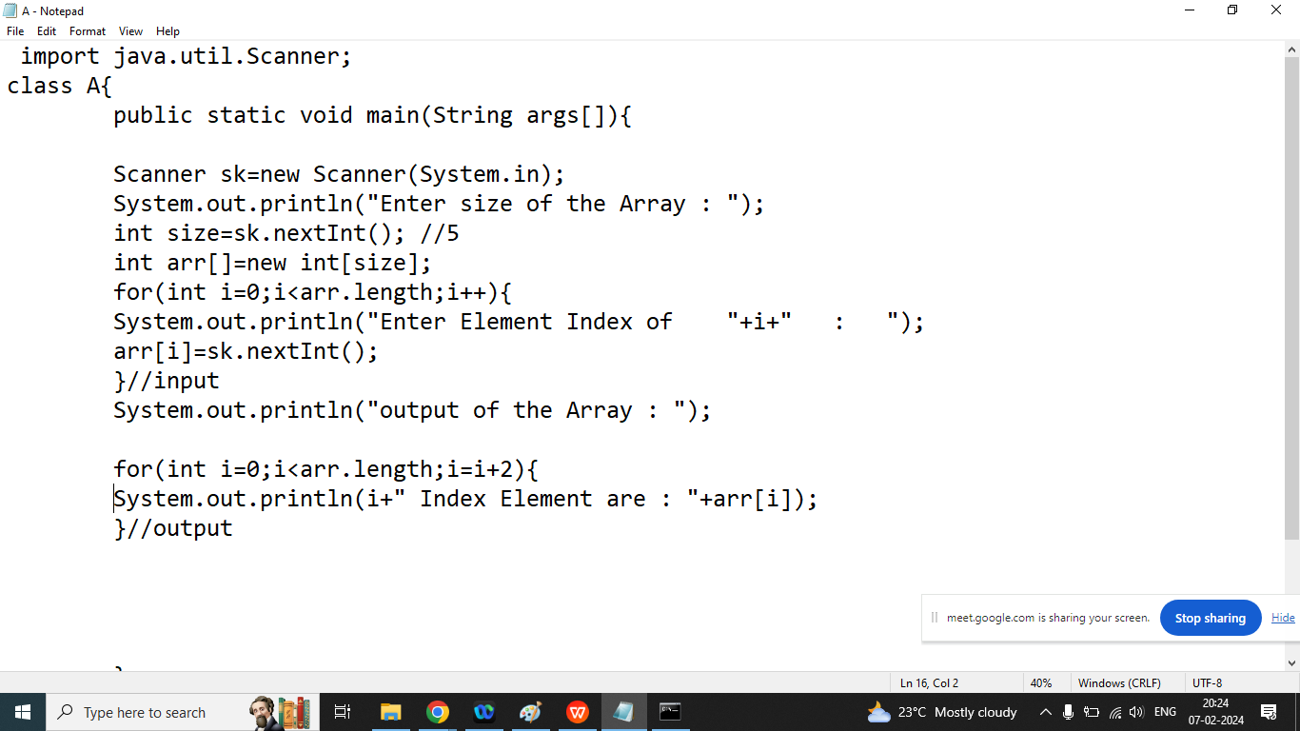

Q1.Write a java program to print maximum element from the Array

Array: 10 45 20 456 45 78 1

Maximum Element: 456

class A3{

public static void main(String args[]){

int nums[]={10,45,20,456,45,78,1};

int max;

max=nums[0];

for(int i=1;i<nums.length;i++){ //i=7

if(nums[i]>max){

max=nums[i];

}

}

System.out.println("Maximum : "+max);

}

}

Q1.Write a java program to print minimum element from the Array

Array: 10 45 20 456 45 78 1

Maximum Element: 1

class A3{

public static void main(String args[]){

int nums[]={10,45,20,456,45,78,1};

int min;

min=nums[0];

for(int i=1;i<nums.length;i++){ //i=7

if(nums[i]<min){

min=nums[i];

}

}

System.out.println("Minimum Element : "+min);

}

}

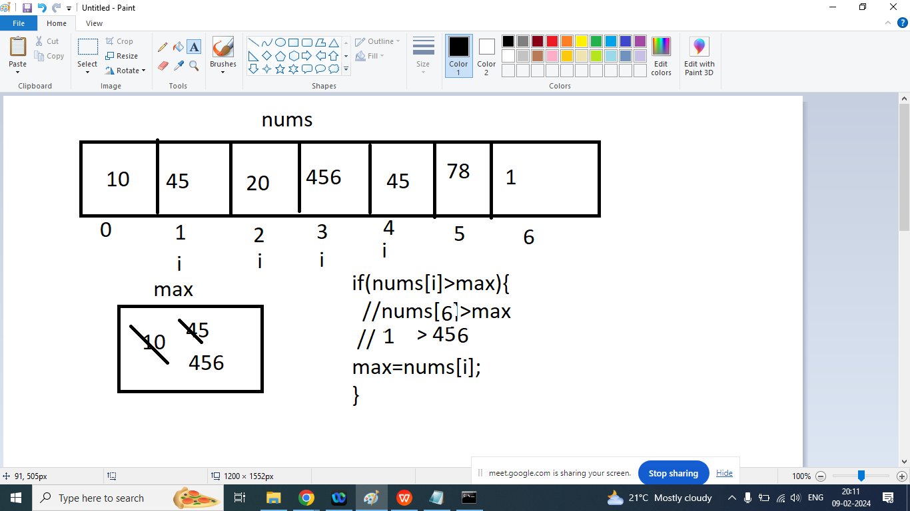

Q3. Write a java program to sort Array in ascending order / increasing order?

Ans:

Array Element : 10 30 20

int A,B,C;

C=A;

A=B;

B=C

class A3{

public static void main(String args[]){

int nums[]={10,30,20,1,34,67,79,45,-1,0};

int i,j;

System.out.println("Before sorting : ");

for(i=0;i<nums.length;i++){

System.out.print("\t"+nums[i]);

}

for(i=0;i<nums.length;i++){//i=2

for(j=i+1;j<nums.length;j++){//j=3

if(nums[i]>nums[j]){

int c;

c=nums[i];//c=30

nums[i]=nums[j];

nums[j]=c;

}

}

}

System.out.println("\nAfter sorting : ");

for(i=0;i<nums.length;i++){

System.out.print("\t"+nums[i]);

}

}

}

Q3. Write a java program to sort Array in descending order / decreasing order?

Ans:

Array Element : 10 30 20

After Sorting: 30 20 10

class A3{

public static void main(String args[]){

int nums[]={10,30,20,1,34,67,79,45,-1,0};

int i,j;

System.out.println("Before sorting : ");

for(i=0;i<nums.length;i++){

System.out.print("\t"+nums[i]);

}

for(i=0;i<nums.length;i++){//i=2

for(j=i+1;j<nums.length;j++){//j=3

if(nums[i]<nums[j]){

int c;

c=nums[i];//c=30

nums[i]=nums[j];

nums[j]=c;

}

}

}

System.out.println("\nAfter sorting : ");

for(i=0;i<nums.length;i++){

System.out.print("\t"+nums[i]);

}

}

}

Q1.Explain 2D Array in Java Programming?

Ans:if we want to store data inform of table or matrix then we should go for 2D array.

2D Array is also known as Array of Array.

Syntax:

Data type ArrayName[][]=new Data Type[ROW SIZE][COLUMN SIZE];

int A[][]=new int[3][3];

|  | COL 0 | COL 1 | COL 2 |
| --- | --- | --- | --- |
| ROW 0 | 00(10) | 01(20) | 02(30) |
| ROW 1 | 10(40) | 11(50) | 12(60) |
| ROW 2 | 20(70) | 21(80) | 22(90) |

How to Initialize 2D Array

ArrayName[ROW INDEX][COLUMN INDEX]=Value;

A[0][0]=10;

A[0][1]=20;

A[0][2]=30;

A[1][0]=40;

A[1][1]=50;

A[1][2]=60;

A[2][0]=70;

A[2][1]=80;

A[2][2]=90;

class A4{

public static void main(String args[]){

int A[][]=new int[3][3];

A[0][0]=10;

A[0][1]=20;

A[0][2]=30;

A[1][0]=40;

A[1][1]=50;

A[1][2]=60;

A[2][0]=70;

A[2][1]=80;

A[2][2]=90;

System.out.printf("%d\t%d\t%d",A[0][0],A[0][1],A[0][2]);

System.out.printf("\n%d\t%d\t%d",A[1][0],A[1][1],A[1][2]);

System.out.printf("\n%d\t%d\t%d",A[2][0],A[2][1],A[2][2]);

}

}

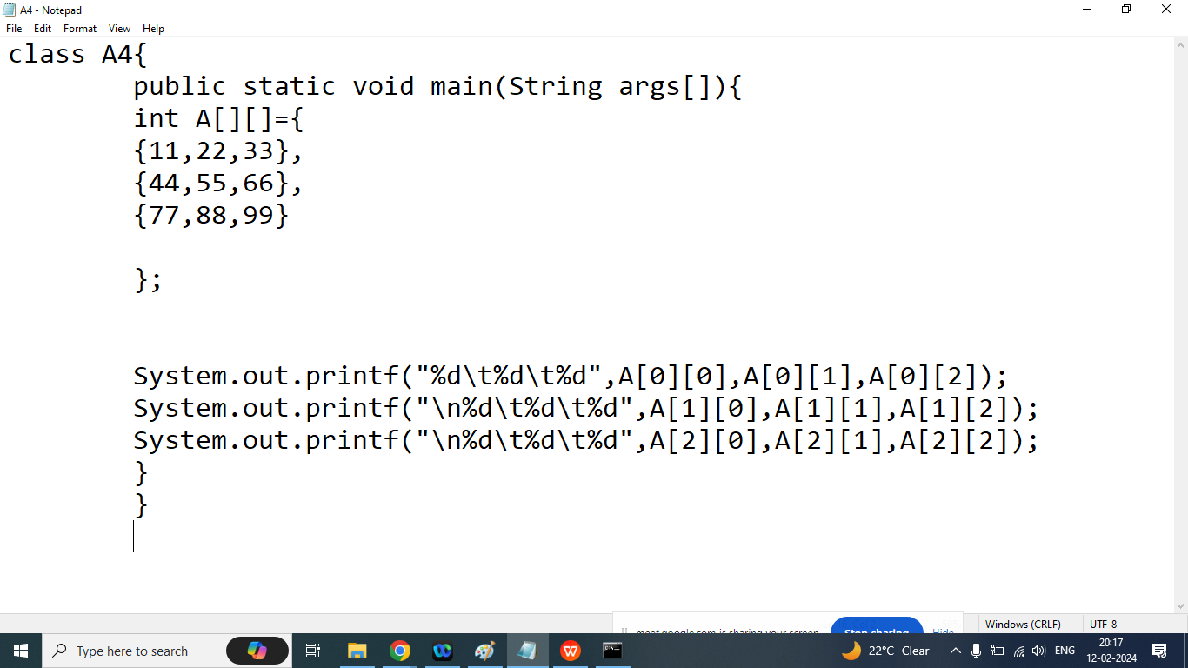

import java.util.Scanner;

class A4{

public static void main(String args[]){

int A[][]=new int[3][3];

Scanner sk=new Scanner(System.in);

System.out.println("Enter Element Index of 00 : ");

A[0][0]=sk.nextInt();

System.out.println("Enter Element Index of 01 : ");

A[0][1]=sk.nextInt();

System.out.println("Enter Element Index of 02 : ");

A[0][2]=sk.nextInt();

System.out.println("Enter Element Index of 10 : ");

A[1][0]=sk.nextInt();

System.out.println("Enter Element Index of 11 : ");

A[1][1]=sk.nextInt();

System.out.println("Enter Element Index of 12 : ");

A[1][2]=sk.nextInt();

System.out.println("Enter Element Index of 20 : ");

A[2][0]=sk.nextInt();

System.out.println("Enter Element Index of 21 : ");

A[2][1]=sk.nextInt();

System.out.println("Enter Element Index of 22 : ");

A[2][2]=sk.nextInt();

System.out.printf("%d\t%d\t%d",A[0][0],A[0][1],A[0][2]);

System.out.printf("\n%d\t%d\t%d",A[1][0],A[1][1],A[1][2]);

System.out.printf("\n%d\t%d\t%d",A[2][0],A[2][1],A[2][2]);

}

}

import java.util.Scanner;

class A4{

public static void main(String args[]){

int A[][]=new int[3][3];

Scanner sk=new Scanner(System.in);

int r,c;

for(r=0;r<A[0].length;r++){

for(c=0;c<A[0].length;c++){

System.out.println("Enter Element Index of "+r+c+" : ");

A[r][c]=sk.nextInt();

}

}//input

for(r=0;r<A[0].length;r++){

for(c=0;c<A[0].length;c++){

System.out.printf("\t%d",A[r][c]);

}

System.out.println("");

}//output

}

}

Matrix Addition

Transpose Matrix

Java

Q3. Explain String class in Java?

Ans:

If we want to store multiple character or alpha numeric character then we should go for String class

If our content are fixed we won’t perform any modification then we should go for String

If we are trying to perform some modification on String object then every modification new object will created(internally)

String: If our content are fixed we won’t perform any modification then we should go for String

StringBuffer: If our content are not fixed we want perform some and thread safety required,modification then we should go for StringBuffer

StringBuilder:If our content are not fixed we want perform some and thread safety not required then we should go for StringBuilder

Q1. Explain String class in java programming?

Ans:

If our content are fixed and we will not perform any modification then we should goo for String class

String is a immutable class present in java.lang package

String is a class, so class can have a constructor or method

Constructor

1. String()
2. String(String)

There are two ways to create object of String class

1. **Using String Literals (“”)**

String s1=”Hello”;

String s2=”Hello”;

String s3=”Hello”;

Note: if we are using string Literals then memory will allocated only SCP which is present inside HEAP Area

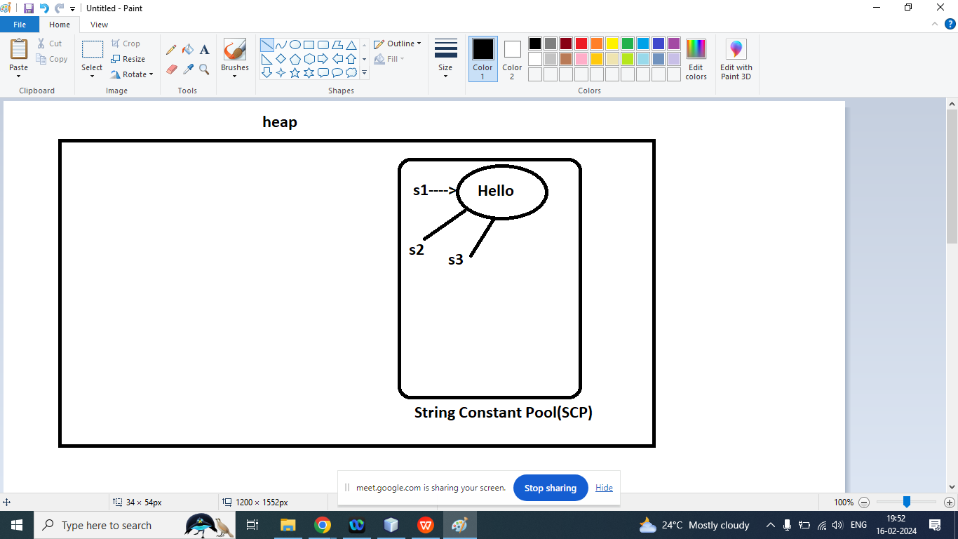

1. Using new Keywords

**String s1=new String(“Hello”);**

First in the above code Two Object will created

First Inside Heap and second Inside SCP

Note: if we are using new keyword to create an object of String class then every time new object will created inside heap, but inside SCP first check the content if content are available then no new object will created inside SCP. If content not present in the SCP then new object will created.

**String s1=new String(“Hello”);**

**String s2=new String(“Hello”);**

**String s3=new String(“Hello”);**

**String s4=s3;**

First in the above code Two Object will created

First Inside Heap and second Inside SCP

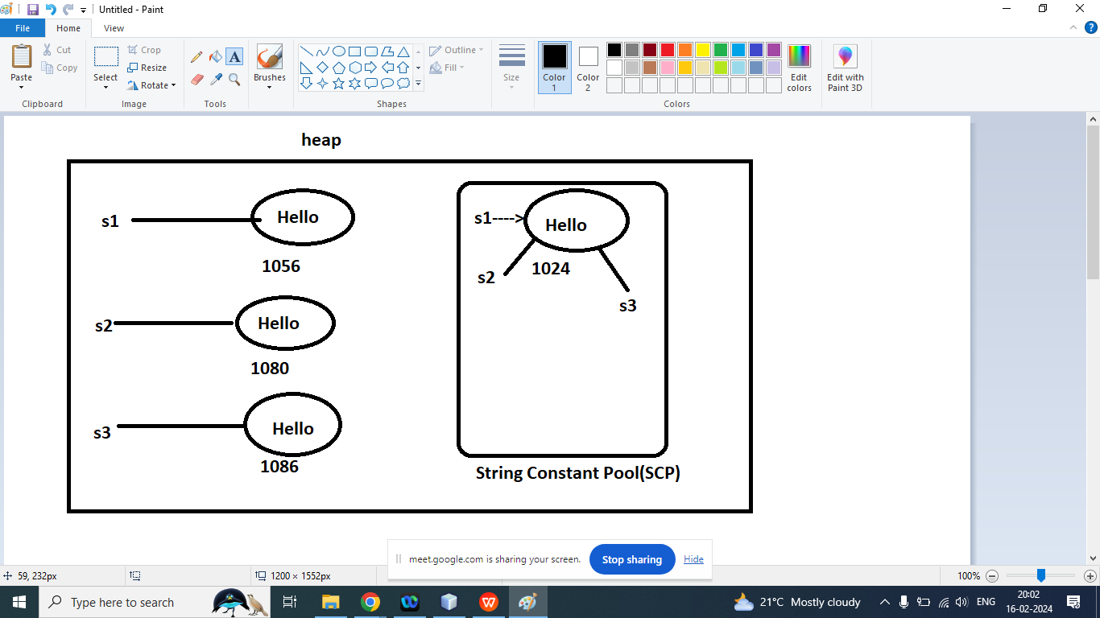

Q3. what is the difference == operator and equals method?

Ans:

== Operator: Meant for Reference compression

Note: First check reference of heap memory if the reference are same then it will return true

If no object present in the heap then it will check SCP, if SCP area two object points to same reference then it will return true otherwise false.

Q1.Explain String Class Constructor in Java Programming?

Ans:

1. String()
2. String(String)
3. String(char arr[],int start,int n)
4. String(byte arr[],int start,int n)
5. String(char arr[])

String x=”welcome”;

String y=new String(”bhopal”);

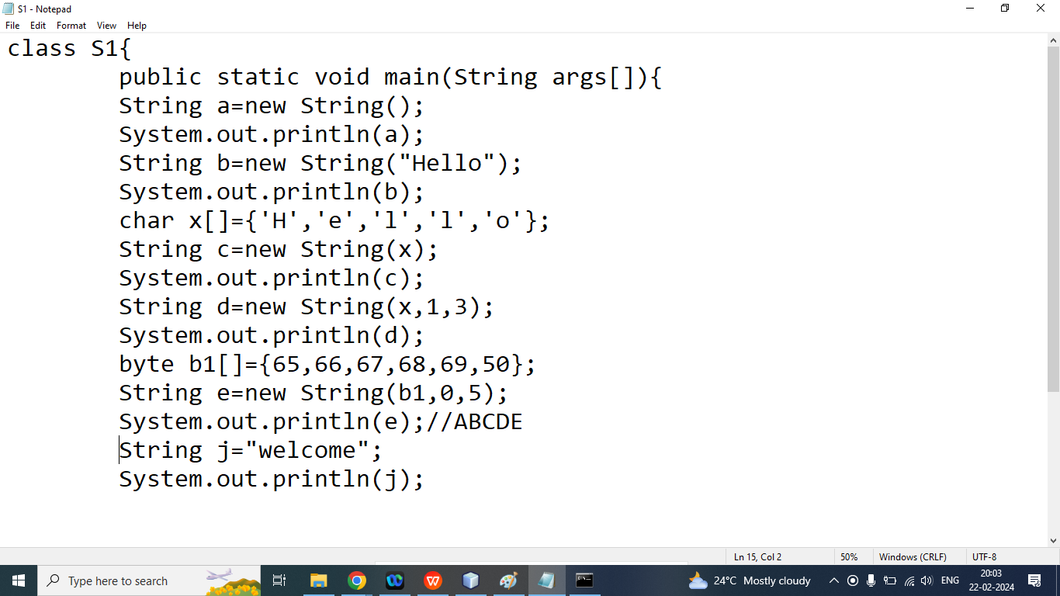

Q2.Explain String class methods in java programming?

Ans:

1. char charAt(int index)
2. int compareTo(String)
3. String concat(String)
4. int contains(String)
5. Boolean endsWith(String)
6. Boolean equals(String)
7. Boolean equalsIgnoreCase()
8. int indexOf(String)
9. int lastIndexOf(String)
10. Boolean isEmpty()
11. Int length()
12. String replace()
13. String[]split(“ ”)
14. char[] toCharArray(String)
15. boolean startsWith(String)
16. String substring(int start)
17. String substring(int start,int end)
18. String toLowerCase()
19. String toUpperCase()
20. toString()
21. String trim()
22. String valueOf(int)
23. String valueOf(float)
24. String valueOf(double)
25. String valueOf(boolean)
26. String valueOf(byte)

Q3. Explain String class charAt() method?

Ans: Returns the character at the specific index(position)

Syntax:

char charAt(int index)

Example:

String s=”Welcome”;

| W | E | L | C | O | M | E |
| --- | --- | --- | --- | --- | --- | --- |
| 0 | 1 | 2 | 3 | 4 | 5 | 6 |

char b=s.charAt(3);

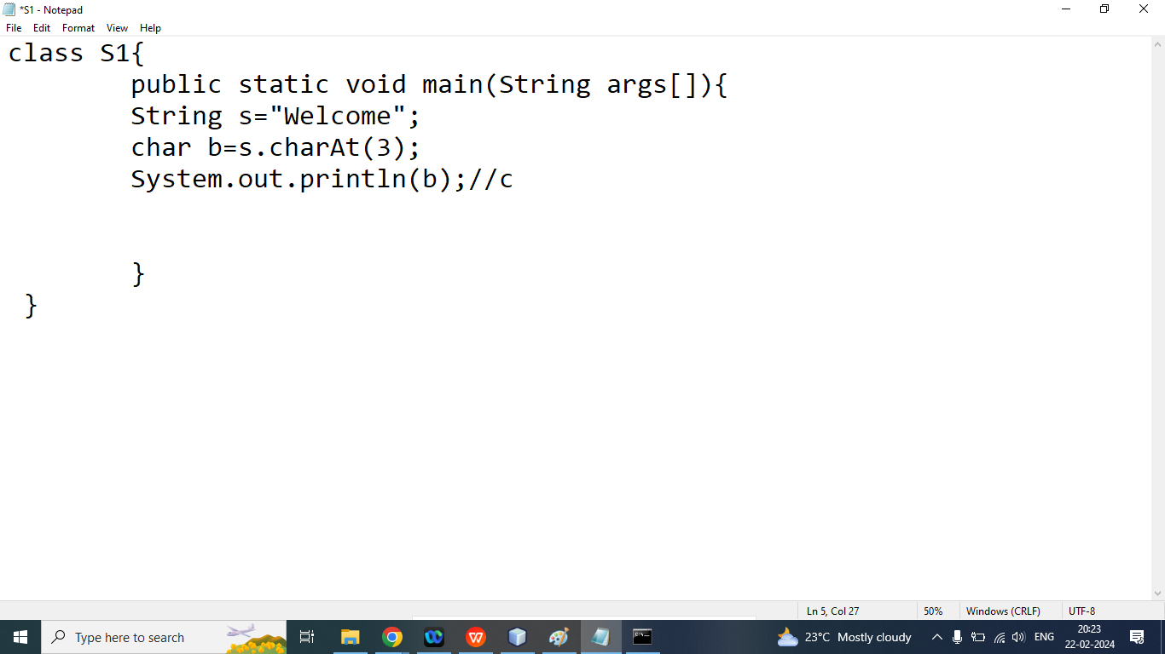

Q2. Explain String class concat() method?

Ans: Appends a String to the end of another String.

Syntax:

String concat(String)

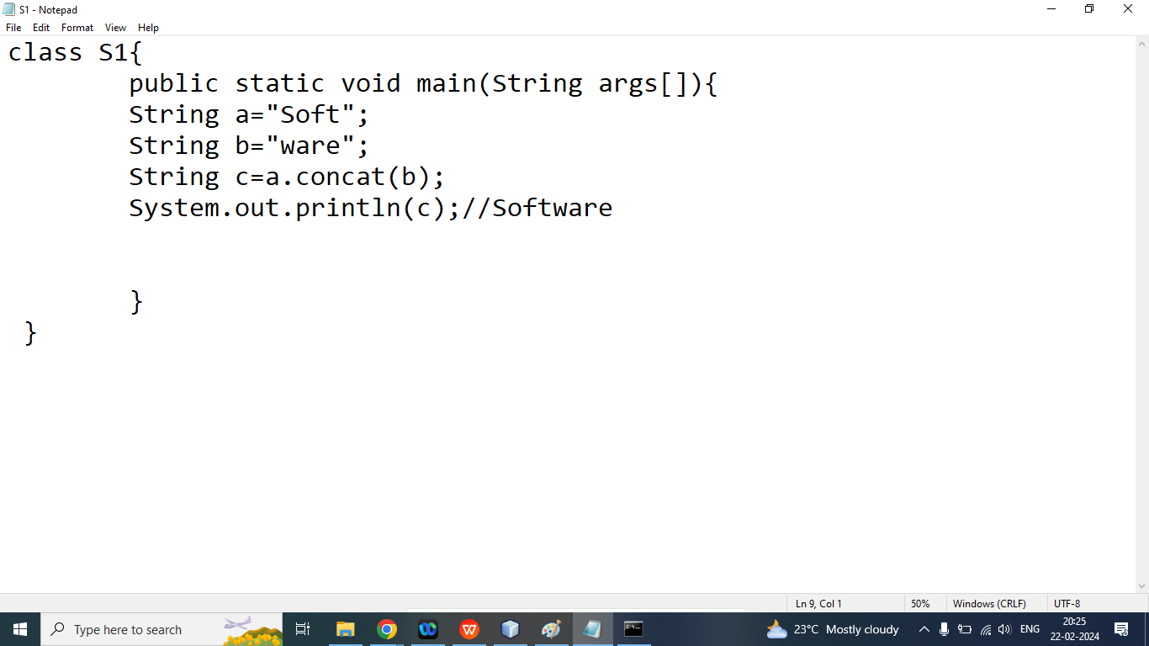

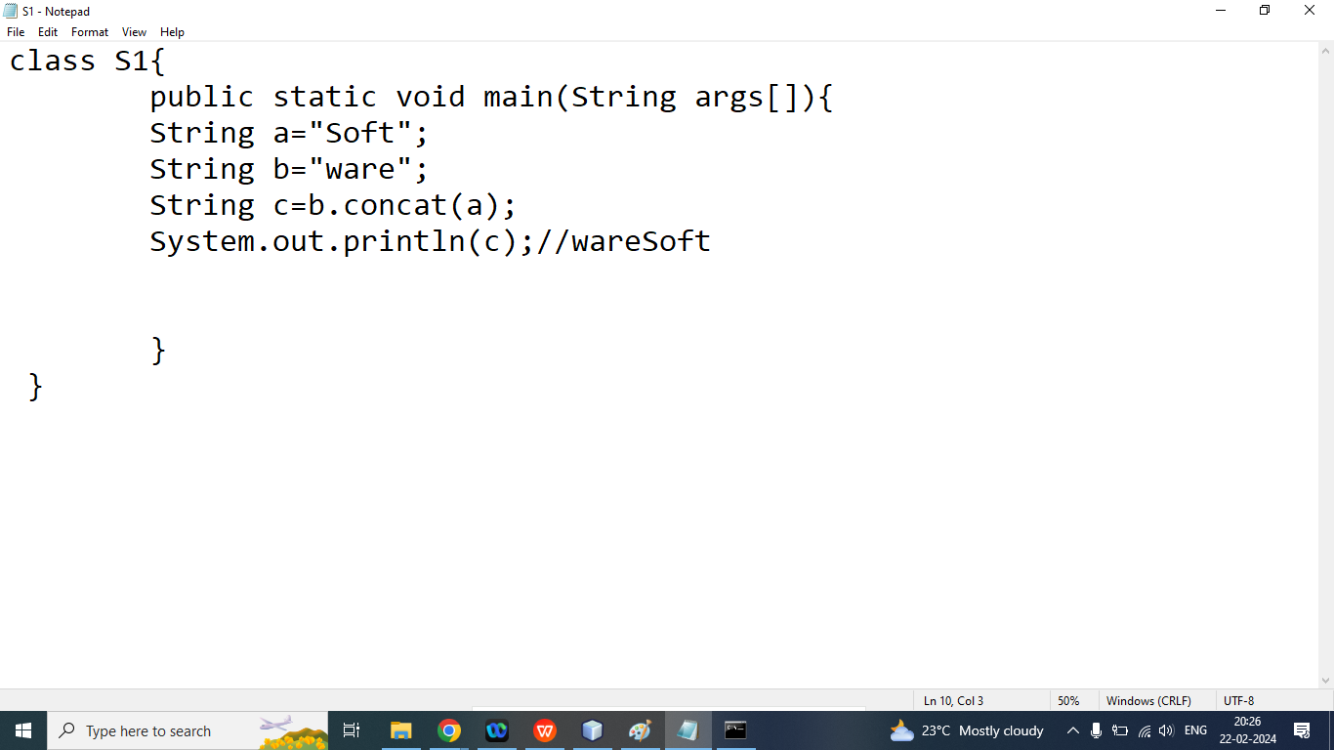

Home Work

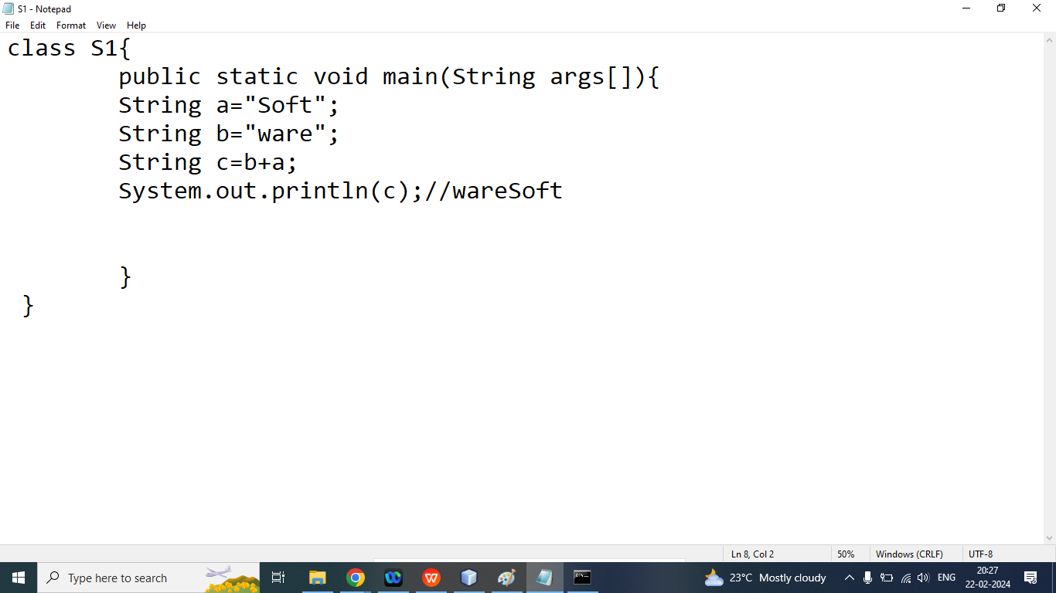

Q3. What is the difference between concat() method and + operator?

Q1. Explain String class compareTo Method in java Programming?

Ans: CompareTo() method is used to compare The String according to alphabetically order.

Syntax:

int compareTo(String x)

String s1=”a”;//97

String s2=”a”;//97

If s1>s2 It will return Positive Value

If s1<s2 It will return Negative Value

If s1==s2 it will return 0

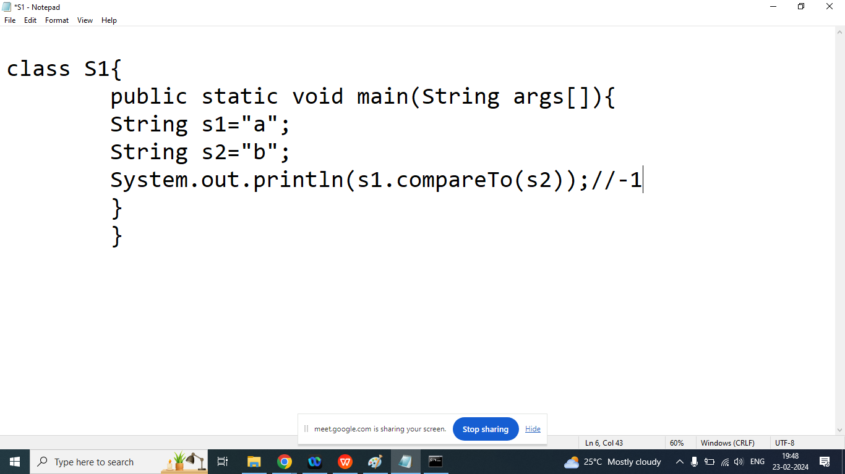

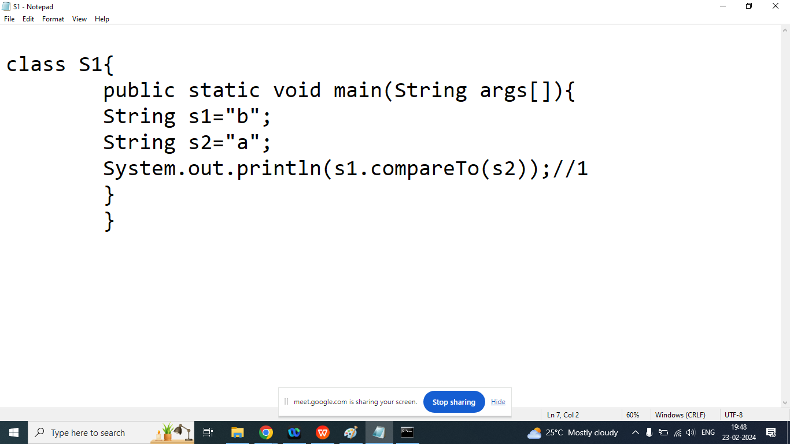

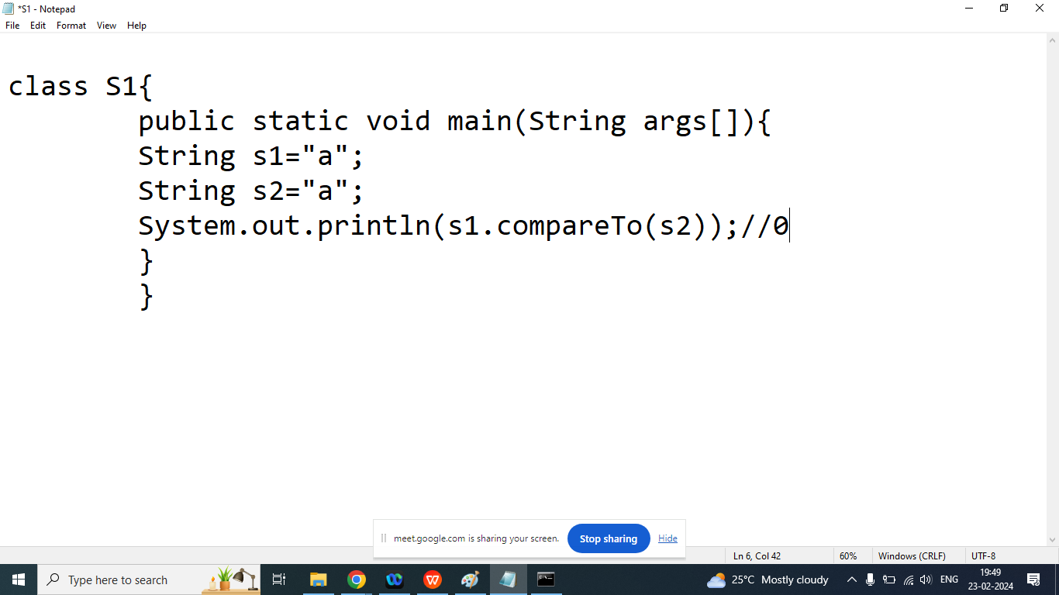

class S1{

public static void main(String args[]){

String s1="b";

String s2="a";

if(s1.compareTo(s2)==0){

System.out.println("S1 and S2 are Equal");

}

else if(s1.compareTo(s2)<0){

System.out.println("S1 is Smaller");

}else if(s1.compareTo(s2)>0){

System.out.println("S2 is Smaller");

}

}

}

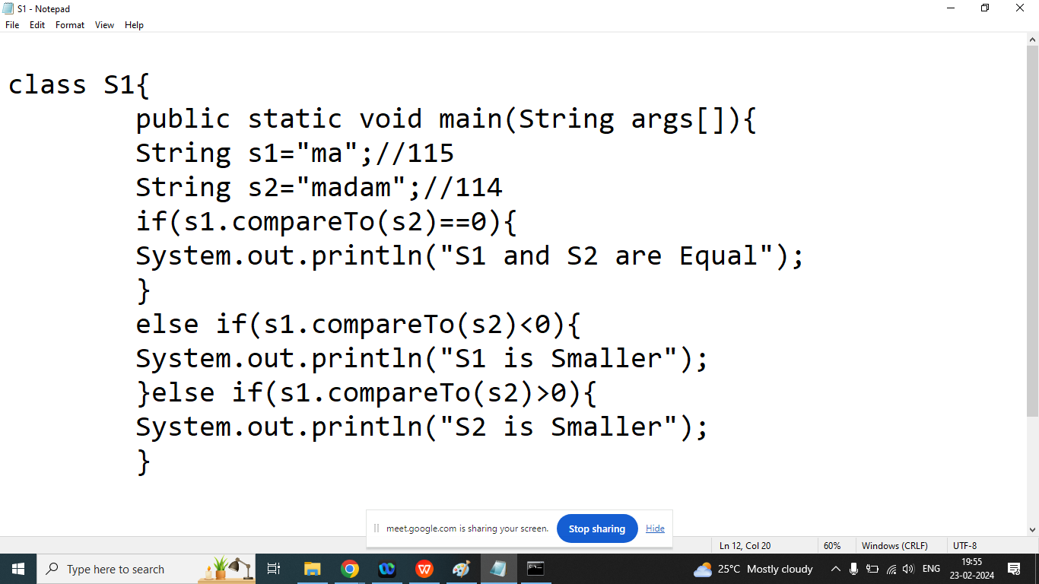

Q2.Explain String class contains method in java programming?

Ans: Check whether a String contains a sequence of characters.

Syntax:

boolean contains(String)

Example:

String s=”Learning of Java is very easy”;

Boolean b=s.contains(“Java”);

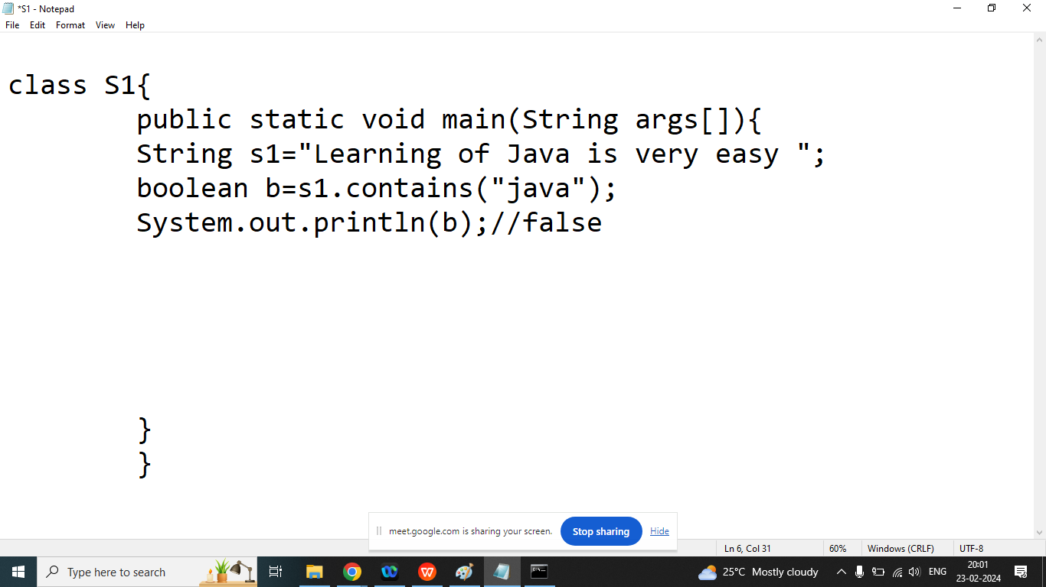

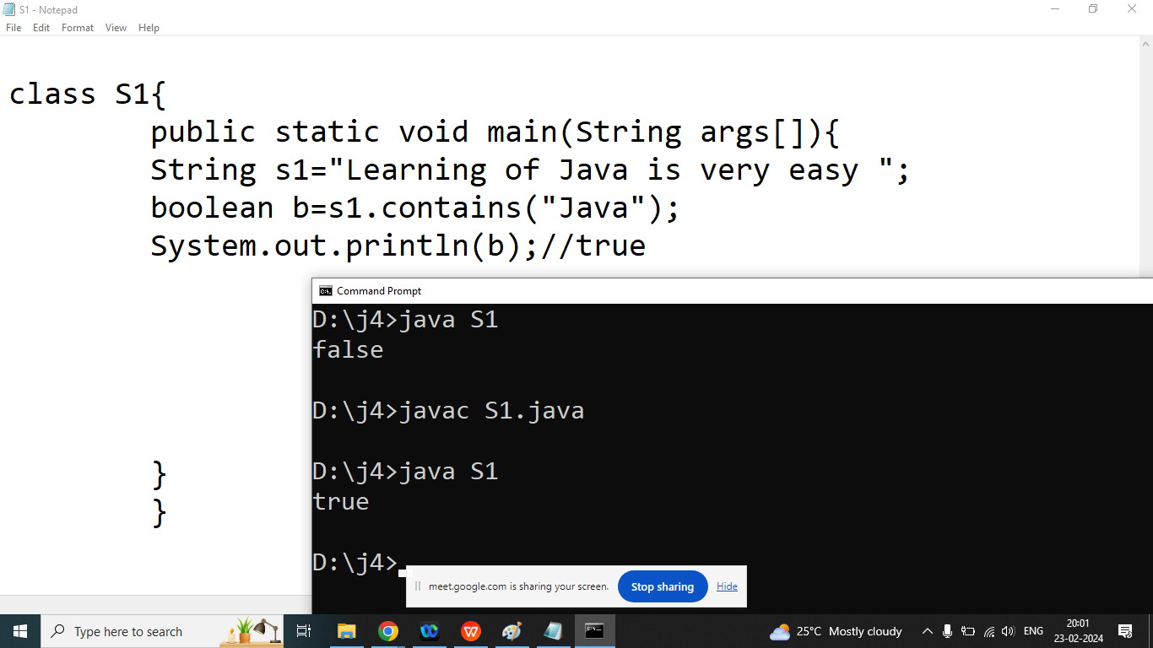

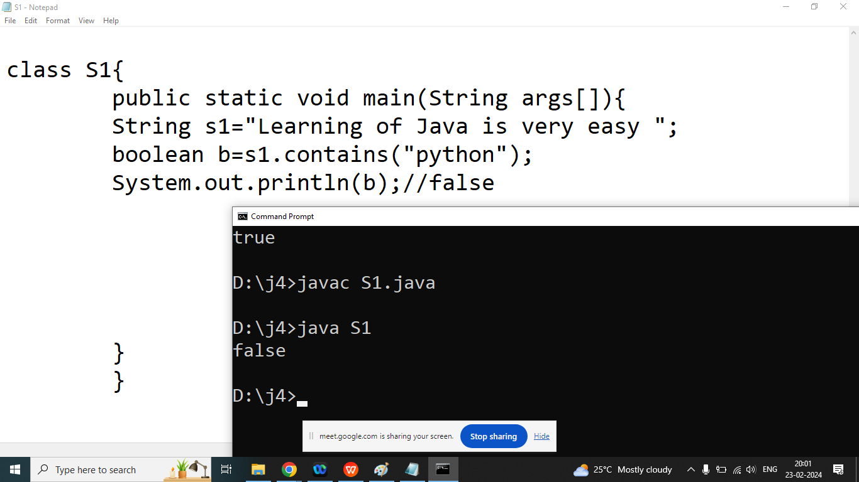

Q4. Explain String class endsWith()?

Ans:

Checks whether a string ends with the specified characters

Syntax:

Boolean endsWith(String)

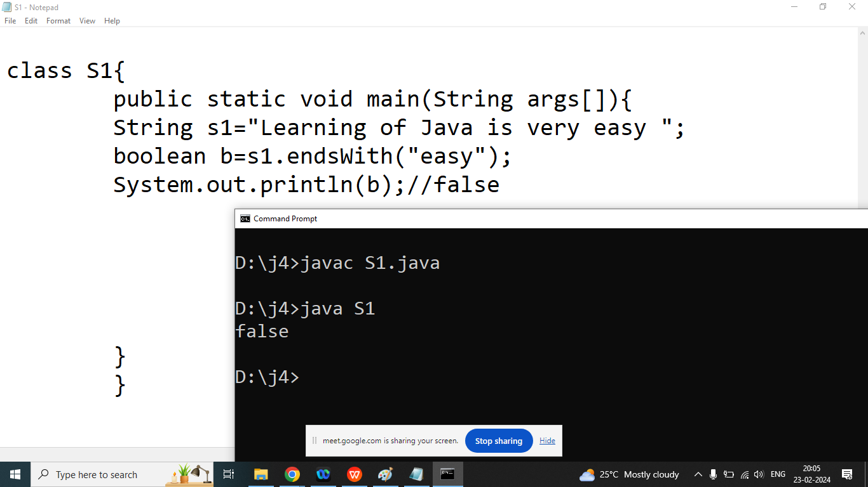

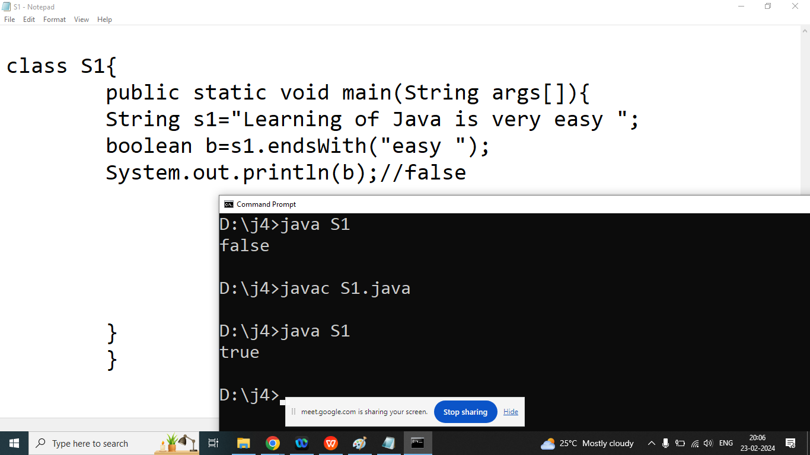

Q4. Explain String class startsWith()?

Ans:starts with the specified characters

Syntax:

Boolean startsWith(String)

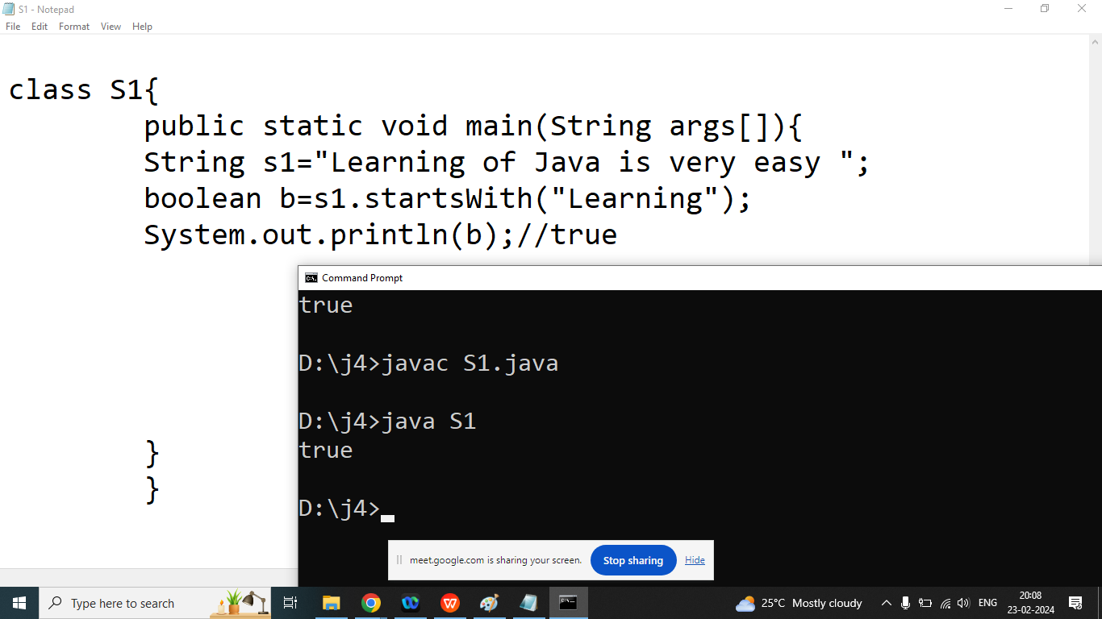

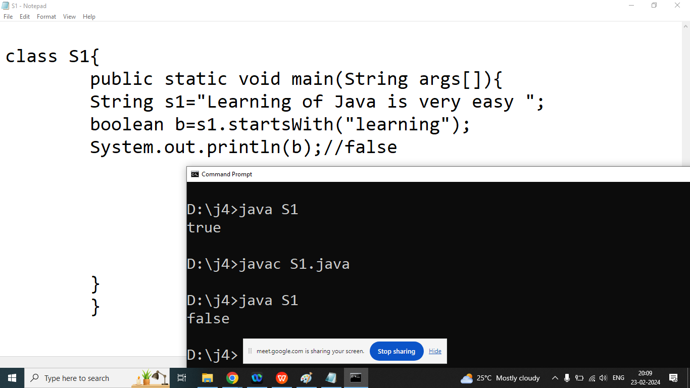

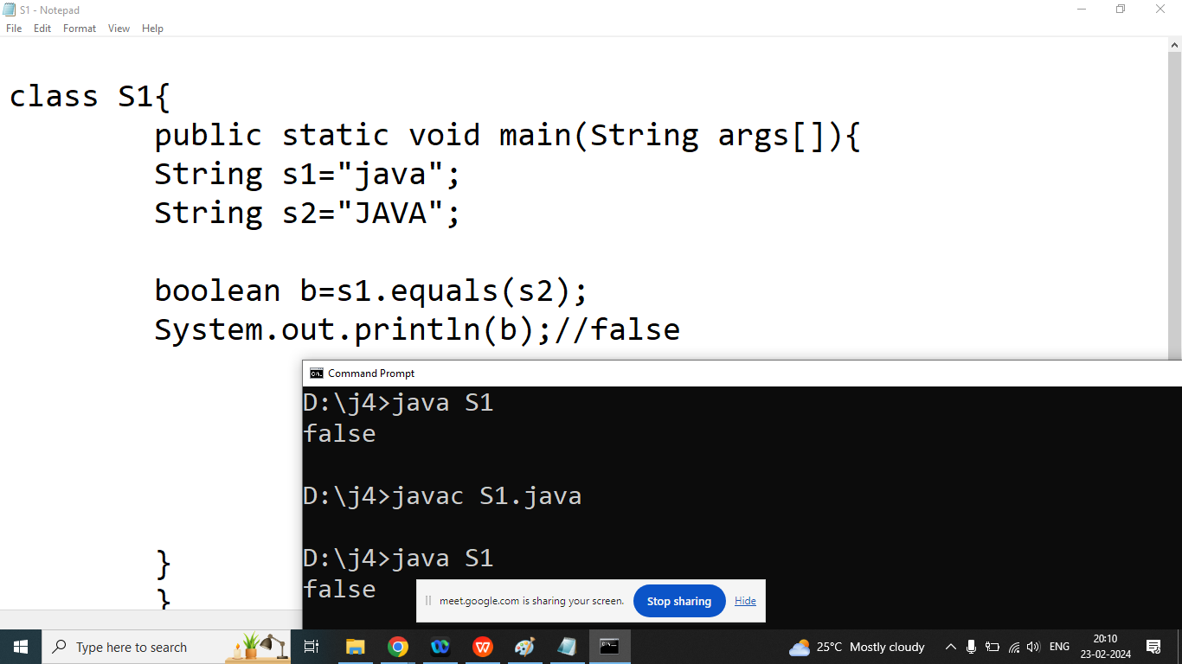

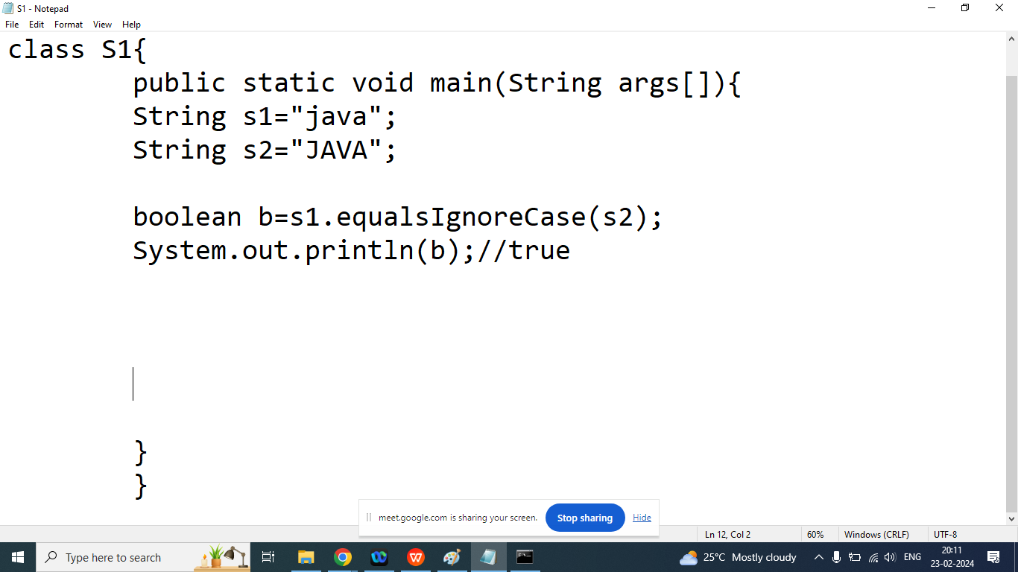

Q2. Explain String class indexOf() method in java programming?

Ans: Returns the position of the first found occurrence of specified characters in a String

It will return -1 if the given characters is not found in the String

Syntax:

int indexOf(String);

int indexOf(String,int position);

String s=”welcome”;

| w | e | l | c | o | m | e |
| --- | --- | --- | --- | --- | --- | --- |
| 0 | 1 | 2 | 3 | 4 | 5 | 6 |

int a=s.indexOf(“e”);

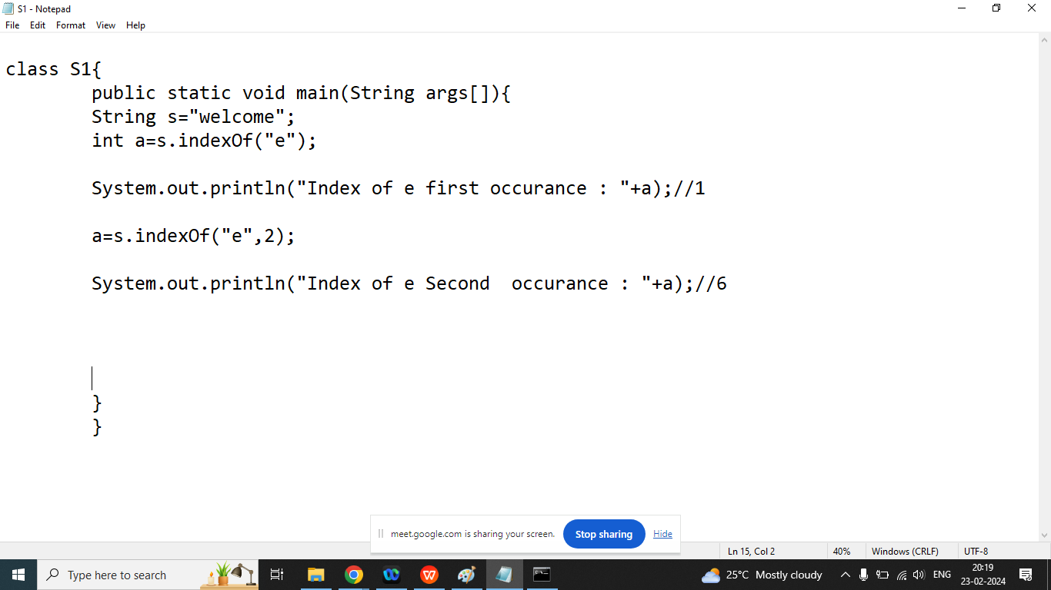

Q2. Explain String class lastIndexOf() method in java programming?

Ans: Returns the position of the last found occurrence of specified characters in a String

It will return -1 if the given characters is not found in the String

Syntax:

int lastIndexOf(String);

int lastIndexOf(String,int position);

String s=”welcome”;

| w | e | l | c | o | m | e |
| --- | --- | --- | --- | --- | --- | --- |
| 0 | 1 | 2 | 3 | 4 | 5 | 6 |

int a=s.lastIndexOf(“e”);

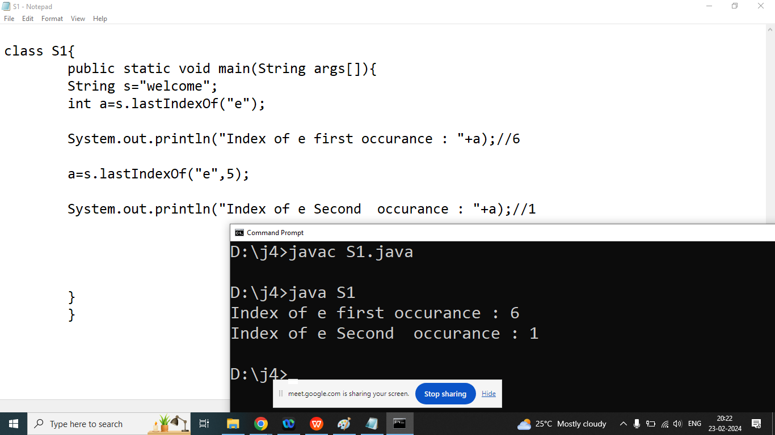

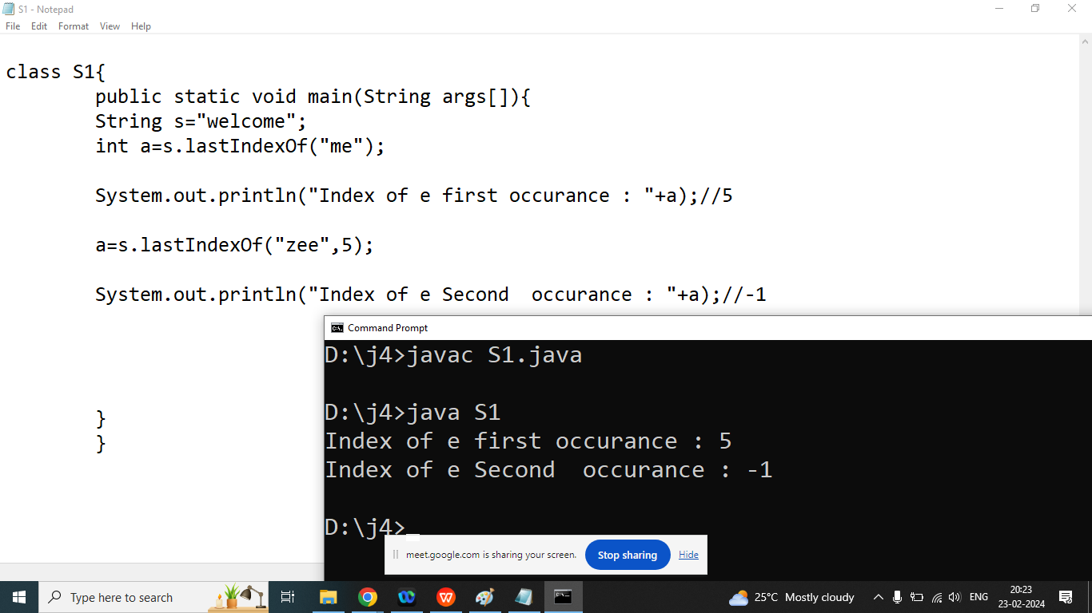

Q4.Explain String class isEmpty() method?

Ans: checks whether a String is Empty or not.

Syntax:

Boolean isEmpty()

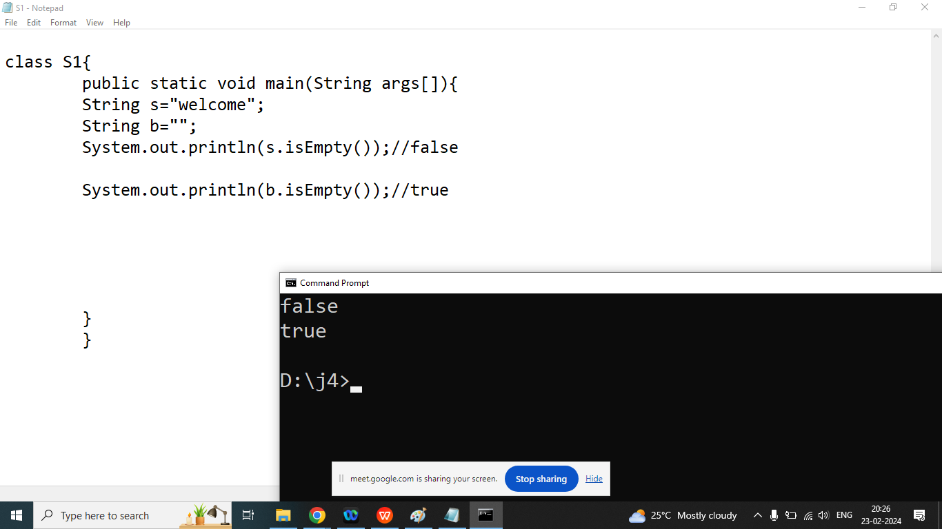

Q5. Explain String class length() in java programming?

Ans:

It is used to count number of characters in the given String include space or others.

Syntax:

int length()

String s=” wel come ”;

int a=s.length();

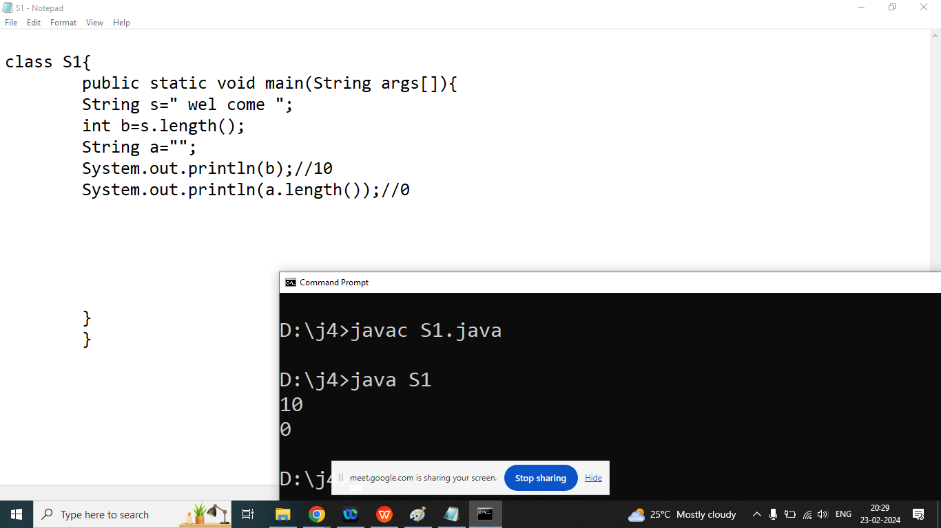

Q1. Explain String class replace() method in java programming?

Ans: Returns a new String where all old character replaced by new characters

Syntax:

String replace(char old, char new);

String replace(String old, String new);

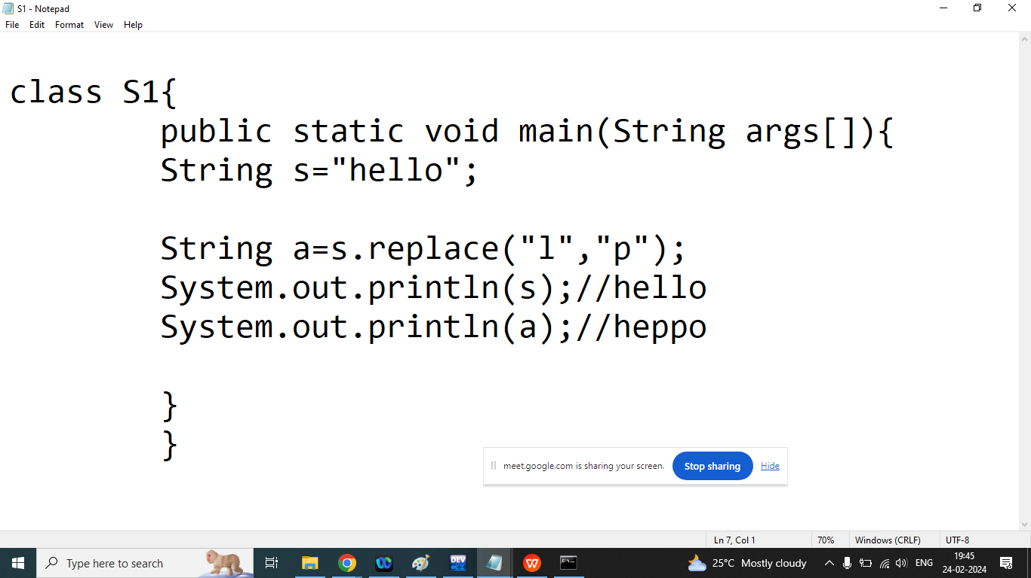

Q2. Explain String class split() method in java programming?

Ans:

A String is a sequence of characters and we want to retrieve or split string based on special character or regular expression then we should go for Split method

Syntax:

String [] split(separator)

Example:

String s=”Bhopal is a city of lake”;

String str[]=s.split(“ ”);

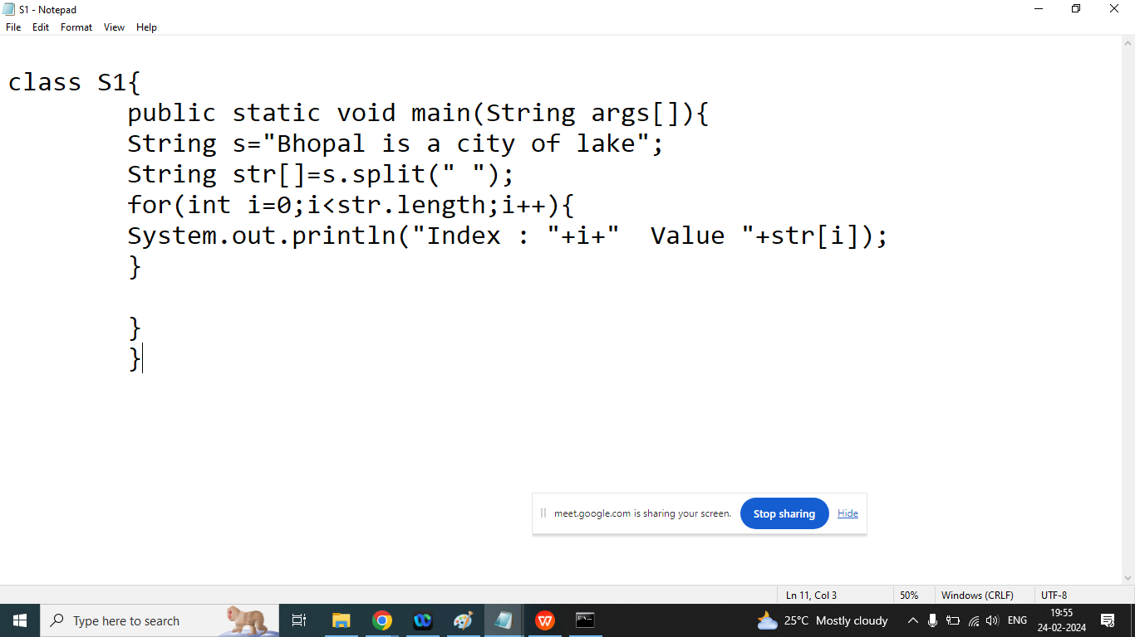

Q3. Write a java program to print character by character from the sentence

Enter String : WELCOME

W

E

L

C

O

M

E

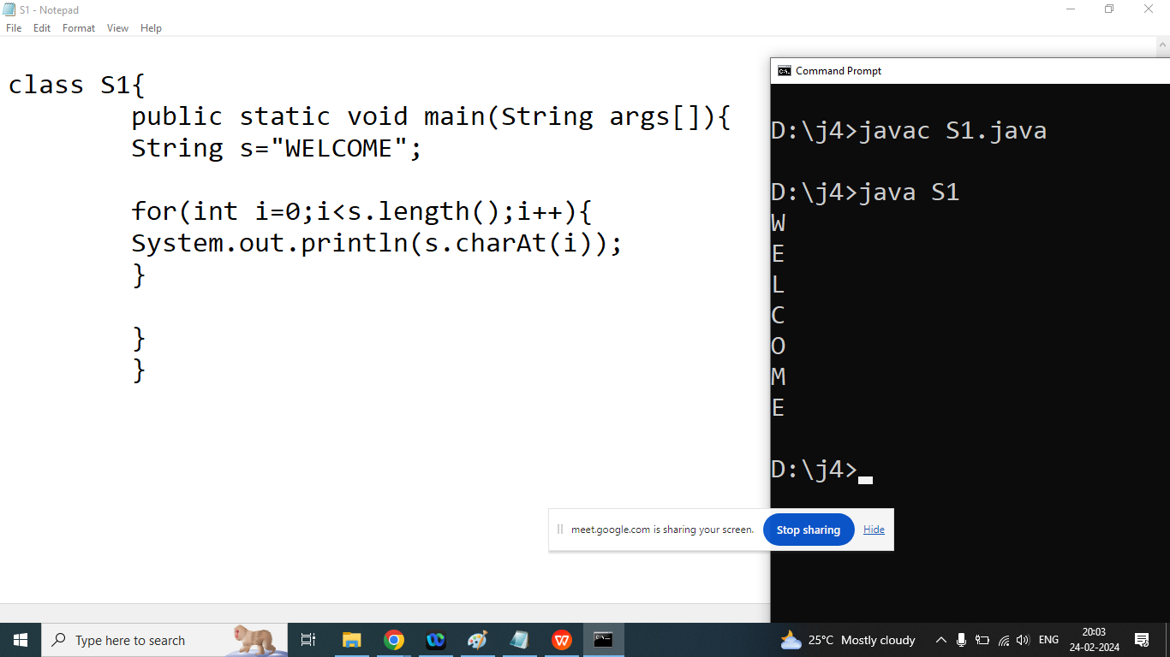

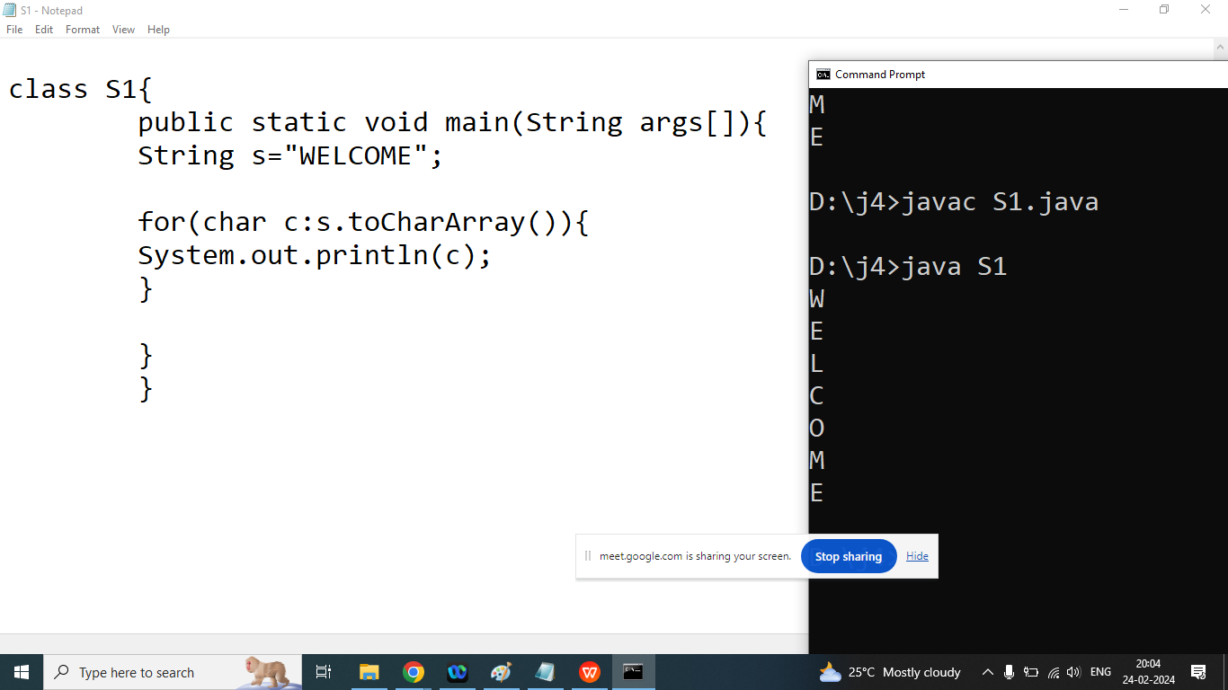

Q3. Explain String class toCharArray() method in java programming?

Ans:

It is used to convert String into character array in java programming

Syntax:

char [] toCharArray();

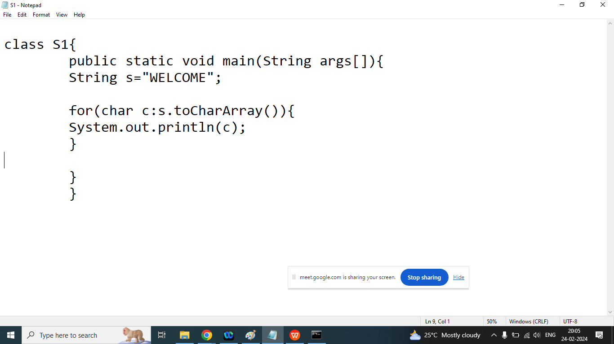

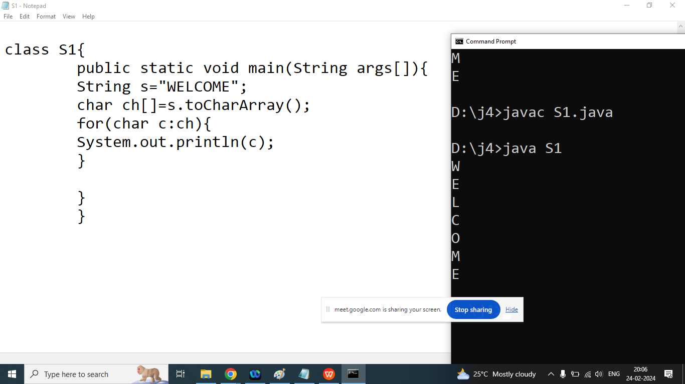

Q4. Explain substring() method in java programming?

Ans: It is used to extract a substring from the text or sentence

Syntax:

String substring(int start);

Note : start index always inclusive

String substring(int start,int end);

Note : start index always inclusive and end index always exclusive

Example:

String s=”weclome”;

String s1=s.substring(1);

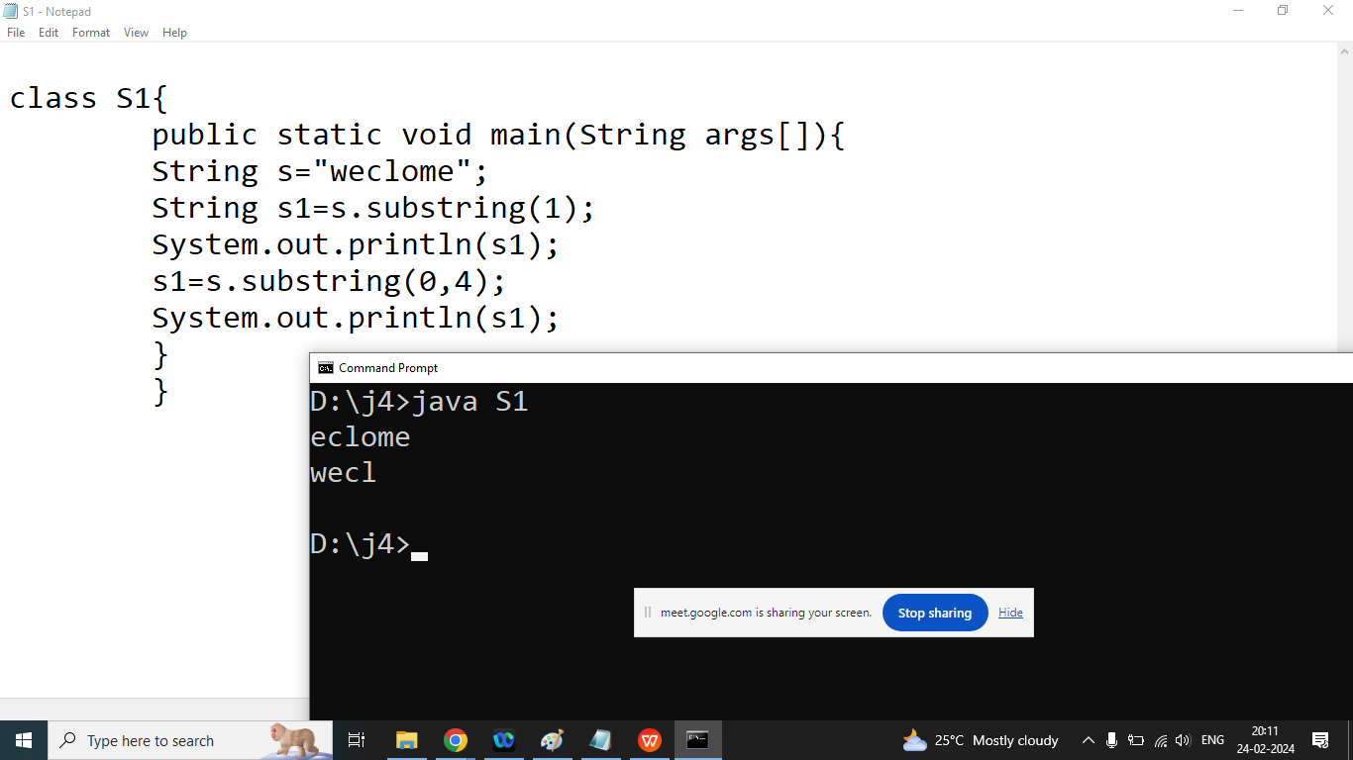

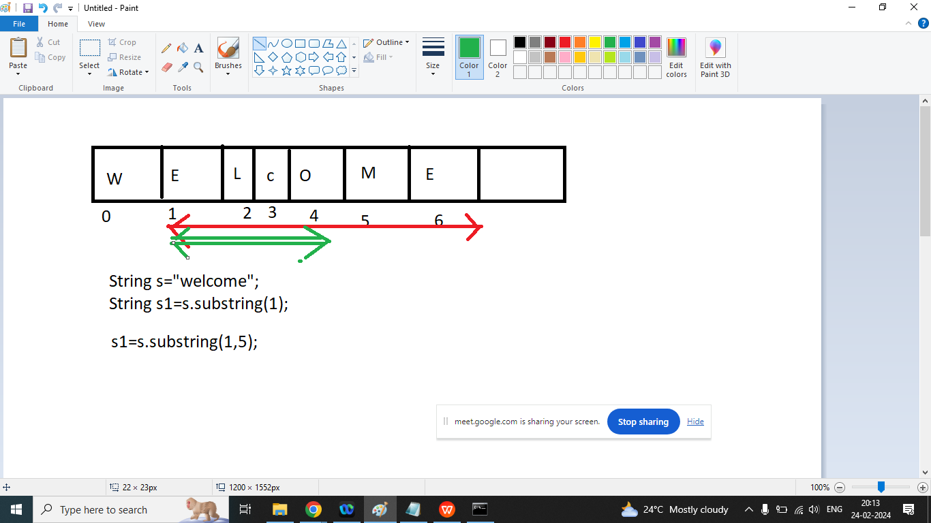

Q4. Explain String class toUpperCase() or toLowerCase();

Ans:

toUpperCase:

It is used to convert lowercase String into Uppercase

toLowerCase:

It is used to convert UpperCase String into LoweCase

Syntax:

String toUpperCase()

String toLowerCase()

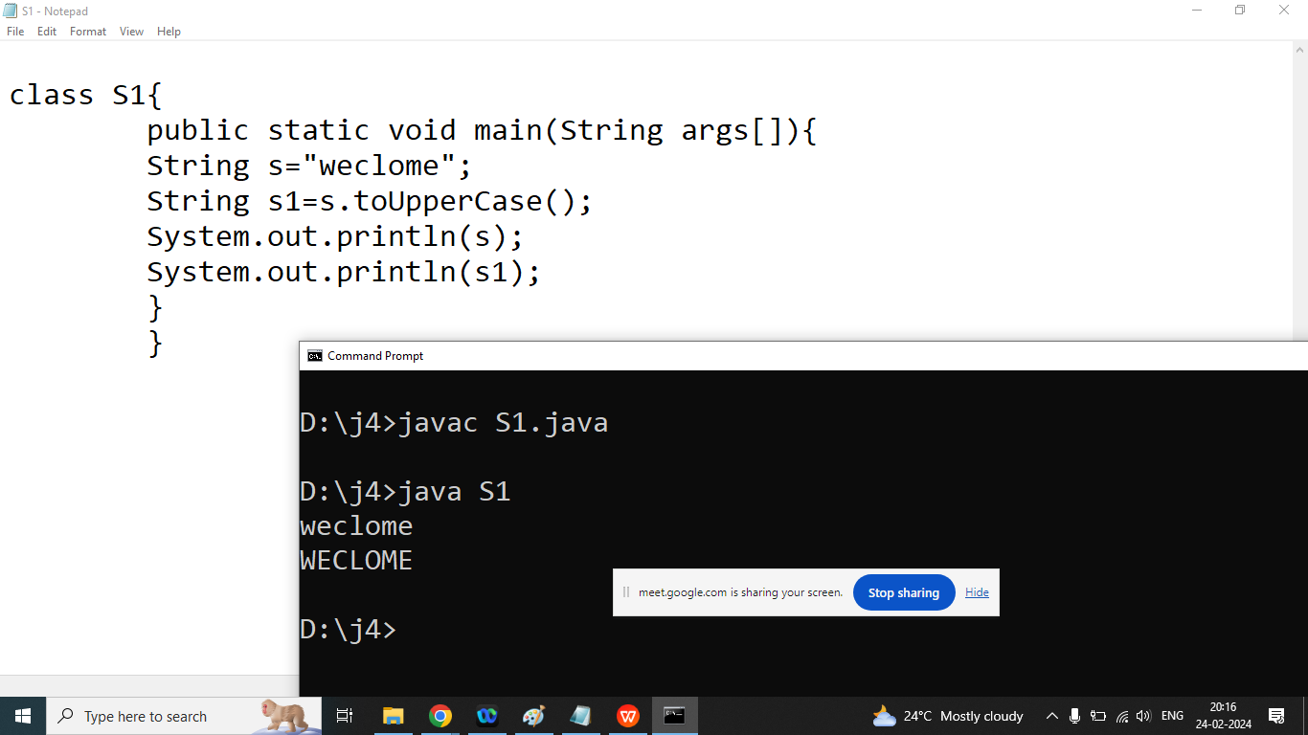

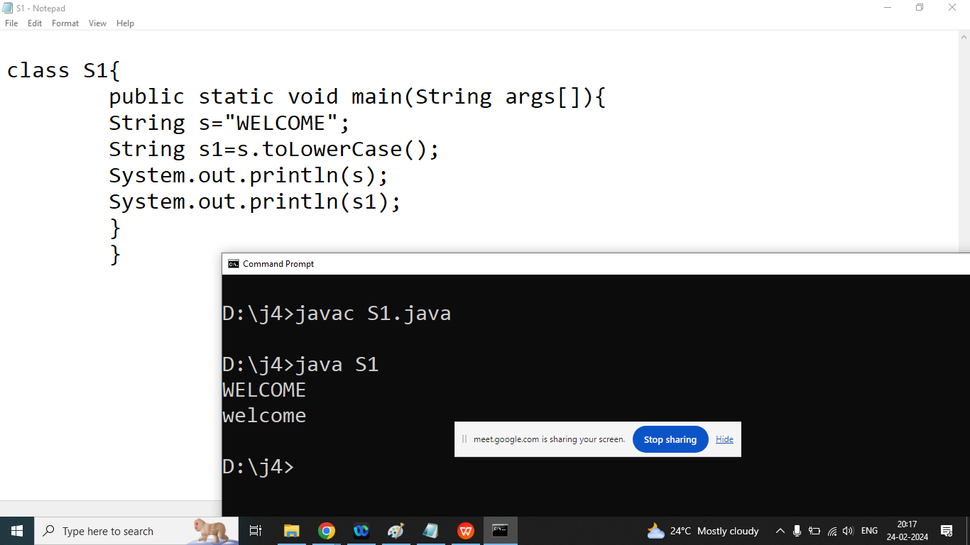

Q5.Explain String class trim() method in java programming?

Ans:

It is used to remove leading space and trailing space from the string.

String s=” Hello World ”;

|  |  | H | e | l | l | o |  |  | w | o | r | l | d |  |  |
| --- | --- | --- | --- | --- | --- | --- | --- | --- | --- | --- | --- | --- | --- | --- | --- |
| 0 | 1 | 2 | 3 | 4 | 5 | 6 | 7 | 8 | 9 | 10 | 11 | 12 | 13 | 14 | 15 |

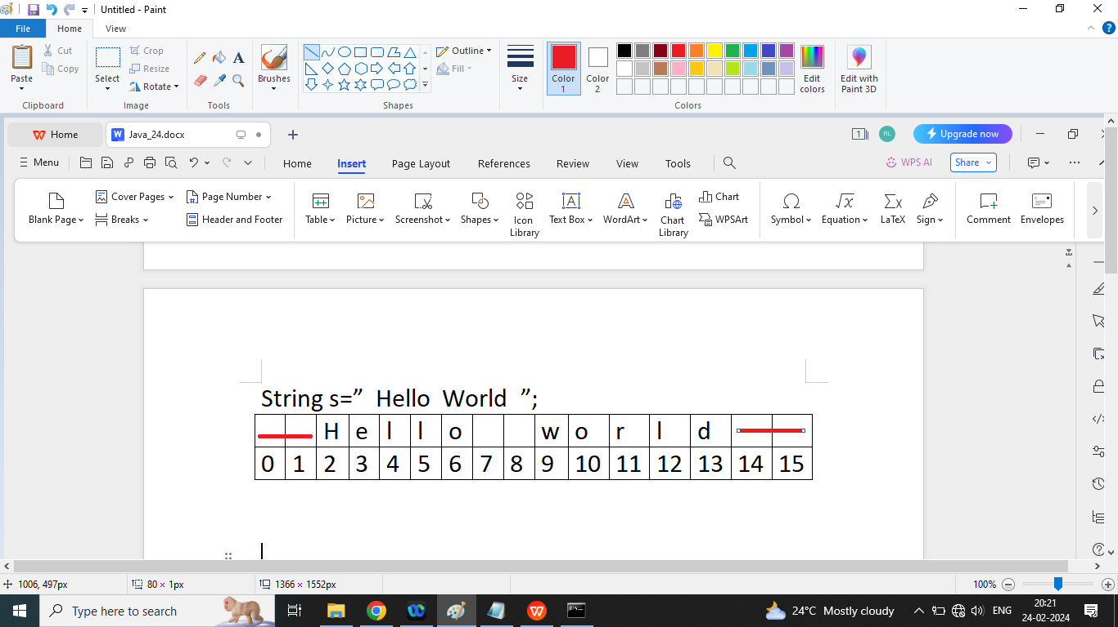

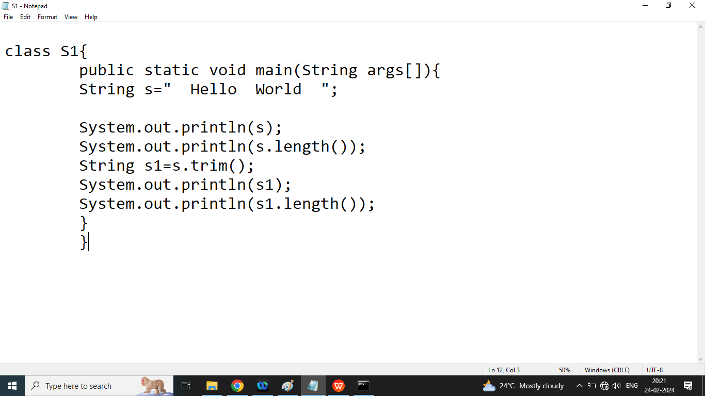

Q5. Explain String class valueOf() method in java?

Ans:

It is used to convert Any type to String object.

This is overloaded method

Syntax:

Static String valueOf(int)

Static String valueOf(float)

Static String valueOf(char)

Static String valueOf(double)

Static String valueOf(boolean)

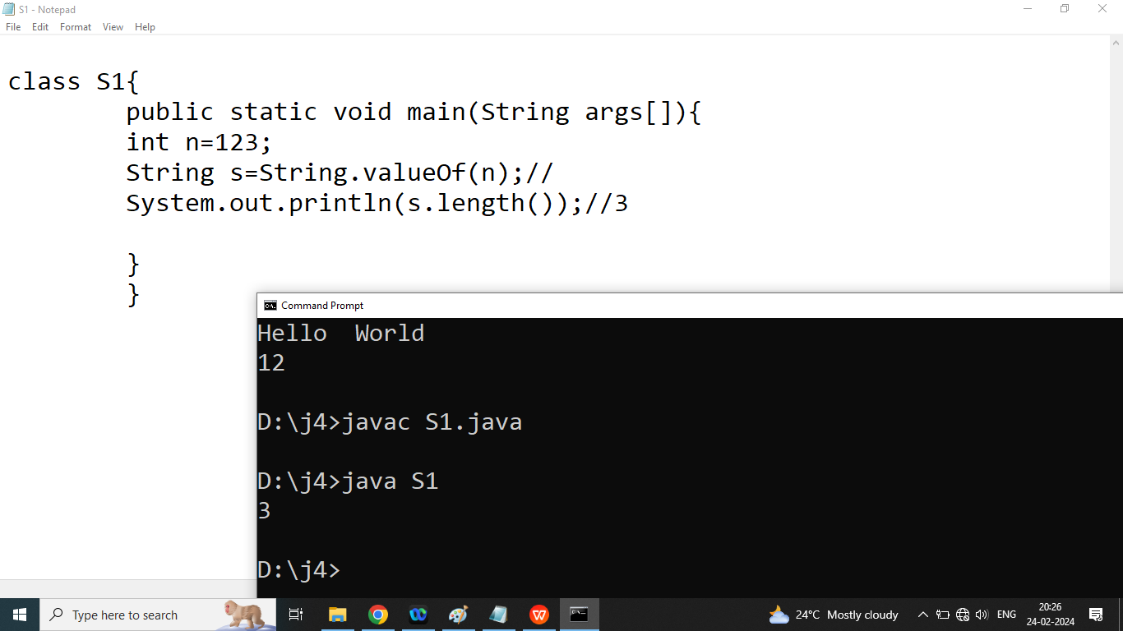

Q2. Explain toString() method in java?

Ans: It is used to convert any object to String

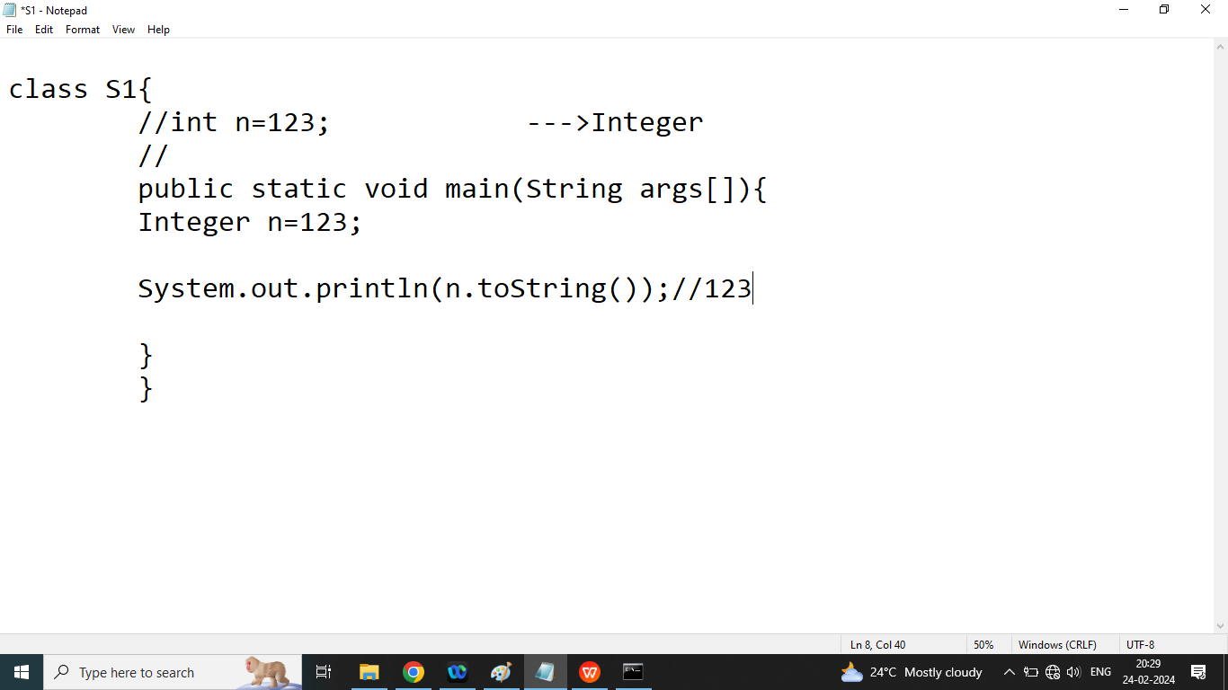

Q1. Explain StringBuffer class in java?

Ans:

String: Immutable

StringBuffer: Mutable(Synchronized)

If our content are not fixed and we want to perform modification and thread safety

Is required then we should go for StringBuffer

StringBuilder: Mutable(Not Synchronized)

If our content are not fixed and we want to perform modification and thread safety

Is not required then we should go for StringBuilder

Note:

1. All methods of StringBuffer is Synchronized by default
2. No method of StringBuilder are synchronized

StringBuffer:

* StringBuffer objects are mutable, meaning that you can change the contents of the buffer without creating a new object like String
* The initial capacity of StringBuffer is 16
* The append is used to add characters, String, float, double to the StringBuffer

Append method always add at the end of StringBuffer.

* The insert method is used to insert characters, String, integer, float, double
* The delete method is used to remove characters from the buffer
* The reverse method is used to reverse the order of characters in the buffer.

Q2. Explain StringBuffer class append method?

Ans:

It is used to add new item at the end of StringBuffer.

Syntax:

StringBuffer append(Integer i)

StringBuffer append(char i)

StringBuffer append(float i)

StringBuffer append(double i)

StringBuffer append(boolean i)

Example:

class S1{

public static void main(String args[]){

StringBuffer sb=new StringBuffer();

System.out.println(sb.capacity());

sb.append("This is String ");

sb.append(3.14);

sb.append('A');

sb.append(true);

System.out.println(sb);

System.out.println(sb.capacity());

// capacity=(current capacity + 1 )*2;

}

}

class S1{

public static void main(String args[]){

StringBuffer sb=new StringBuffer("Welcome");

System.out.println(sb.capacity());//23

//capacity of SB is Parameterized as String

// default capacity of SB + length of the String

}

}

class S1{

public static void main(String args[]){

StringBuilder sb=new StringBuilder(100);

System.out.println(sb.capacity());//100

//constructor with Specified Initial Capacity

}

}

Q3. Explain StringBuffer class insert method?

Ans: if we want to add new element at specific position then we should go for insert

Syntax:

insert(int index, data type element)

class S1{

public static void main(String args[]){

StringBuilder sb=new StringBuilder("to");

sb.insert(0,"welcome");

sb.insert(7,' ');

sb.insert(10," Bhopal");

System.out.println(sb);

}

}

Q4. Explain StringBuffer class deleteCharAt() method?

Ans: it is used to delete a specific character from the given String

Syntax:

deleteCharAt(int index);

class S1{

public static void main(String args[]){

StringBuilder sb=new StringBuilder("welcome");

System.out.println(sb);

sb.deleteCharAt(1);

System.out.println(sb);

}

}

class S1{

public static void main(String args[]){

StringBuilder sb=new StringBuilder("welcome");

System.out.println(sb);

sb.delete(1,3);

// delete(int start,int end-1)

System.out.println(sb);

}

}

Q4. Write a java program to delete alternate character from the String

class S1{

public static void main(String args[]){

StringBuilder sb=new StringBuilder("welcome to bhopal");

System.out.println(sb);

for(int i=0;i<sb.length();i=i+2){

sb.deleteCharAt(i);

}

System.out.println(sb);

}

}

Q4. Explain StringBuffer reverse() method?

Ans: It is used to reverse the string

Syntax:

reverse()

Write a java program to reverse String without using reverse method?

class S1{

public static void main(String args[]){

String s="Welcome";

//0123456

//reverse : emoclew

String res="";//emocleW

for(int i=s.length()-1;i>=0;i--){//i=6,5,4,3,2,1,0

char c=s.charAt(i);

res=res+c;

}

System.out.println(res);

System.out.println(s);

}

}

class S1{

public static void main(String args[]){

StringBuffer s=new StringBuffer("Welcome");

String s1=s.reverse().toString();

System.out.println(s);

System.out.println(s1);

}

}

Q3. Explain StringBuilder class in java programming?’

Ans:

StringBuilder is also mutable class

StringBuilder exactly same as StringBuffer except all methods of StringBuilder is Synchronized but no method of StringBuilder is Synchronized

String: if our content are fixed and we will not perform any changes then we should go for String class

String is immutable class

String is final class and we cannot extends String class

**StringBuffer:** if our content are not fixed and we want perform a changes and thread safety is required then we should go for StringBuffer class

Performance is slow as compare to StringBuilder

StringBuilder:

if our content are not fixed and we want perform a changes and thread safety is not required then we should go for StringBuilder class

Performance is fast as compare to StringBuffer

Next Topics:

OOPS

Class

Object

Member data

Member function

Access specifier

Constructor

Encapsulation

Inheritance

this

super

Polymorphism

Method overloading(compile time polymorphism)

Method Overriding(Run time polymorphism)

Abstraction

Final

Variable argument

Interface

Multiple inheritance through the interface

Note:

1. Java does not support operator overloading
2. Java Does not support friend function
3. Java does not support inline function
4. Java does not support const but in place of const we use final keyword
5. Java does not support pointer
6. Java does not support multiple inheritance through the class but we achieve this using interface
7. Java does not support destructor for release un-used memory internally garbage collector is used

Note: in java the default access specifier is

Default (it means it can access inside the folder)

Q1. Explain access specifier in java programming?

Ans: access specifier can specify the scope of class, interface, member data, member function.

There are 4 types of access specifier in java

1. private: It can access only inside the class.

Note: we use private access specifier for method, constructor, variable

We recommended private access specifier for the member data

In case of inheritance member data should not be private.

1. Public: It can access from anywhere

We can use public access specifier for class, interface, method,

Variable.

We recommended public access specifier for method, constructor, class

1. Protected: it can access inside the class or its child class and its package

It can be used with member data.

1. Default: if no access specifier then by default it is treated as default()

Means it can access inside package,class)

Class:

Member data

Member function

class Rectangle{

//instance variable memberdata--

//input()

//output()

//getArea()

//getPara()--🡪Methods/Member function

public static void main(String args[]){

int l;

int b;

//local variable

Input

Output

Calculate area

Calculate Parameter

}

}

Q1. Write a c++ program to compare two values

void CompareTwoValues(int a,int b){

}

void CompareTwoValues(float a,float b){

}

void CompareTwoValues(char a,char b){

}

Enter value 1 : 100

Enter Value 2: 400

Value 2 is Greater

Enter value 1 : 13.5

Enter Value 2: 11.56

Value 1 is Greater

//compare two values?

#include<iostream>

using namespace std;

int compare(int a,int b){

cout<<endl<<"Parameter with 2 int method is called";

return a>b?a:b;

}

float compare(float a,float b){

cout<<endl<<"Parameter with 2 float method is called";

return a>b?a:b;

}

char compare(char a,char b){

cout<<endl<<"Parameter with 2 character method is called";

return a>b?a:b;

}

int main(){

int i1,i2;

float f1,f2;

char c1,c2;

i1=100;

i2=400;

cout<<endl<<"Largest of two int variable value : "<<compare(i1,i2);

f1=13.5;

f2=11.5;

cout<<endl<<"Largest of two float variable value : "<<compare(f1,f2);

c1='a';

c2='z';

cout<<endl<<"Largest of two char variable value : "<<compare(c1,c2);

return 0;

}

================================

Enter value 1 : A

Enter Value 2: Z

Value 2 is Greater

=======================

//compare two values?

#include<iostream>

using namespace std;

template<class T>

T compare(T a,T b){

cout<<endl<<"This is genric Function work for all types";

return a>b?a:b;

}

int main(){

int i1,i2;

float f1,f2;

char c1,c2;

i1=100;

i2=400;

cout<<endl<<"Largest of two int variable value : "<<compare(i1,i2);

f1=13.5;

f2=11.5;

cout<<endl<<"Largest of two float variable value : "<<compare(f1,f2);

c1='a';

c2='z';

cout<<endl<<"Largest of two char variable value : "<<compare(c1,c2);

return 0;

}

==================================

//use of all_of method

#include<iostream>

#include<algorithm>

using namespace std;

int main(){

int ar[6]={10,20,30,40,50,-60};

//check if all elements are positive

all_of(ar,ar+6,[](int x){ return x>0;})?cout<<"All are positive":cout<<"All are not positive";

return 0;

}

=====================================================

//use of all_of method

#include<iostream>

#include<algorithm>

using namespace std;

int main(){

int ar[6]={10,20,30,40,50,60};

//check if all elements are positive

all_of(ar,ar+6,[](int x){ return x%2==0;})?cout<<"All are even":cout<<"All are not even";

return 0;

}

Q1. Explain class and object in the java programming?

Ans:

Purpose:

It is used to create a user defined data type in java programming

Definition:

Class is the collection of Member data/Instance variable /State

Class is a set Of Rules

Class is a blue print of an object

Member data can specify what types of data can be occur

Member function

Member function act mediator between user and data

Object: Object is an instance of a class

Object is a variable of a class

int num;

1. Constructor is automatically called when object created by new
2. In a class if we don’t write any constructor then compiler automatically add default constructor

Rectangle r=new Rectangle();

//default constructor is called

//Task of constructor

//1. Allocate memory of all member data

//2. Assign Some value to the instance variable

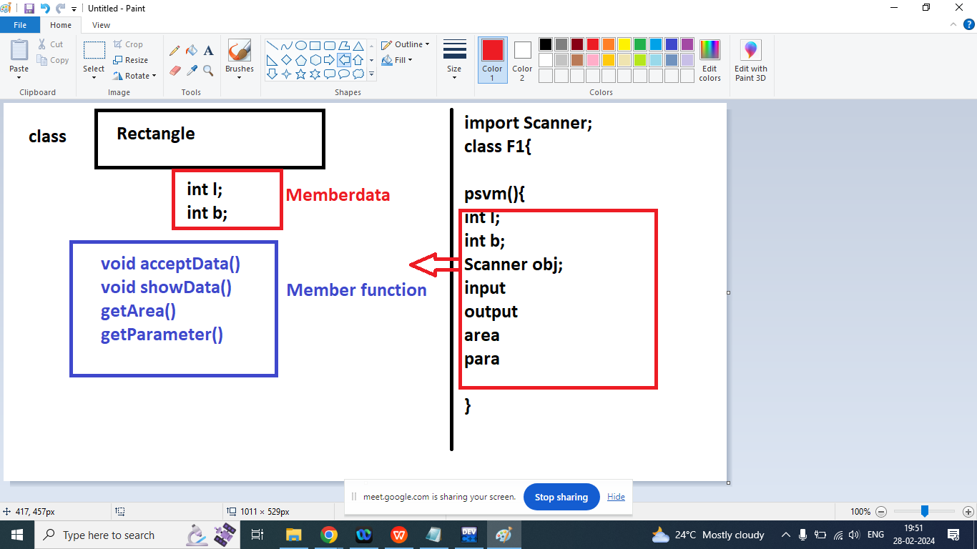

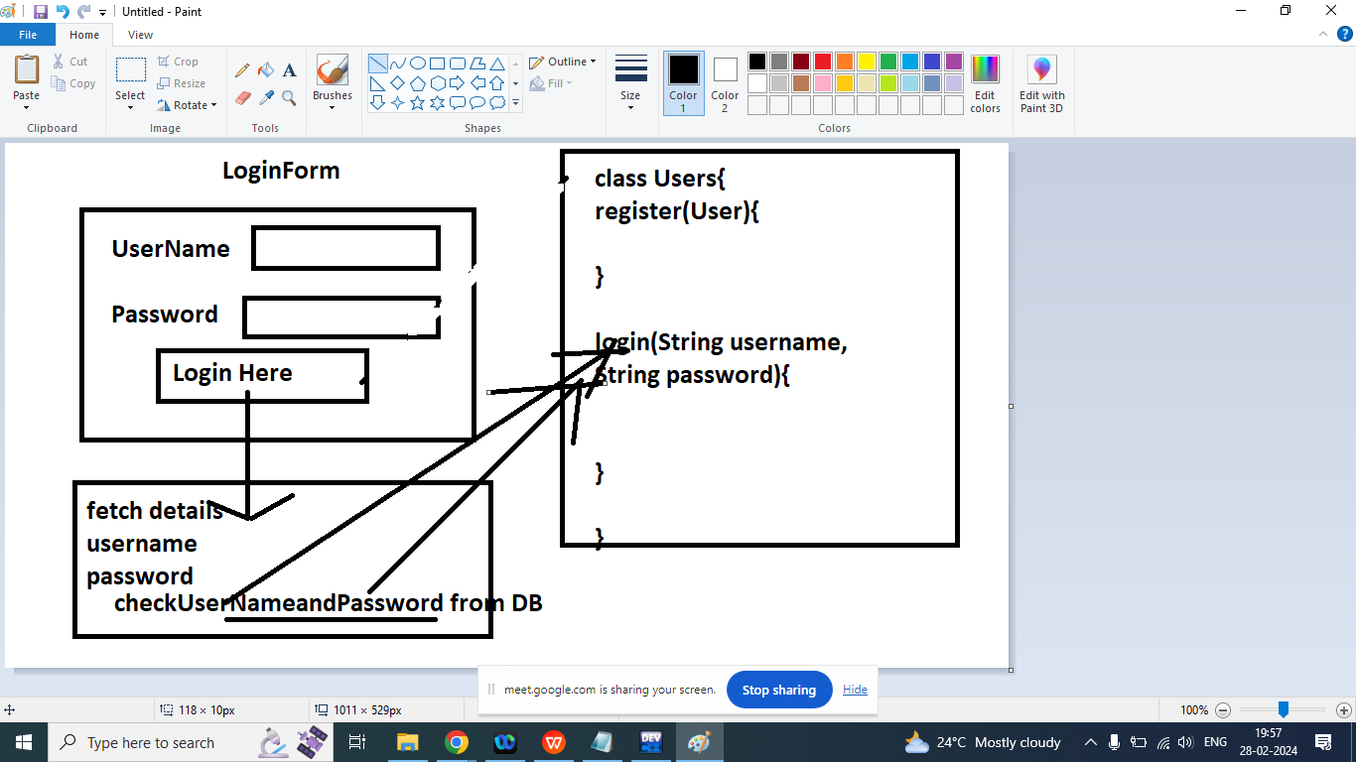

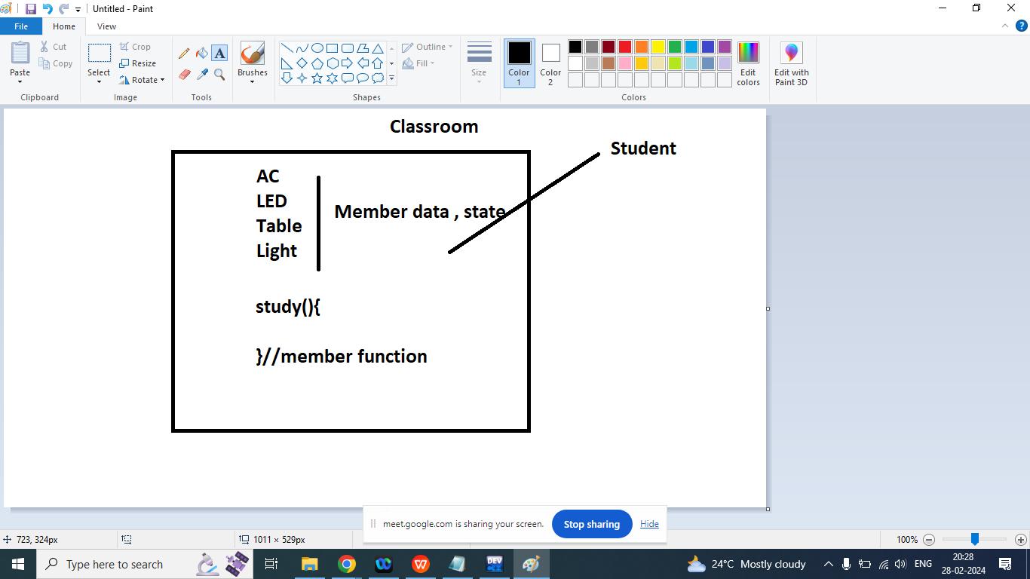

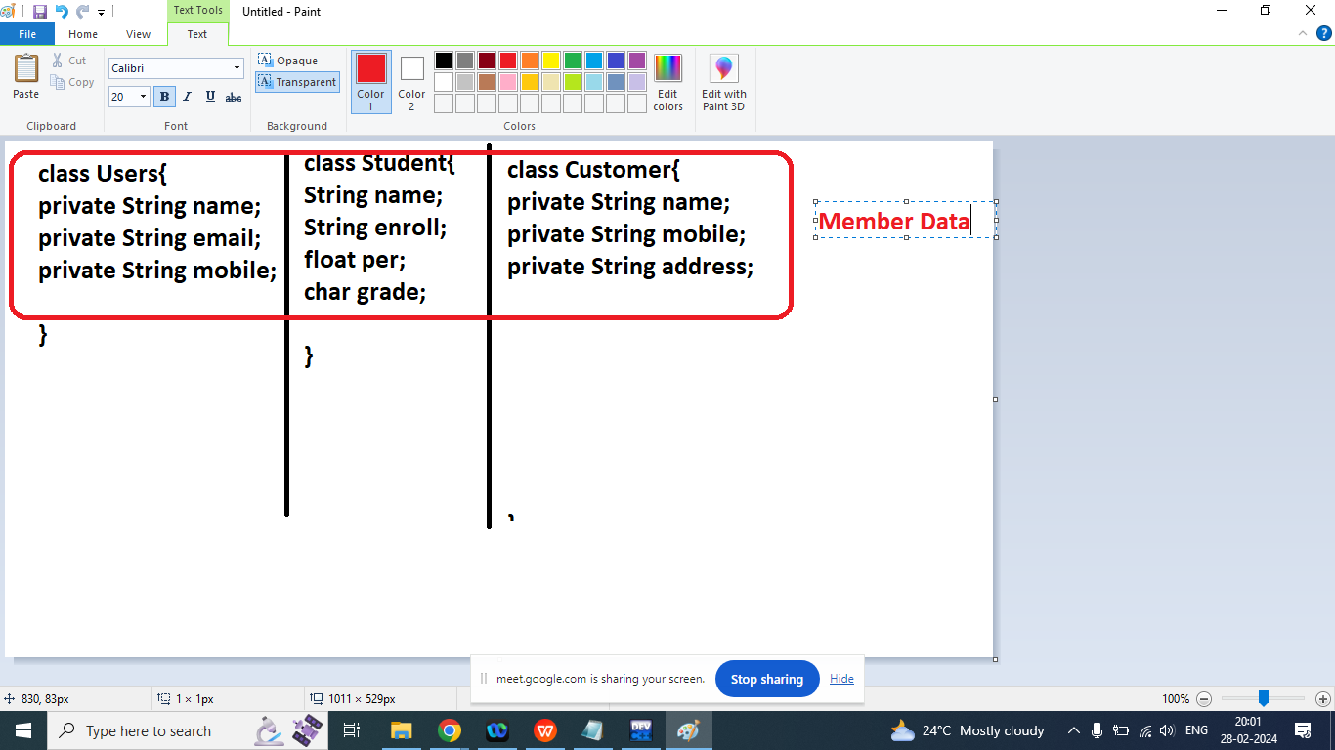

Q1. Explain class and Object with Example?

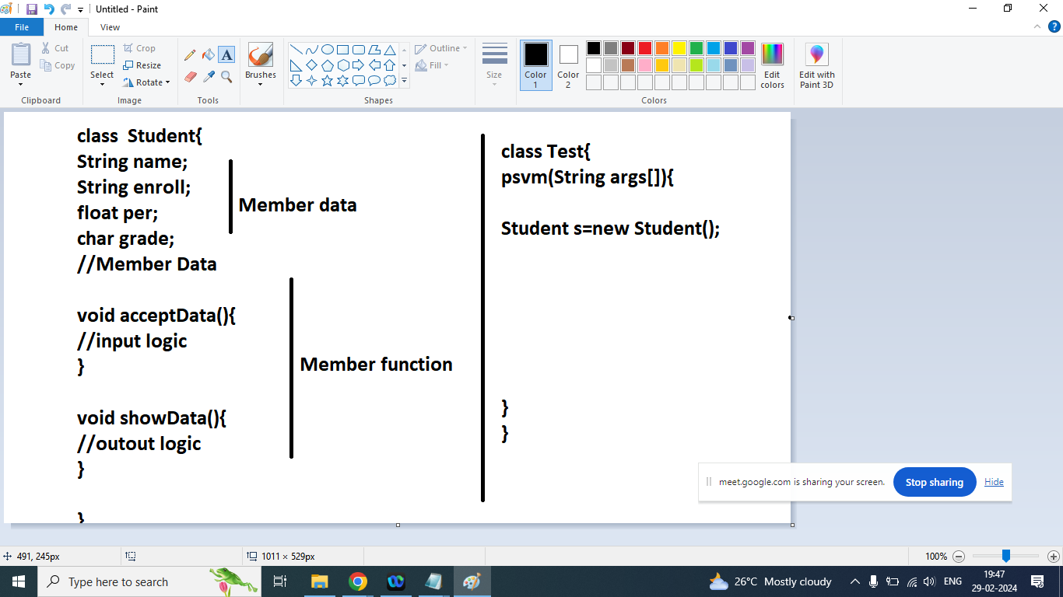

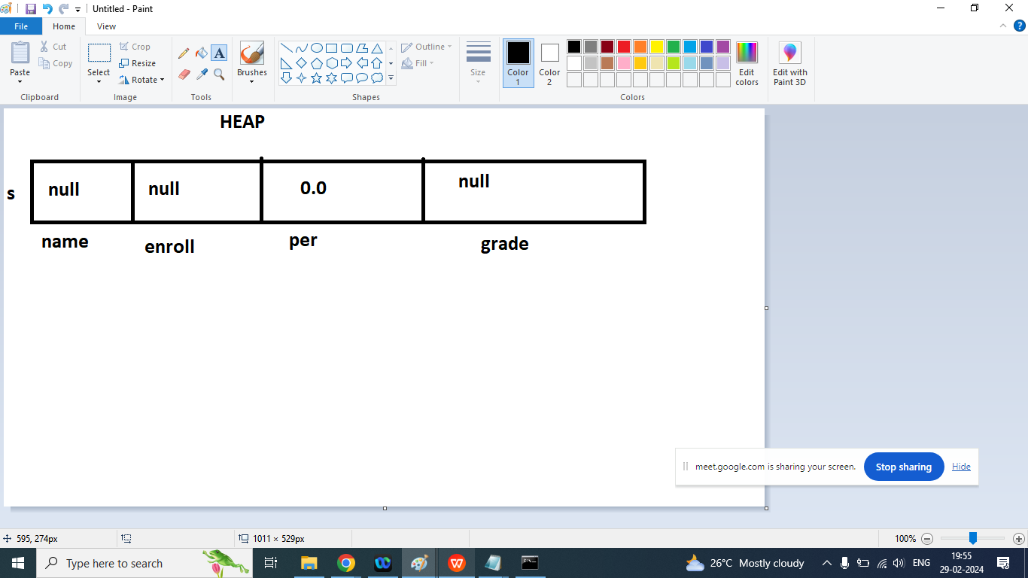

How to call methods of the class

ObjectName.methodName();

Student s=new Student();

s.showData();

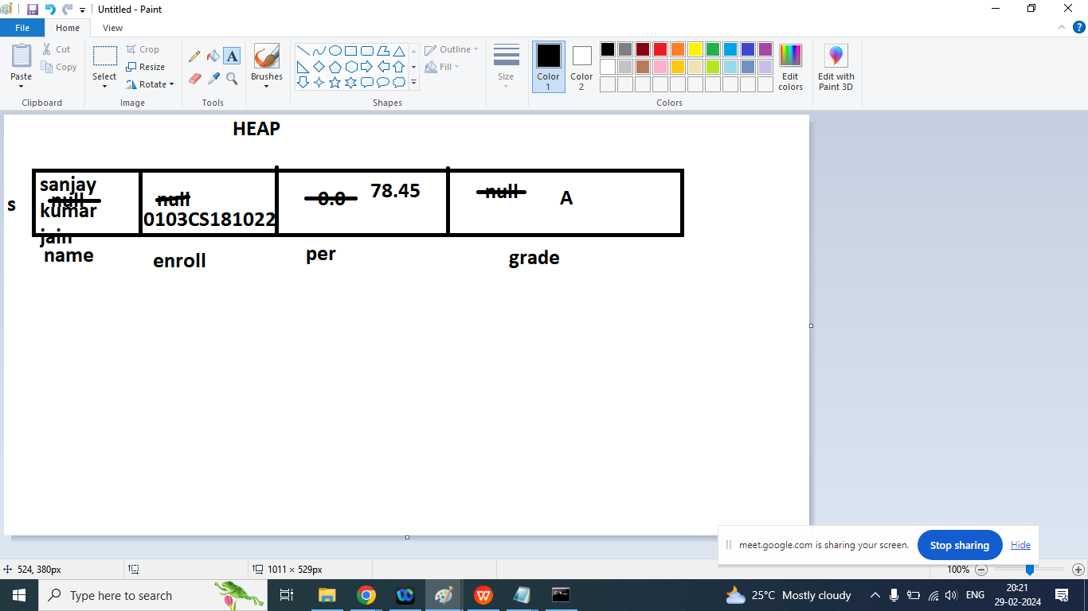

import java.util.Scanner;

class Rect{// class name should be noun

int l;

int b;

void getData(){

Scanner obj=new Scanner(System.in);

System.out.println("Enter Length : ");

l=obj.nextInt();

System.out.println("Enter Breadth : ");

b=obj.nextInt();

}

void showData(){

System.out.println("Length : "+l);

System.out.println("Breadth : "+b);

}

void getArea(){

System.out.println("Area : "+(l*b));

}

void getPira(){

System.out.println("Pirameter : "+2*(l+b));

}

public static void main(String args[]){

Rect r=new Rect();

r.getData();

r.showData();

r.getArea();

r.getPira();

}

}

—--------------------------------------------------------------------------------------

Q1. Fibonacci Series?

class Fibo{

public static void fib(int n){

int a=0,b=1,c=0;

System.out.print(a+" "+b);

for(int i=2;i<=n;i++){

c=a+b;

a=b;

b=c;

System.out.print(" "+c);

}

}

public static void main(String args[]){

fib(10);

}

}

package javadoubtsessionmarch1;

public class ArmstrongNumber {

public static boolean isArmstrong(int n){//153

int m=n;

int sum=0;

while(n!=0){//0

int r=n%10;//r=1

sum=sum+(r*r*r);//sum=153

n=n/10;

}

if(m==sum){

return true;

}

else{

return false;

}

}

public static void main(String[] args) {

System.out.println(""+isArmstrong(371));

}

}

/*

* To change this license header, choose License Headers in Project Properties.

* To change this template file, choose Tools | Templates

* and open the template in the editor.

*/

package javadoubtsessionmarch1;

/**

*

* @author Admin

*/

public class Convert1 {

public static void main(String[] args) {

char ch='a';

System.out.println(""+(char)(ch-32));

}

}

/*

* To change this license header, choose License Headers in Project Properties.

* To change this template file, choose Tools | Templates

* and open the template in the editor.

*/

package javadoubtsessionmarch1;

/**

*

* @author Admin

*/

public class FindNumberOfDays {

public static String findDays(int year,int month){

String days="";

switch(month){

case 1:

days="31";

break;

case 2:

if(year%4==0){

days="29";

}

else{

days="28";

}

break;

}

return year+" "+month+" Number of Days : "+days;

}

public static void main(String[] args) {

System.out.println(""+findDays(2024,2));

}

}

/*

* To change this license header, choose License Headers in Project Properties.

* To change this template file, choose Tools | Templates

* and open the template in the editor.

*/

package javadoubtsessionmarch1;

import java.util.Scanner;

public class GoldBatchNumberProgram {

public static boolean isPrime(int num) {

int count = 0;

for (int i = 2; i < num; i++) {

if (num % i == 0) {

count = 1;

}

}

if (count == 0) {

return true;

} else {

return false;

}

}

public static void main(String[] args) {

int N;

Scanner sk=new Scanner(System.in);

System.out.println("Enter Any Number : ");

N=sk.nextInt();//30

System.out.println("Prime Factors Are : ");

int a=3;

int b=0;//a=7

while(a<=N/2){//N=30,a=15

b=N-a;//b=17;

if(isPrime(a)&&isPrime(b)){

System.out.println("a : "+a+"\t b= "+b);

//a =7 b=23

// a=11 b=19

//a=13 b=17

}

a=a+2;

}

}

}

/*

* To change this license header, choose License Headers in Project Properties.

* To change this template file, choose Tools | Templates

* and open the template in the editor.

*/

package javadoubtsessionmarch1;

class HammingNumber {

public static boolean isHamming(int num) {//6

boolean b = true;

for (int i = 2; i <= num; i++) {//2...7..35

//only checks for numbers except 2,3,5

if (i != 2 && i != 3 && i != 5) {

if (num % i == 0 && isPrime(i)) {

//System.out.println("Prime Factor : " + i);

b = false;

break;

}

}

}

return b;

}

public static boolean isPrime(int num) {

int count = 0;

for (int i = 2; i < num; i++) {

if (num % i == 0) {

count = 1;

}

}

if (count == 0) {

return true;

} else {

return false;

}

}

public static void main(String args[]) {

int countHm=0;

int i=1;

while(countHm!=20){

if(isHamming(i)){

System.out.print("\t"+i);

countHm++;

}

i++;

}

}

}

/*

* To change this license header, choose License Headers in Project Properties.

* To change this template file, choose Tools | Templates

* and open the template in the editor.

*/

package javadoubtsessionmarch1;

/**

*

* @author Admin

*/

public class ISBN {

public static boolean isValidISBN(String str){

int sum=0;

int dNumber;

if(str.length()<10){

return false;

}

dNumber=10;

for(int i=0;i<str.length();i++){

char c=str.charAt(i);

int intNumber=Integer.parseInt(String.valueOf(c));

sum=sum+intNumber*dNumber;

dNumber--;

System.out.println(""+c);

}

if(sum%11==0){

return true;

}

return false;

}

public static void main(String[] args) {

String n="1259060977";

System.out.println(""+isValidISBN(n));

}

}

package javadoubtsessionmarch1;

import java.util.Scanner;

public class KeithNumberProgram {

public static boolean isKeith(int num){//197

boolean b;

int n1=num;//n1=19

String s=Integer.toString(n1);//s="197"

int d=s.length();//d=3

int arr[]=new int[n1];

int i;

for(i=d-1;i>=0;i--){//2,1,0,-1

arr[i]=n1%10;

n1=n1/10;

}

int sum=0;

i=d;//3//i=

while(sum<num){

sum=0;

for(int j=1;j<=d;j++){//j=3,i=7

sum=sum+arr[i-j];//sum=sum+arr[4]; sum=164+33=197

}

arr[i]=sum;

i++;

}

if(num==sum){

System.out.println("This is Keith Number ");

b=true;

}

else{

System.out.println("This is not a Keith Number ");

b=false;

}

return b;

}

public static void main(String[] args) {

int n;

Scanner sk=new Scanner(System.in);

System.out.println("Enter Any Number : ");

n=sk.nextInt();

System.out.println(""+isKeith(n));

}

}

/*

* To change this license header, choose License Headers in Project Properties.

* To change this template file, choose Tools | Templates

* and open the template in the editor.

*/

package javadoubtsessionmarch1;

/**

*

* @author Admin

*/

public class NthPrimeNumber {

public static boolean isPrime(int num){

int count=0;

for(int i=1;i<=num;i++){

if(num%i==0){

count++;

}

}

if(count==2){

return true;

}else{

return false;

}

}

public static void main(String[] args) {

int arr[]=new int[40];

int j=0;

for (int i = 2; i < 40; i++) {

if(isPrime(i)){

arr[j]=i;

j++;

}

}

for(int i=0;i<arr.length;i=i+2){

if(arr[i]!=0){

System.out.print("\t"+arr[i]);

}

}

}

}

package javadoubtsessionmarch1;

public class SmithNumber {

public static int calculateSum(int n){

int sum=0;

while(n!=0){//0

int r=n%10;//r=1

sum=sum+r;

n=n/10;

}

return sum;

}

public static boolean isPrime(int num) {

int count = 0;

for (int i = 2; i < num; i++) {

if (num % i == 0) {

count = 1;

}

}

if (count == 0) {

return true;

} else {

return false;

}

}

public static boolean checkSmith(int n){//17

int sum=0;

if(isPrime(n)){

System.out.println("This is not a smith Number");

}

else{

int num=n;

for(int i=2;i<=num;i++){

if(isPrime(i)==true){

if(num%i==0){

sum=sum+calculateSum(i);

num=num/i;

i=1;

}

}

}

if(sum==calculateSum(n)){

System.out.println("This is Smith Number");

return true;

}else{

System.out.println("This is not a Smith Number");

}

}

return false;

}

public static void main(String[] args) {

System.out.println(""+checkSmith(119));

}

}

Q1. Write a java program to create a class Product?

Ans:

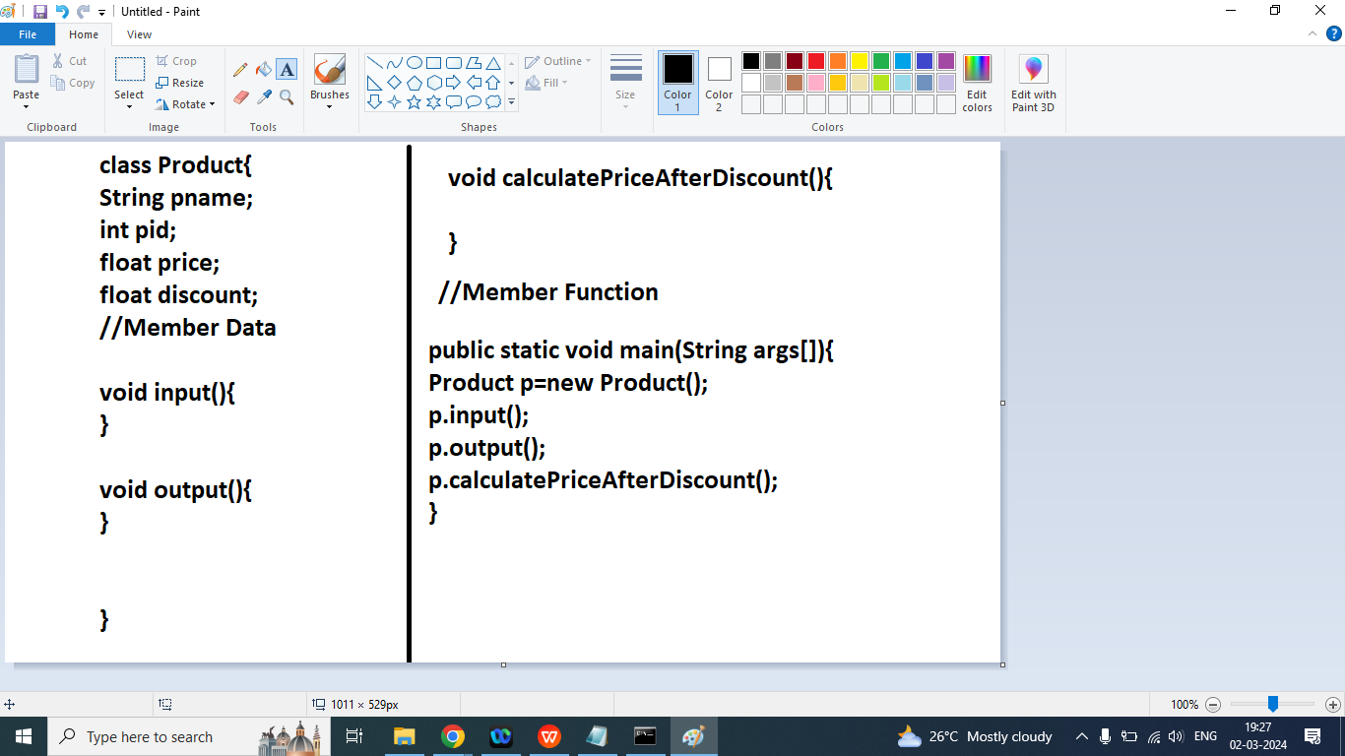

import java.util.Scanner;

class Product{

String pname;

int pid;

float price;

float discount;

//Member Data

void input(){

Scanner sk=new Scanner(System.in);

System.out.println("Enter Product Name : ");

pname=sk.nextLine();

System.out.println("Enter Product ID : ");

pid=sk.nextInt();

System.out.println("Enter Product Price : ");

price=sk.nextFloat();

System.out.println("Enter Discount Percentage : ");

discount=sk.nextFloat();

}

void output(){

System.out.println("Product Name : "+pname);

System.out.println("Product ID : "+pid);

System.out.println("Product Price without Discount: "+price);

System.out.println("Product Discount Percentage : "+discount);

}

void calculatePriceAfterDiscount(){

price=price-(price*discount/100);

System.out.println("Price after Discount : "+price);

}

public static void main(String args[]){

Product p=new Product();

p.input();

p.output();

p.calculatePriceAfterDiscount();

}

}

Homework

1.

class Circle{

}

class Student{

String name;

String enrollment;

Int m;

Int p;

Int c;

Int e;

Int h;

void acceptData(){}

void showData(){}

int getTotalMarks(){}

float getTotalPercentage(){}

int getDivision(){}

}

class Employee{

String name;

String empcode;

float sal;

Int deptno;

void getData(){

}

void showData(){

}

float getHRA(){}

float getDA(){}

float getTA(){}

Float getTotalncetive(){}

Float grossSalary(){

return sal+getTotalIncentive();

}

}

}

Q1. Vector Example

/******************************************************************************

Online C++ Compiler.

Code, Compile, Run and Debug C++ program online.

Write your code in this editor and press "Run" button to compile and execute it.

*******************************************************************************/

#include <iostream>

#include<vector>

using namespace std;

int main()

{

vector<int> v;

for(int i=10;i<=100;i=i+10){

v.push_back(i);

}

for(int i=0;i<v.size();i++){

cout<<"\t"<<v[i];

}

cout<<"\nUsing For Each : "<<endl;

for(int x:v){

cout<<"\t"<<x;

}

cout<<"\nUsing Iterator forward direction : "<<endl;

for(auto x=v.begin();x<v.end();x++){

cout<<"\t"<<*x;

}

cout<<"\nUsing Iterator Backward direction : "<<endl;

for(auto x=v.rbegin();x<v.rend();x++){

cout<<"\t"<<*x;

}

return 0;

}

/******************************************************************************

Online C++ Compiler.

Code, Compile, Run and Debug C++ program online.

Write your code in this editor and press "Run" button to compile and execute it.

*******************************************************************************/

#include <iostream>

#include<vector>

using namespace std;

int main()

{

vector<string> v{"Akash","Deepak","Shivam","Aman"};

for(string x:v){

cout<<"\t"<<x;

}

cout<<"\nTraverse Vector data using iterator : \n";

for(auto i=v.begin();i<v.end();i++){

cout<<"\t"<<*i;

}

cout<<"\nTraverse Using Iterator : \n";

vector<string>::const_reverse_iterator itr=v.crend()-1;

cout<<*itr;

return 0;

}

JAVA

Q1.Explain Constructor in java programming?

Ans:

Constructor is a special member function in a class it is used to initialized a user defined data type

Constructor is automatically called when object created by new.

Note: Java does not support a copy constructor

Rules of Constructor

1. Class Name and constructor must be name.
2. Constructor does not have any return type even void.
3. A class can have more than one constructor it means we can overload the constructor
4. Compiler automatically add default constructor in your program if you does not write any constructor in program.
5. Constructor initialize a member data by its default value of a data type.

Default vale:

int : 0

Long: 0

float : 0.0

Double: 0.0

String: null

Object: null

Boolean: false

Character: space

Types of Constructor:

1. Default constructor: It does not take any parameter:

Syntax:

class ClassName{

public ClassName(){

//body

}

}

1. Parameterized Constructor: It takes a Parameter

Syntax:

class ClassName{

public ClassName(Parameter pm){

//body

}

}

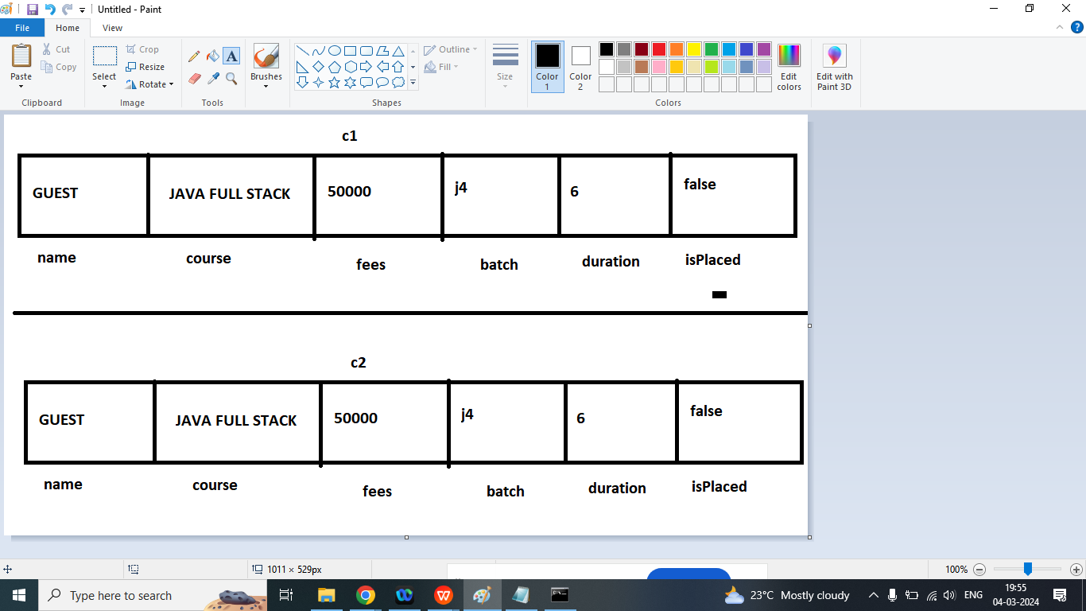

class Cybrom{

String name;

String course;

float fees;

String batch;

int duration;

boolean isPlaced;

//Member data

Cybrom(){

System.out.println("Default constructor is Called");

name="GUEST";

course="JAVA FULL STACK";

fees=50000f;

batch="J4";

duration=6;

isPlaced=false;

}

void showData(){

System.out.println("Name : "+name);

System.out.println("Course : "+course);

System.out.println("Fees : "+fees);

System.out.println("Batch : "+batch);

System.out.println("Duration : "+duration);

System.out.println("IsPlaced : "+isPlaced);

}

public static void main(String args[]){

Cybrom c1=new Cybrom();

Cybrom c2=new Cybrom();

System.out.println("This is c1 Object data");

c1.showData();

System.out.println("This is c2 Object data");

c2.showData();

}

}

Example: Parameterized constructor

class Cybrom{

String name;

String course;

float fees;

String batch;

int duration;

boolean isPlaced;

//Member data

Cybrom(){

System.out.println("Default constructor is Called");

name="GUEST";

course="JAVA FULL STACK";

fees=50000f;

batch="J4";

duration=6;

isPlaced=false;

}

Cybrom(String n,String c,float f,String b,int d,boolean b1){

System.out.println("Parameterized constructor is Called");

name=n;

course=c;

fees=f;

batch=b;

duration=d;

isPlaced=b1;

}

void showData(){

System.out.println("Name : "+name);

System.out.println("Course : "+course);

System.out.println("Fees : "+fees);

System.out.println("Batch : "+batch);

System.out.println("Duration : "+duration);

System.out.println("IsPlaced : "+isPlaced);

}

public static void main(String args[]){

Cybrom c1=new Cybrom("Ram","JAVA FUll STACK",45600,"J4",6,false);

Cybrom c2=new Cybrom();

System.out.println("This is c1 Object data");

c1.showData();

System.out.println("This is c2 Object data");

c2.showData();

}

}

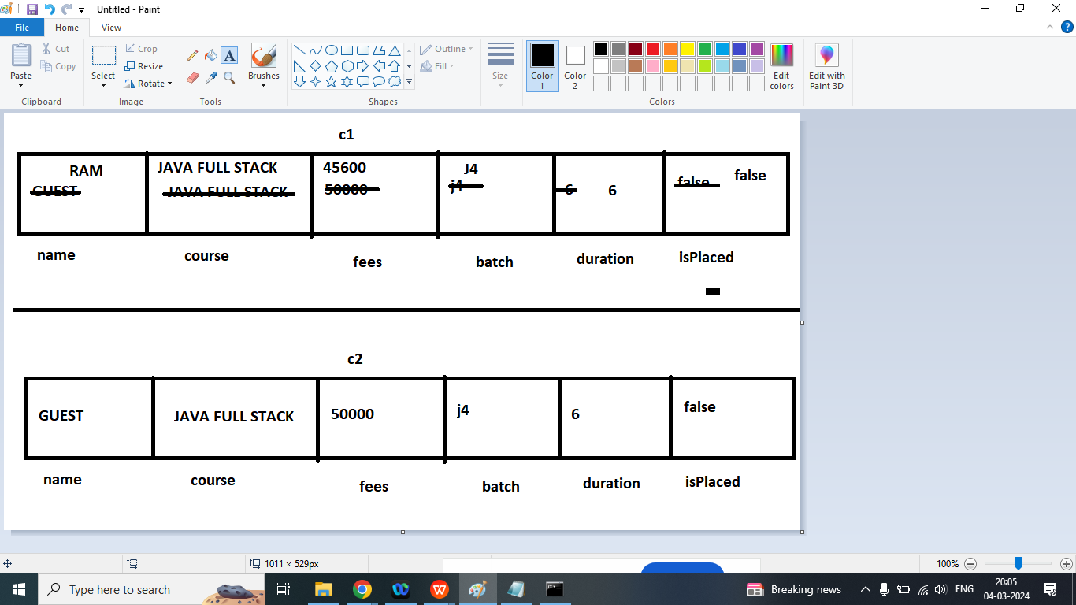

Q1. Write a java program to create a Student class with default and parameterized constructor

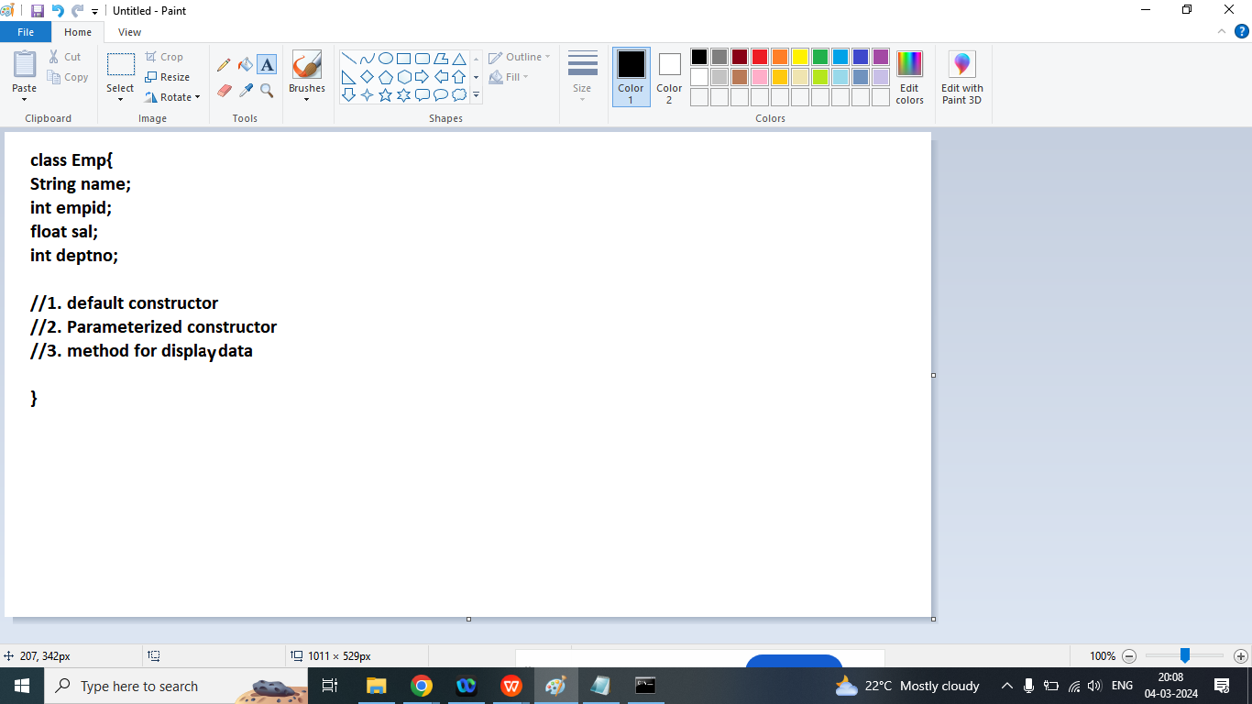

Q1. Explain this keyword in java programming?

Ans:

The this keyword refers to the current object in a method or constructor.

The most common use of this keyword is to eliminate the confusion between class attribute and parameters with the same name.

We use this keyword

name=name;

//Local variable=Instance variable

//Instance variable=local variable

class Cybrom{

String name;

String course;

float fees;

String batch;

int duration;

boolean isPlaced;

//Member data

Cybrom(){

System.out.println("Default constructor is Called");

name="GUEST";

course="JAVA FULL STACK";

fees=50000f;

batch="J4";

duration=6;

isPlaced=false;

}

Cybrom(String name,String course,float fees,String batch,int duration,boolean isPlaced){

System.out.println("Parameterized constructor is Called");

this.name=name;

this.course=course;

this.fees=fees;

this.batch=batch;

this.duration=duration;

this.isPlaced=isPlaced;

}

void showData(){

System.out.println("Name : "+name);

System.out.println("Course : "+course);

System.out.println("Fees : "+fees);

System.out.println("Batch : "+batch);

System.out.println("Duration : "+duration);

System.out.println("IsPlaced : "+isPlaced);

}

public static void main(String args[]){

Cybrom c1=new Cybrom("Ram","JAVA FUll STACK",45600,"J4",6,false);

Cybrom c2=new Cybrom();

System.out.println("This is c1 Object data");

c1.showData();

System.out.println("This is c2 Object data");

c2.showData();

}

}

Others uses of this:

1. this keyword is also used to call current class constructor

Example:

this();//to call default constructor

this(name,course,batch,fees);//to call Parameterized constructor

1. To call current class method

this.methodName();

Note: this statement must be written in first line

class Cybrom{

String name;

String course;

float fees;

String batch;

int duration;

boolean isPlaced;

//Member data

public Cybrom(){

System.out.println("Default constructor is Called");

name="GUEST";

course="JAVA FULL STACK";

fees=50000f;

batch="J4";

duration=6;

isPlaced=false;

}

public Cybrom(String name,String course,float fees,String batch,int duration,boolean isPlaced){

// this();//to call default constructor

System.out.println("Parameterized constructor is Called");

this.name=name;

this.course=course;

this.fees=fees;

this.batch=batch;

this.duration=duration;

this.isPlaced=isPlaced;

}

void showData(){

System.out.println("Name : "+name);

System.out.println("Course : "+course);

System.out.println("Fees : "+fees);

System.out.println("Batch : "+batch);

System.out.println("Duration : "+duration);

System.out.println("IsPlaced : "+isPlaced);

}

void abc(){

this.showData();//call current class method

}

public static void main(String args[]){

Cybrom c1=new Cybrom("Ram","JAVA FUll STACK",45600,"J4",6,false);

Cybrom c2=new Cybrom();

System.out.println("This is c1 Object data");

c1.abc();

System.out.println("This is c2 Object data");

c2.showData();

}

}

#include<set>

#include<iostream>

using namespace std;

int main(){

set<string> g1={"A","Z","B","Y","C","c"};

cout<<endl<<"Print Set Data : \n";

for(string x:g1){

cout<<"\t"<<x;

}

return 0;

}

=====================================

//sort data in descending order

#include<set>

#include<iostream>

using namespace std;

int main(){

set<string,greater<string>> g1={"A","Z","B","Y","C","c"};

cout<<endl<<"Print Set Data : \n";

for(string x:g1){

cout<<"\t"<<x;

}

return 0;

}

=====================================

Example: Count :

#include<set>

#include<iostream>

using namespace std;

int main(){

set<string,greater<string>> g1={"A","Z","B","Y","C","c"};

cout<<endl<<"Print Set Data : \n";

for(string x:g1){

cout<<"\t"<<x;

}

cout<<endl<<"Count a : "<<g1.count("a");

return 0;

}

=============================

//swap Example

#include<set>

#include<iostream>

using namespace std;

int main(){

set<string,greater<string>> g1={"A","Z","B","Y","C"};

set<string,greater<string>> g2={"a","z","b","y","c"};

cout<<endl<<"Print Data g1 before swapping \n";

for(string x:g1){

cout<<"\t"<<x;

}

cout<<endl<<"Print Data g2 before swapping \n";

for(string x:g2){

cout<<"\t"<<x;

}

g1.swap(g2);

cout<<endl<<"Print Data g1 after swapping \n";

for(string x:g1){

cout<<"\t"<<x;

}

cout<<endl<<"Print Data g2 after swapping \n";

for(string x:g2){

cout<<"\t"<<x;

}

return 0;

}

==============================

//stack example

#include<stack>

#include<iostream>

using namespace std;

int main(){

stack<int> g1;

for(int i=1;i<=10;i++){

g1.push(i);

}

while(!g1.empty()){

cout<<endl<<g1.top();

g1.pop();

}

return 0;

}

===============================

Q1. Explain Encapsulation in java programming?

Ans:

Hiding non-essentials information to user.

You achieve Encapsulation using

1. Declare member data as private
2. Access private variable using public method getter.
3. Assign /change value of private member data using setter

Properties:(getter):

1. The Return type of getter method is always same as Its member data , data type.
2. Getter method does not take any argument
3. Name of the getter name

Example:

Prefix+suffix()

get+memberData(){

}

class Student{

private String name="Ram";

private String enroll="0103CS";

public String getName(){

return name;

}

public String getEnroll(){

return enroll;

}

}

1. Setter:
2. The Return type of setter method is always void
3. Setter method is take one argument which is same its member data.
4. Syntax

Prefix+suffix(Data type member data){

}

class Student{

private String name="Ram";

private String enroll="0103CS";

public String getName(){

return name;

}

public String getEnroll(){

return enroll;

}

public void setName(String name){

this.name=name;

}

public void setEnroll(String enroll){

this.enroll=enroll;

}

}

class Test{

public static void main(String args[]){

Student s=new Student();

System.out.println("Name : "+s.getName());

System.out.println("Enroll : "+s.getEnroll());

s.setName("AKASH");

s.setEnroll("0131CS");

System.out.println("Name : "+s.getName());

System.out.println("Enroll : "+s.getEnroll());

}

}

Q2.Explain Inheritance in java programming?

Ans:

Passing properties from one class to another class is known as Inheritance

Properties may be member data or member function

In case of Inheritance member data or member function should not be private.

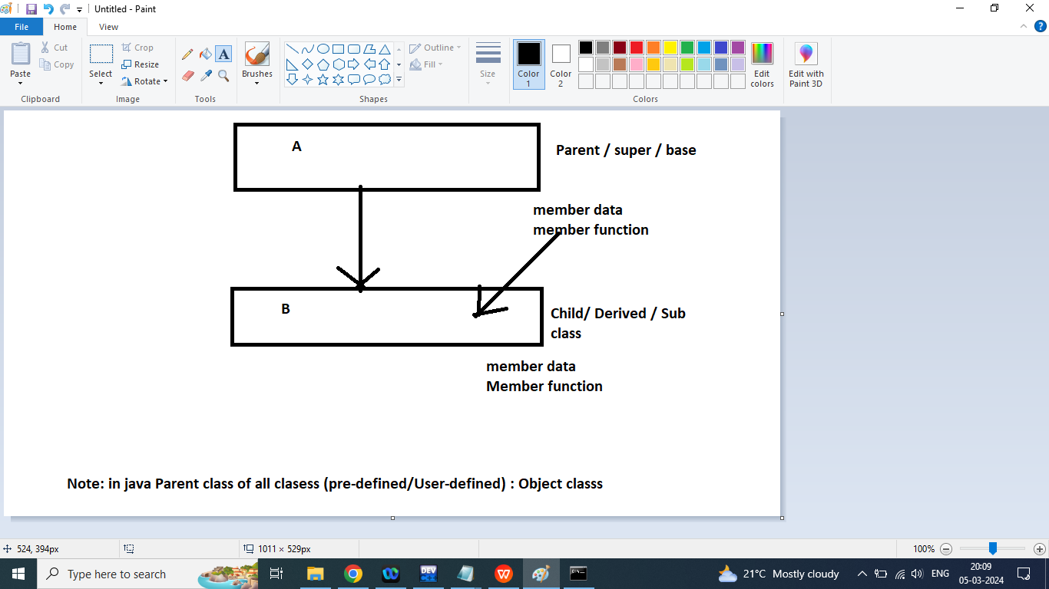

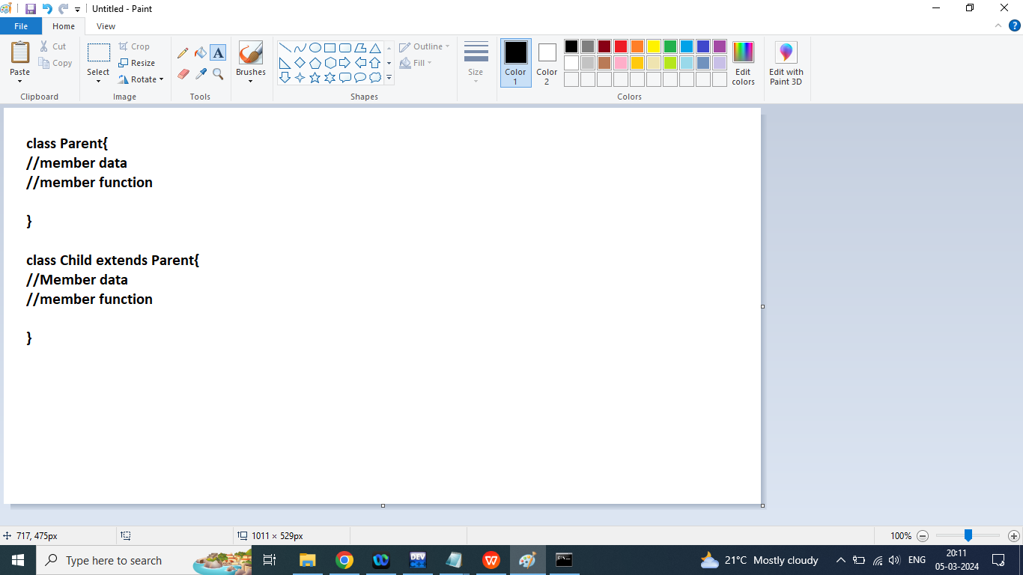

class Parent{

String fname="KARTIK";

String mname="shivani";

public void show(){

System.out.println(fname+" : "+mname);

}

public static void main(String args[]){

System.out.println("This is Parent class Main Method");

}

}

class Child extends Parent{

public static void main(String args[]){

System.out.println("This is Child class Main Method");

}

}

Q2. Write a java program to print sum of alternate addition and subtraction

class Ad{

public static int addSub(int input1,int input2){//input=1(-)

int sum=input1;

boolean flag=true;

for(int i=input1-1;i>=1;i--){//input=5 sum=1 flag=true

if(input2==1){

if(flag){

sum=sum-i;

flag=false;

}

else{

sum=sum+i;

flag=true;

}

}

if(input2==2){

if(flag){

sum=sum+i;

flag=false;

}

else{

sum=sum-i;

flag=true;

}

}

}

return sum;

}

public static void main(String args[]){

System.out.println(addSub(6,2));

}

}

//6-5+4-3+2-1=3

Q1. Explain super keyword in java programming?

Ans:

It is used to call parent class methods/constructor from the child class

1. Call Parent class Default constructor from child Class

super();

1. Call Parent class Parameterized constructor from child Class

super(cname,code);

1. Call Parent class method from the child class

super.methodName();

Note: super statement always used in first line of the block/method/constructor

Q2. Explain Inheritance in Java?

Ans: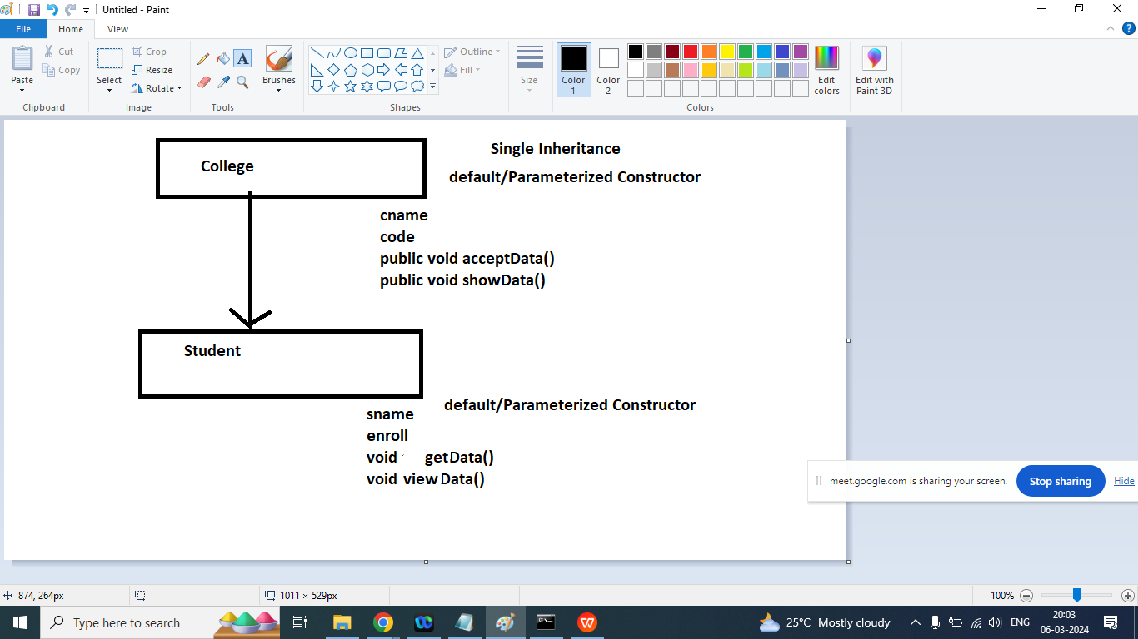

import java.util.Scanner;

class College{

protected String cname;

protected int code;

College(){

System.out.println("This is College class Default constructor");

}

College(String cname,int code){

this.cname=cname;

this.code=code;

System.out.println("This is College class Parameterized constructor");

}

public void acceptData(){

Scanner sk=new Scanner(System.in);

System.out.println("Enter College Name : ");

cname=sk.nextLine();

System.out.println("Enter College Code : ");

code=sk.nextInt();

}

public void showData(){

System.out.println("College Name : "+cname);

System.out.println("College Code : "+code);

}

}

import java.util.Scanner;

class Student extends College{

protected String sname;

protected String enroll;

Student(){

System.out.println("This is Student class Default constructor");

}

Student(String cname,int code,String sname,String enroll){

super(cname,code);

this.sname=sname;

this.enroll=enroll;

System.out.println("This is Student class Parameterized constructor");

}

public void getData(){

super.acceptData();

Scanner sk=new Scanner(System.in);

System.out.println("Enter Student Name : ");

sname=sk.nextLine();

System.out.println("Enter Student Enrollment : ");

enroll=sk.nextLine();

}

public void viewData(){

super.showData();

System.out.println("Student Name : "+sname);

System.out.println("Student Enrollment : "+enroll);

}

public static void main(String args[]){

Student s=new Student();

//Student s=new Student("LNCT",103,"Ram","0103CS181022");

s.getData();

s.viewData();

}

}

Q1. Explain static keyword in java programming?

Ans:

static data

*any data if declared as static is shared by all the objects

* it is referred as class data rather than object data

* to access static data, syntax is:

ClassName.dataName

*Benefits

It saves memory

It permits sharing

class Abc

{

int a;

int b;

static int c;

}

Abc x = new Abc();

Abc y = new Abc();

Abc z = new Abc();

static methods

* any method that works only and only static data

should be declared as static

* to invoke/call a static method, syntax is:

ClassName.methodName(<args>);

Note : NO OBJECT IS REQUIRED

* functions that do not work on any member data,

they are also declared as static (reusability)

class Abc{

int a;

int b;

static int count;

public Abc(){

count++;

}

public Abc(int a,int b){

this.a=a;

this.b=b;

count++;

}

public static int getCount(){

return count;

}

public static void main(String args[]){

Abc obj1=new Abc();

Abc obj2=new Abc();

Abc obj3=new Abc();

System.out.println("Object Count : "+count);

System.out.println("Object Count : "+Abc.count);

System.out.println("Object Count : "+getCount());

System.out.println("Object Count : "+count);

System.out.println("Object Count : "+Abc.getCount());

System.out.println("Object Count : "+getCount());

}

}

Static Block:

It is used to initialize a static member data

Static block always executed main method

If we write multiple static block in the program then it will executed according the order that are declared.

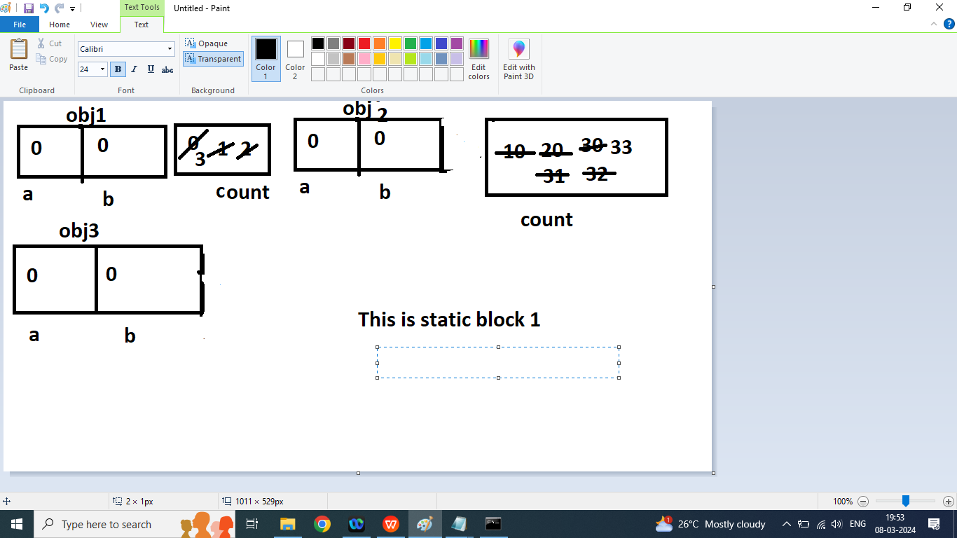

class Abc{

int a;

int b;

static int count;

static{

System.out.println("This is static block 1");

count=10;

}

public Abc(){

count++;

}

public Abc(int a,int b){

this.a=a;

this.b=b;

count++;

}

public static int getCount(){

return count;

}

static{

System.out.println("This is static block 2");

count=20;

}

public static void main(String args[]){

System.out.println("This is Main Method Here");

Abc obj1=new Abc();

Abc obj2=new Abc();

Abc obj3=new Abc();

System.out.println("Object Count : "+count);

System.out.println("Object Count : "+Abc.count);

System.out.println("Object Count : "+getCount());

System.out.println("Object Count : "+count);

System.out.println("Object Count : "+Abc.getCount());

System.out.println("Object Count : "+getCount());

}

static{

System.out.println("This is static block 3");

count=30;

}

}

class Abc{

int a;

int b;

static int count;

static{

System.out.println("This is static block 1");

count=10;

}

public Abc(){

count++;

}

public Abc(int a,int b){

this.a=a;

this.b=b;

count++;

}

public static int getCount(){

return count;

}

static{

System.out.println("This is static block 2");

count=20;

}

public static void main(String args[]){

System.out.println("This is Main Method Here");

Abc obj1=new Abc();

Abc obj2=new Abc();

Abc obj3=new Abc();

System.out.println("Object Count : "+count);

System.out.println("Object Count : "+Abc.count);

System.out.println("Object Count : "+getCount());

System.out.println("Object Count : "+count);

System.out.println("Object Count : "+Abc.getCount());

System.out.println("Object Count : "+getCount());

}

static{

System.out.println("This is static block 3");

count=30;

}

}

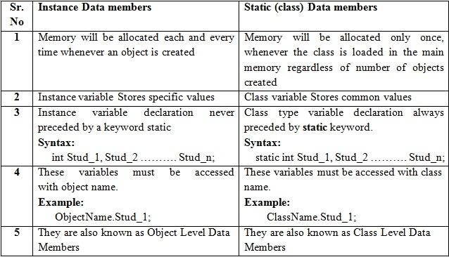

Q1. Test Question Generate Password using Three Numbers

import java.util.Arrays;

class T1{

public static int getPassword(int n1,int n2,int n3){

int unitn1=n1%10;

int unitn2=n2%10;

int unitn3=n3%10;

int runit=0;

if(unitn1<unitn2&&unitn1<unitn3){

runit=unitn1;

}

if(unitn2<unitn1&&unitn2<unitn3){

runit=unitn2;

}

if(unitn3<unitn1&&unitn3<unitn2){

runit=unitn3;

}

System.out.println(runit);

int tensn1=n1%100/10;

int tensn2=n2%100/10;

int tensn3=n3%100/10;

int rtens=0;

if(tensn1<tensn2&&tensn1<tensn3){

rtens=tensn1;

}

if(tensn2<tensn1&&tensn2<tensn3){

rtens=tensn2;

}

if(tensn3<tensn2&&tensn3<tensn1){

rtens=tensn3;

}

int h1=n1/100;

int h2=n2/100;

int h3=n3/100;

int rh=0;

if(h1<h2 && h1<=h3){

rh=h1;

}

if(h2<h1 && h2<h3){

rh=h2;

}

if(h3<h1 && h3<h2){

rh=h3;

}

if(h1==h2){

rh=h1;

}

if(h2==h3){

rh=h2;

}

System.out.println("Smallest Unit place : "+runit);

System.out.println("Smallest tens place : "+rtens);

System.out.println("Smallest Hundred place : "+rh);

int arr[]={unitn1,unitn2,unitn3,tensn1,tensn2,tensn3,h1,h2,h3};

Arrays.sort(arr);

int max=arr[arr.length-1];

String result=max+""+rh+""+rtens+""+runit;

return Integer.parseInt(result);

}

public static void main(String args[]){

System.out.println(getPassword(190,267,853));

}

}

Q1. Explain Abstraction in java programming?

Ans:

Abstraction is a process of hiding implementations

Hiding non essentials information and showing essential information to the user.

Abstraction can be achieve using abstract class or interface.

If a class contains at least one abstract method then compulsory class is also declared an abstract class

A abstract class can contain abstract or non abstract method

A abstract class can contain constructor

A abstract class can contain instance variable or static variables

We cannot create an object of abstract class but it can store reference of its child class.

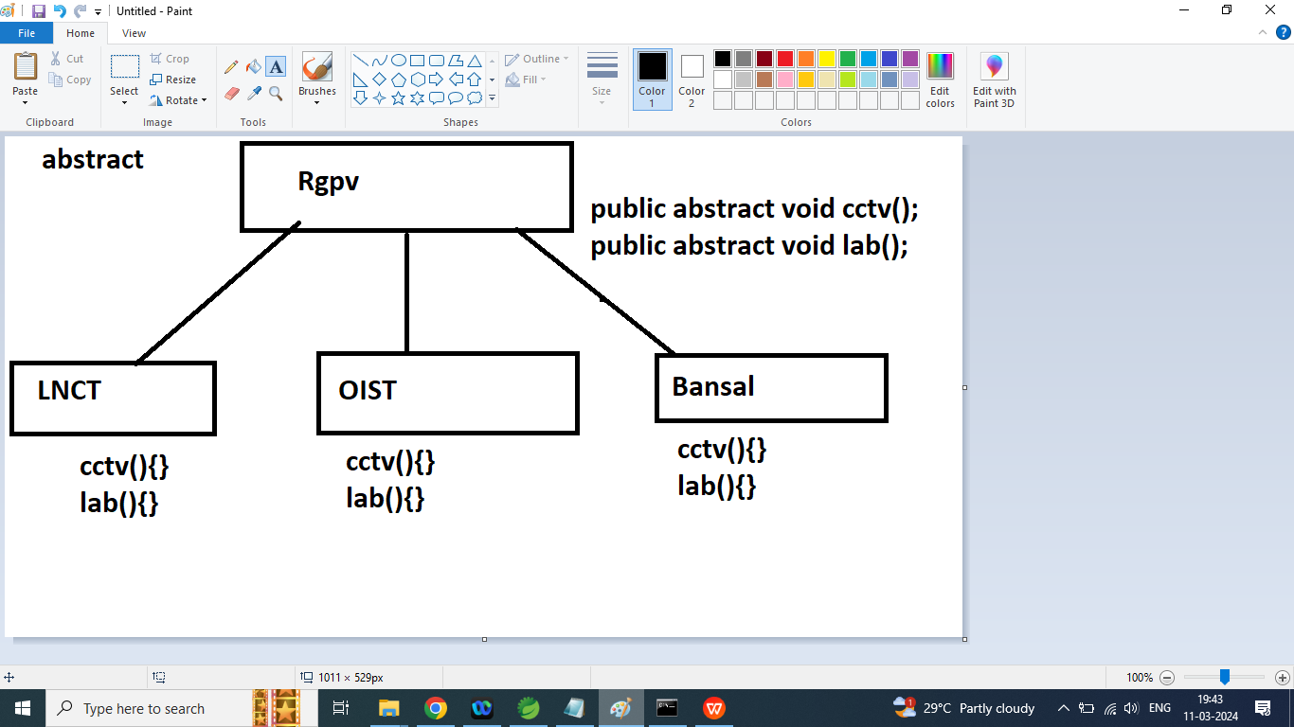

abstract class Rgpv{

String address="NEAR AIRPORT RGPV ";

static String uname="RGPV";

public abstract void cctv();//abstract method

public void examcopyCheck(){

System.out.println("This is Rgpv examcopyCheck method ");

}

public Rgpv(){

System.out.println("This is Rgpv Constructor");

}

}

==

abstract class Rgpv{

String address="NEAR AIRPORT RGPV ";

static String uname="RGPV";

public abstract void cctv();//abstract method

public abstract void lab();//abstract method

public void examcopyCheck(){

System.out.println("This is Rgpv examcopyCheck method ");

}

public Rgpv(){

System.out.println("This is Rgpv Constructor");

}

}

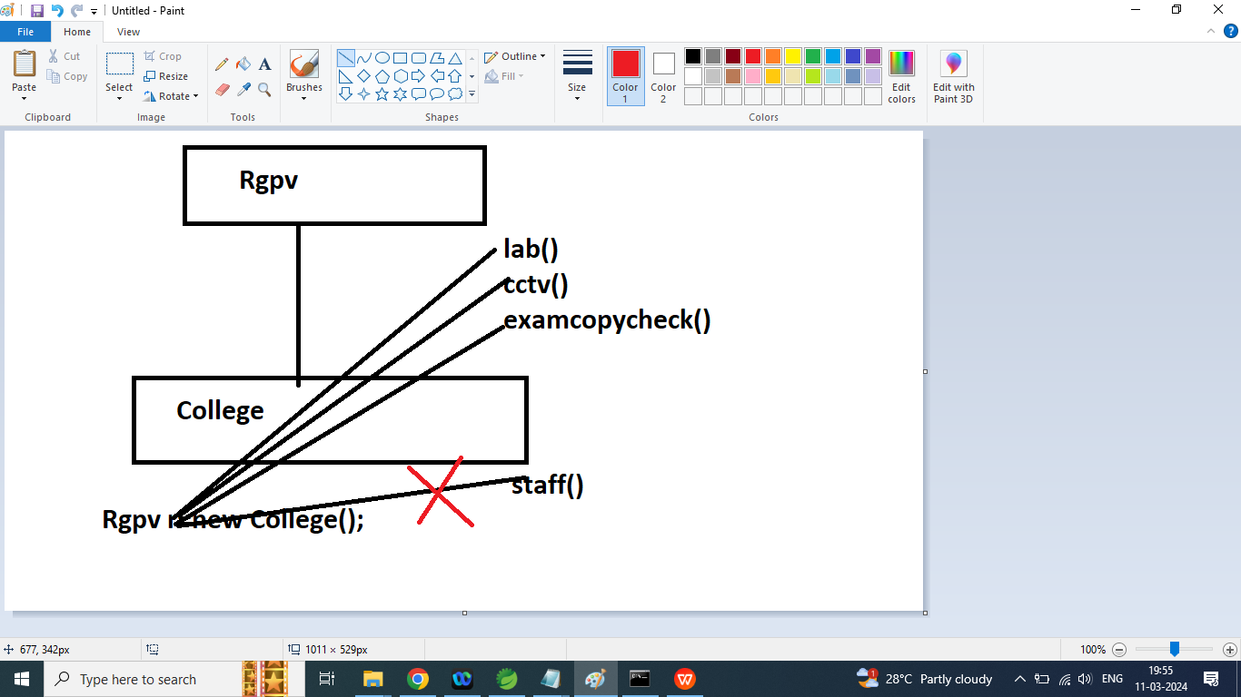

class College extends Rgpv{

public College(){

System.out.println("This is College class default constructor");

}

public void cctv(){

System.out.println("This is cctv rule by RGPV");

}

public void lab(){

System.out.println("This is lab rule by RGPV");

}

public void staff(){

System.out.println("This is College class staff method");

}

public void show(){

System.out.println("name : "+uname);

}

public static void main(String args[]){

Rgpv r=new College();

r.lab();

r.cctv();

r.examCopyCheck();

//r.staff();

College c1=new College();

c1.staff();

c1.lab();

c1.cctv();

c1.examCopyCheck();

c1.show();

c1.uname="LNCTU";

c1.show();

}

}

Q2. Explain Interface in java programming?

Ans:

Another ways to achieve abstraction in java

Th interface is a completely abstract class, that is used to declare abstract method

By default all methods of interface is public or abstract

An interface can contain variable(by default it is final variable)

interface keyword is used to declare a interface

Interface does not contain non-abstract method

Interface does not have any constructor

We cannot create an instance of Interface but it can store reference of its implemented class

A class can implements an interface

A class must be implement or override the interface method

Apart form interface method a Implemented class can have its own methods.

Syntax:

interface Ia{

void a();

}

interface Ia{

int x=10;

void a();

}

interface Ib{

int y=10;

void b();

}

class Test implements Ia,Ib{

public void a(){

System.out.println("This is Ia Interface method");

}

public void b(){

System.out.println("This is Ib Interface method");

}

public void abc(){

System.out.println("This is Test class abc method");

}

public static void main(String args[]){

Ia obj=new Test();

obj.a();

//obj.b();

//obj.abc();

Test obj1=new Test();

obj1.a();

obj1.b();

obj1.abc();

}

}

Q3. Explain Multiple Inheritance in java using interface.

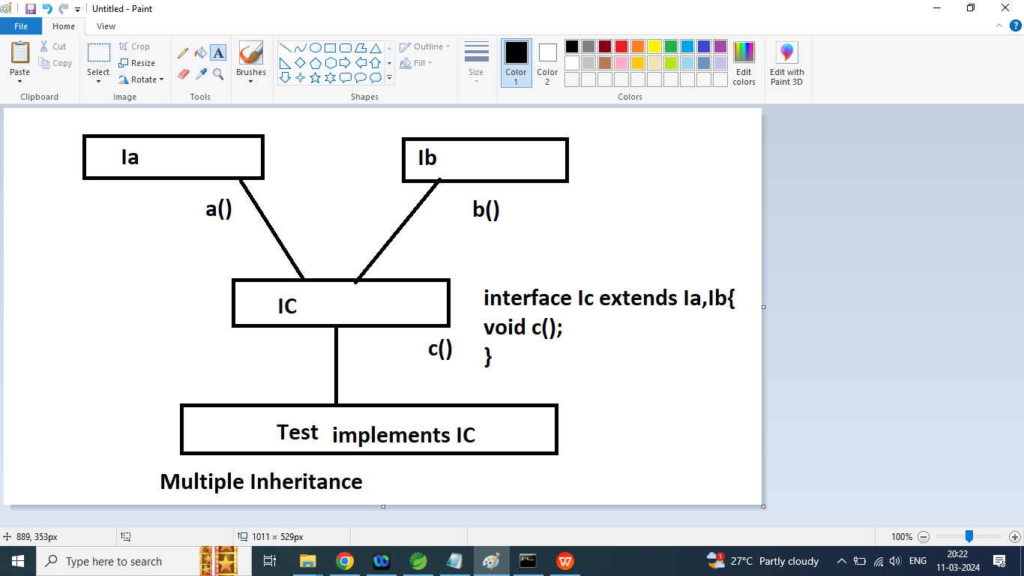

interface Ia{

int x=10;

void a();

}

interface Ib{

int y=20;

void b();

}

interface Ic extends Ia,Ib{

int z=30;

void c();

}

class Test implements Ic{

public void a(){

System.out.println("This is Ia Interface method");

}

public void c(){

System.out.println("This is Ic Interface method");

}

public void b(){

System.out.println("This is Ib Interface method");

}

public void abc(){

System.out.println("Sum : "+(x+y+z));

}

public static void main(String args[]){

Ia obj=new Test();

obj.a();

//obj.b();

//obj.abc();

Test obj1=new Test();

obj1.a();

obj1.b();

obj1.c();

obj1.abc();

}

}

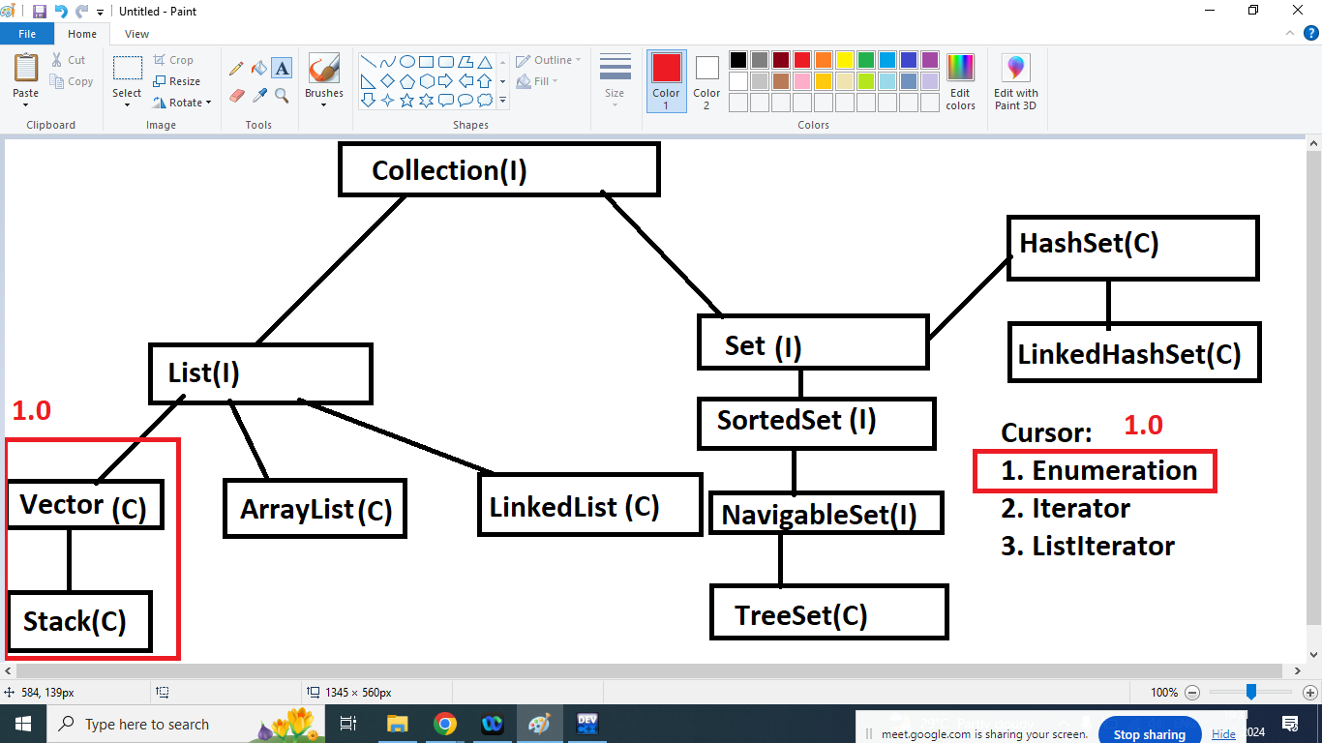

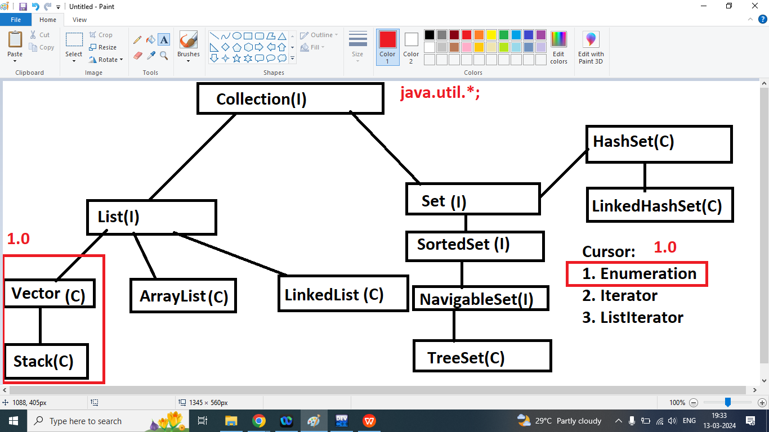

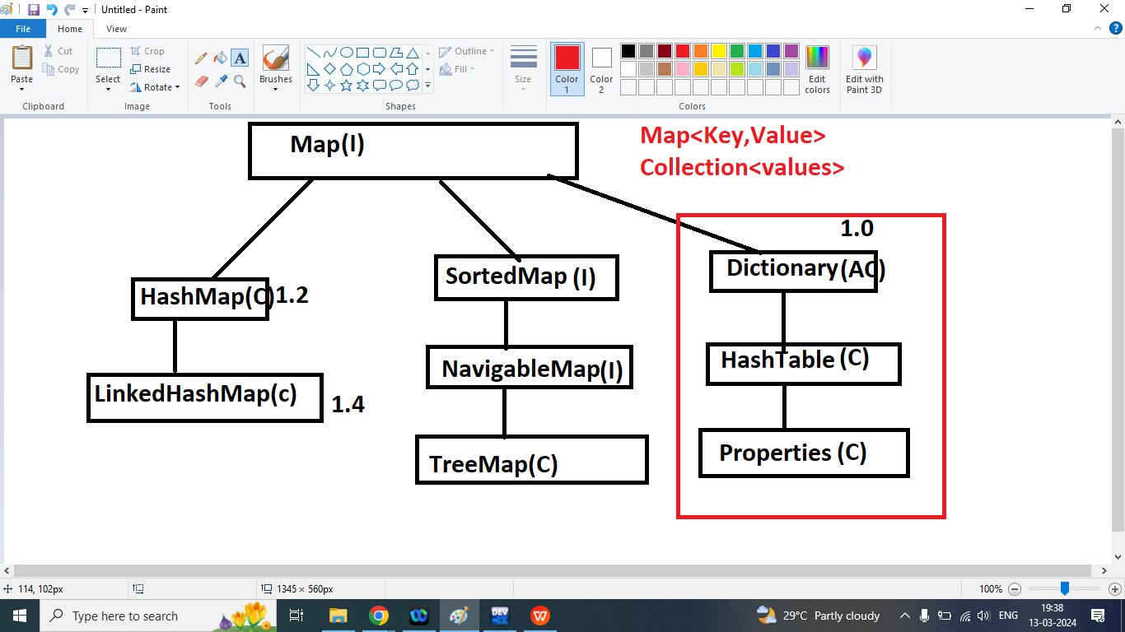

Q3. Explain final Keyword in java programming?

Ans:

Final keyword is used to perform some restrictions

1. Variable: final variable cannot be change

class C1{

public static final int X=10;

public C1(){

}

public static void main(String args[]){

System.out.println(C1.X);

System.out.println(X);

//X=45;

C1 obj=new C1();

System.out.println(obj.X);

}

}

1. Method: Final method cannot me override

class C1{

public static final int X=10;

public C1(){

}

public final void show(){

System.out.println(X);

}

}

class C2 extends C1{

public void show(){

System.out.println(X);

}

}

1. Class: final class cannot be inherit.

final class C1{

public static final int X=10;

public C1(){

}

public void show(){

System.out.println(X);

}

}

class C2 extends C1{

public void show(){

System.out.println(X);

}

}

Note:

Q3. Explain Exception Handling in Java Programming?

Ans:

Exception Handling

Types of Errors

1. Compile Time/Syntax

Egs : Missing ; , misspelling, missing ", using variable without declaration

2. Runtime

Egs: Division By Zero, Invalid Conversion, Accessing invalid index of an array.

1. Runtime error results in an Exception

2. Whenever Exception occurs Java creates an Object of "Exception" or its derive class

3. Exception leads to abnormal termination of program giving some garbage on screen.

4. Handling means making the user aware with problem

For Exception Handling Java provides:

Constructs

1. try

2. catch

3. finally

Statements

1. throw

2. throws

Types of Exception

1. Pre-Defined Exceptions

2. User-Defined Exceptions

try:

+All statements that may result in an error are written within try.

+A method can have nested or multiple try blocks.

catch:

+Every "try" should be followed by atleast 1 catch block.

+Multiple catch blocks works like cases in switch only one will be executed depending on Exception generated.

+catch receives an argument of Exception or its derive class.

+catch is conditional

finally

+finally can be used as a substitute or along with catch.

+There can be only 1 finally.

+finally does not receive any argument.

+finally is unconditional.

throw

+It is used to generate an Exception

throws

+It is used to forward an Exception

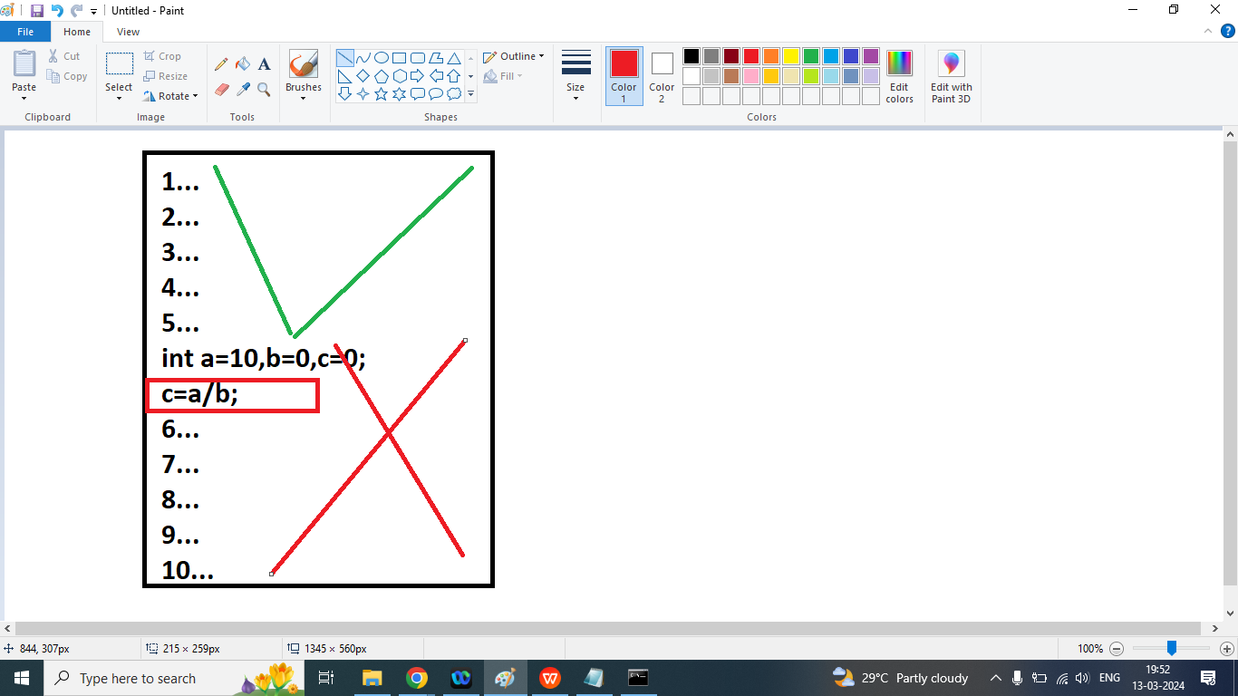

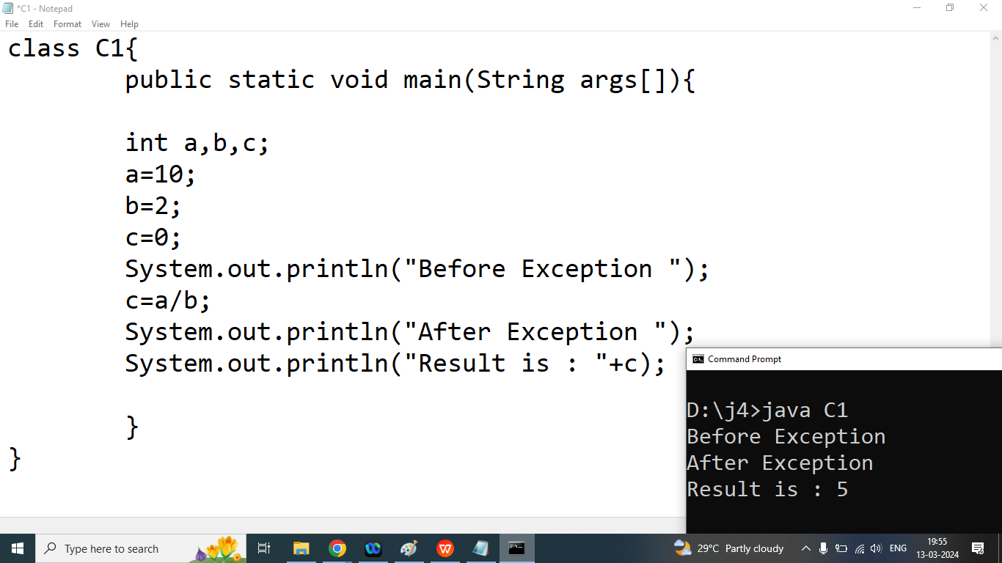

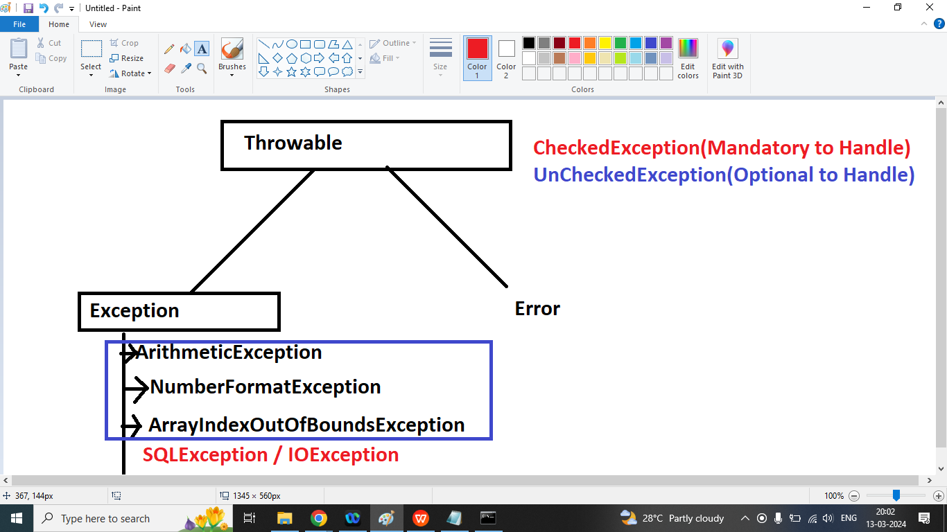

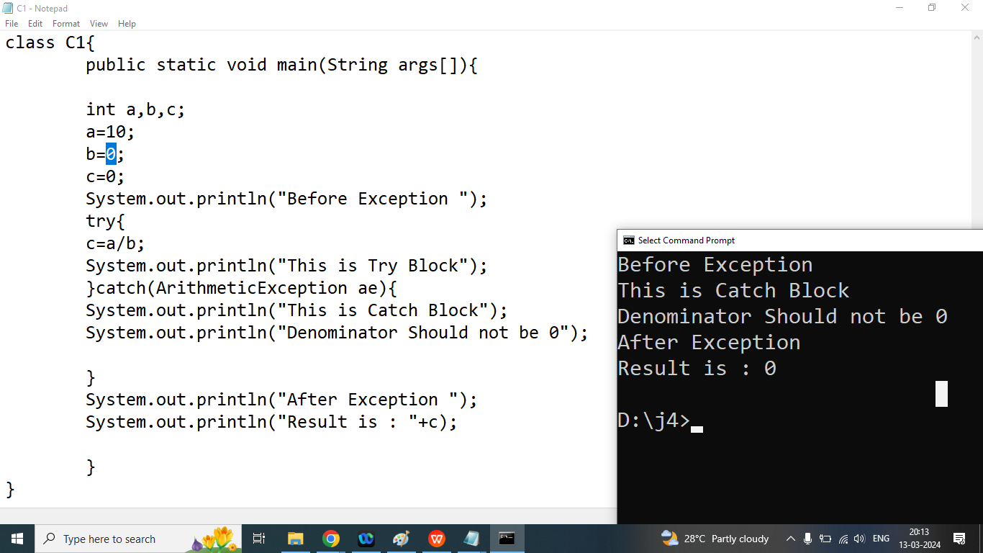

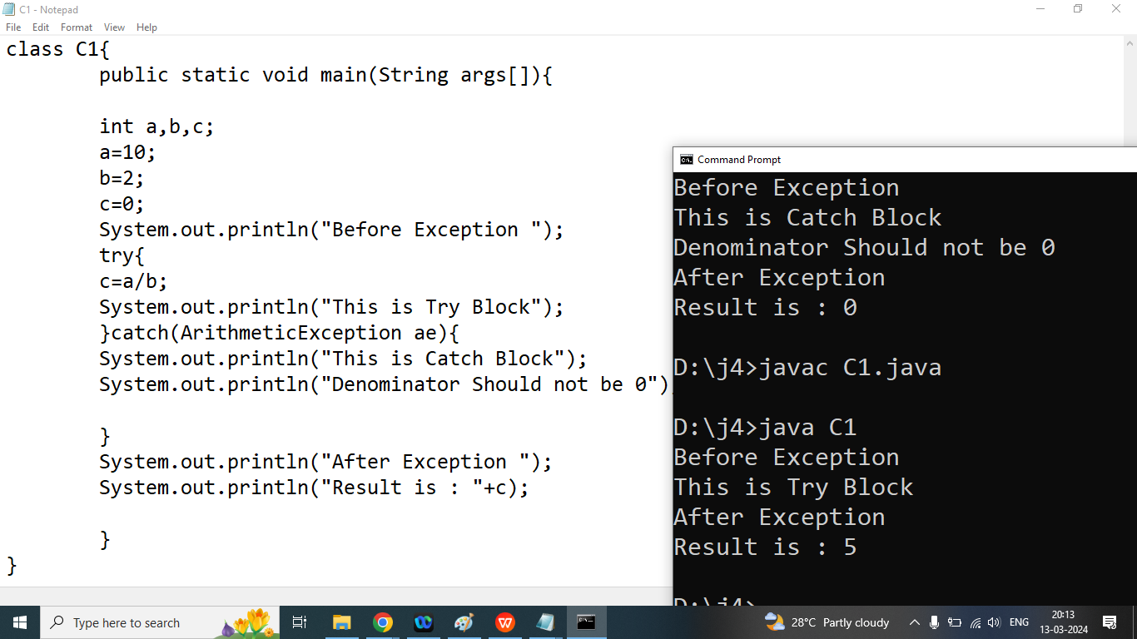

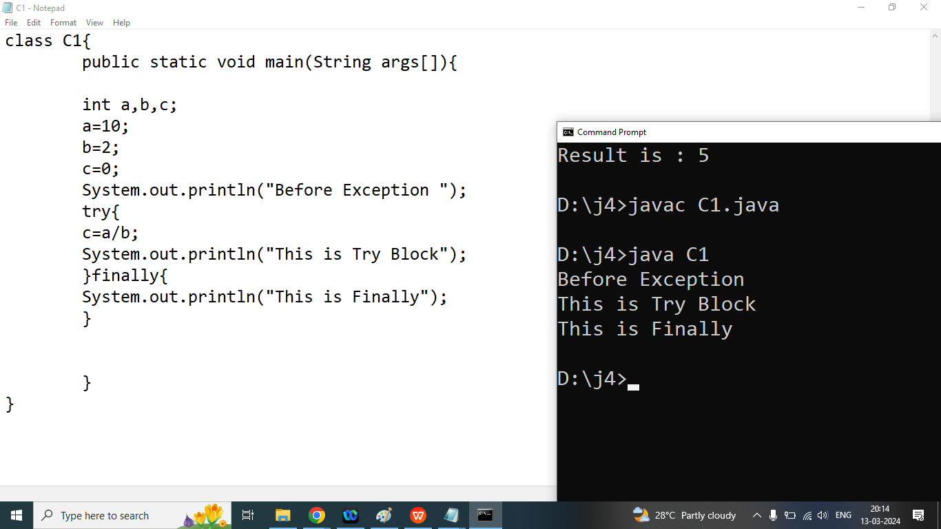

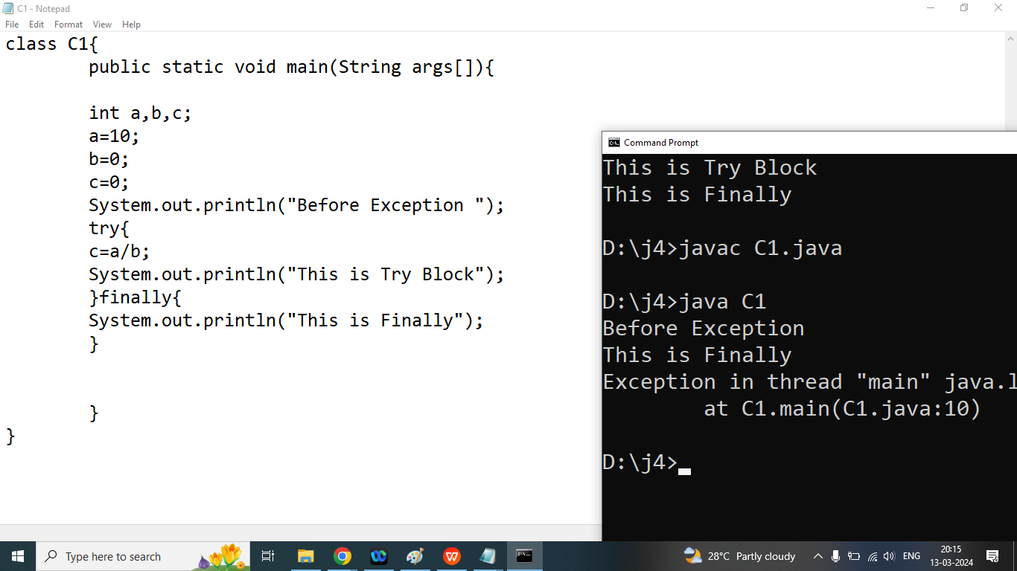

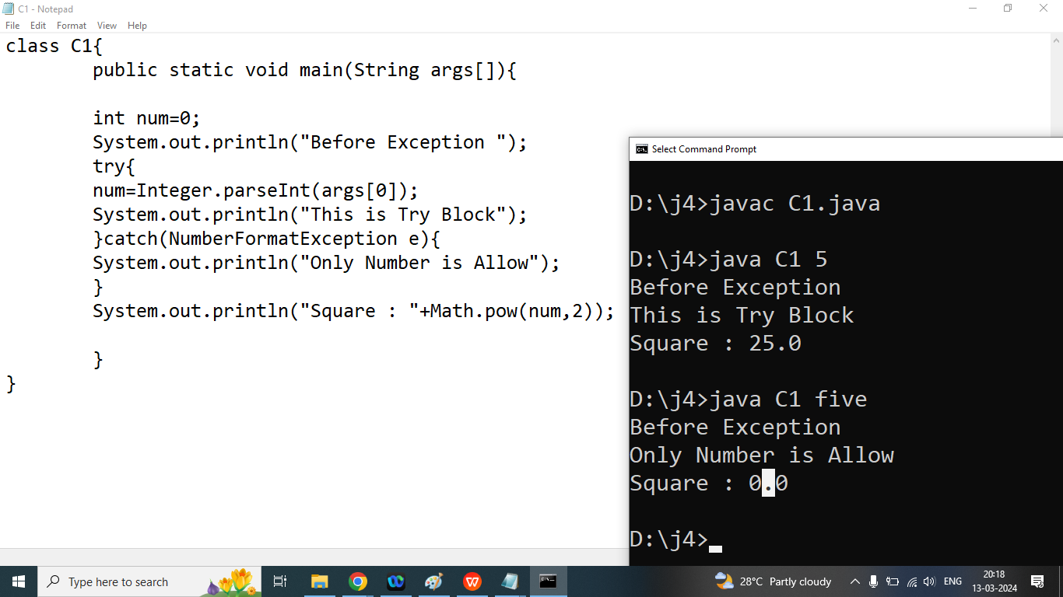

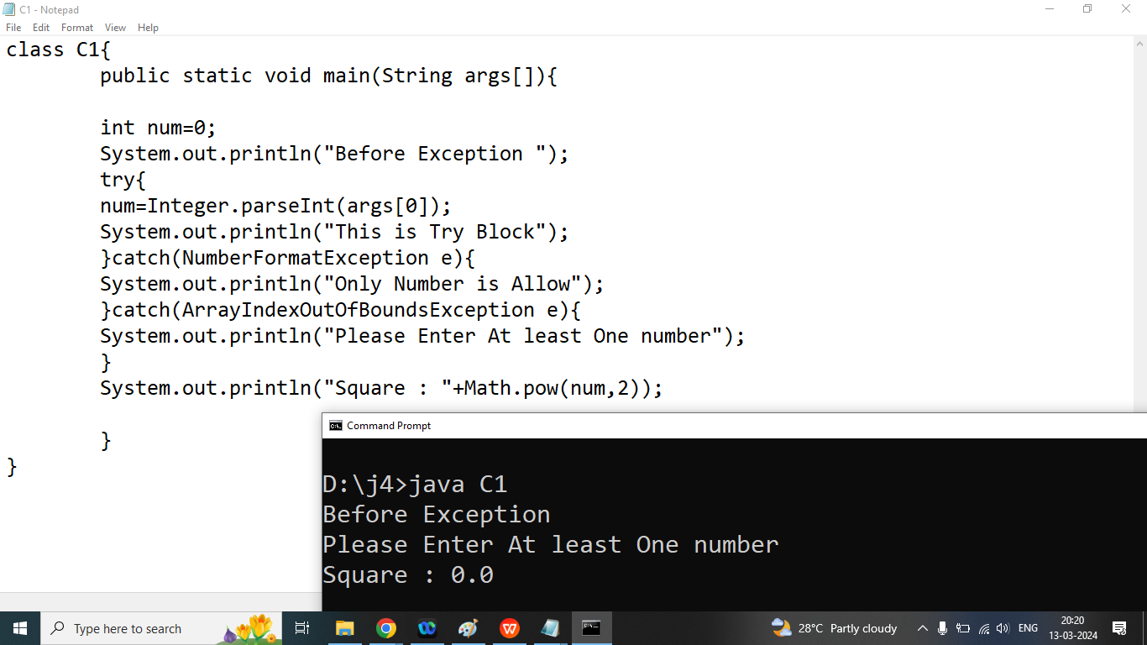

class C1{

public static void main(String args[]){

int num=0;

System.out.println("Before Exception ");

System.out.println("Number of Arguments Passed By Command Line : "+args.length);

try{

num=Integer.parseInt(args[0]);

System.out.println("This is Try Block");

}catch(NumberFormatException e){

System.out.println("Only Number is Allow");

}catch(ArrayIndexOutOfBoundsException e){

System.out.println("Please Enter At least One number");

}

System.out.println("Square : "+Math.pow(num,2));

}

}

Q1. Explain BFS With Program?

import java.util.LinkedList;

import java.util.Queue;

// Class to represent a graph using adjacency list

class Graph {

int vertices;//0

LinkedList<Integer>[] adjList;

Graph(int vertices) {

this.vertices = vertices;

adjList = new LinkedList[vertices];

for (int i = 0; i < vertices; ++i) {

adjList[i] = new LinkedList<>();

}

}

// Function to add an edge to the graph

void addEdge(int u, int v) {

adjList[u].add(v);

}

// Function to perform Breadth First Search on a graph

// represented using adjacency list

void bfs(int startNode) {

// Create a queue for BFS

Queue<Integer> queue = new LinkedList<>();

boolean[] visited = new boolean[vertices];

// Mark the current node as visited and enqueue it

visited[startNode] = true;

queue.add(startNode);

// Iterate over the queue

while (!queue.isEmpty()) {

// Dequeue a vertex from queue and print it

int currentNode = queue.poll();

System.out.print(currentNode + " ");

// Get all adjacent vertices of the dequeued

// vertex currentNode If an adjacent has not

// been visited, then mark it visited and

// enqueue it

for (int neighbor : adjList[currentNode]) {

if (!visited[neighbor]) {

visited[neighbor] = true;

queue.add(neighbor);

}

}

}

}

}

class Main {

public static void main(String[] args) {

// Number of vertices in the graph

int vertices = 5;

// Create a graph

Graph graph = new Graph(vertices);

// Add edges to the graph

graph.addEdge(0, 1);

graph.addEdge(0, 2);

graph.addEdge(1, 3);

graph.addEdge(1, 4);

graph.addEdge(2, 4);

// Perform BFS traversal starting from vertex 0

System.out.print(

"Breadth First Traversal starting from vertex 0: ");

graph.bfs(0);// 0 1 2 3 4

}

}

Q2.How to create User Defined Exception or Custom Exception in java?

Ans:

If we want to create a user defined Exception then we must extends Throwable/Exception

Syntax:

class InvalidAgeException extends Throwable{

private String msg;

public InvalidAgeException(String msg){

this.msg=msg;

}

public String getMsg(){

return msg;

}

}

class C1{

public static void main(String args[]){

int age=0;

System.out.println("Before Exception ");

try{

age=Integer.parseInt(args[0]);

if(age<0 || age>120){

InvalidAgeException x=new InvalidAgeException("InvalidAgeException Occur");

throw x;

}

System.out.println("You Enter Valid Age ");

}catch(InvalidAgeException iae){

System.out.println("Invalid Age Exception catch block Executed");

System.out.println(iae.getMsg());

}

catch(NumberFormatException e){

System.out.println("Only Number is Allow");

}catch(ArrayIndexOutOfBoundsException e){

System.out.println("Please Enter At least One number");

}

}

}

Next class

JDK 1.8

Netbeans 8.2

Mysql : 8.0.13

